Hesketh Park Conservatory – Information Pack

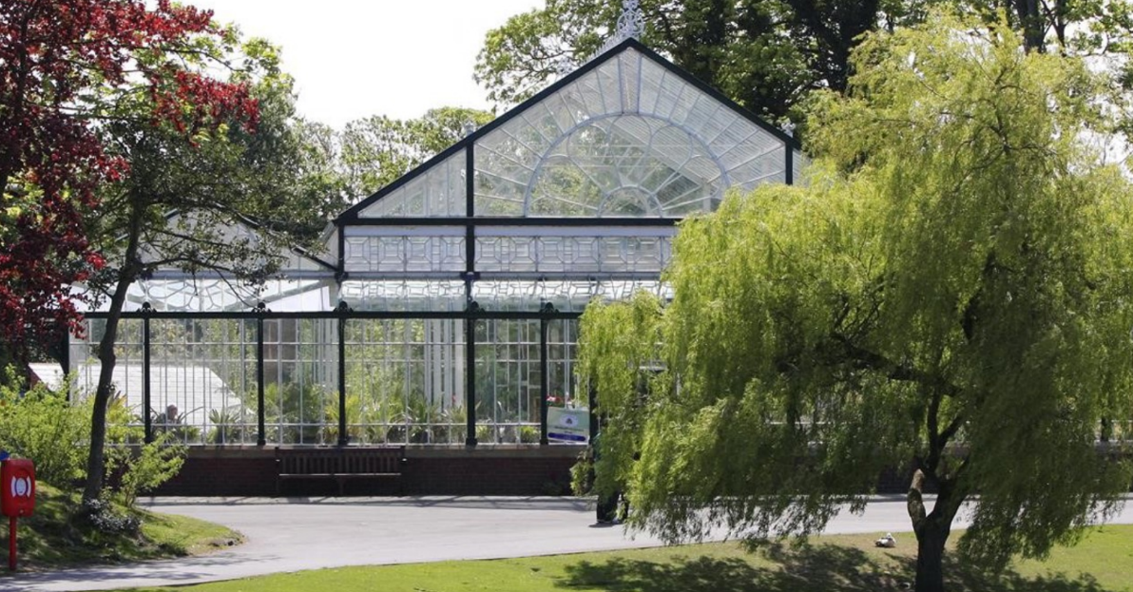

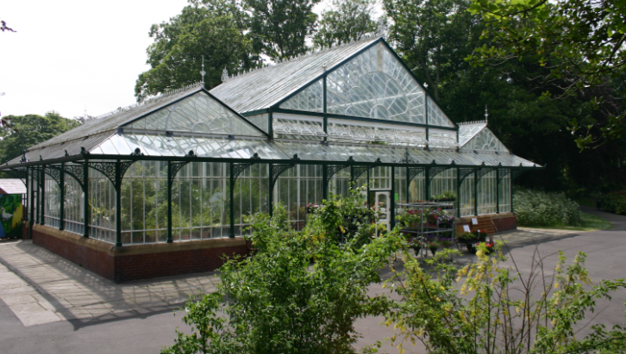
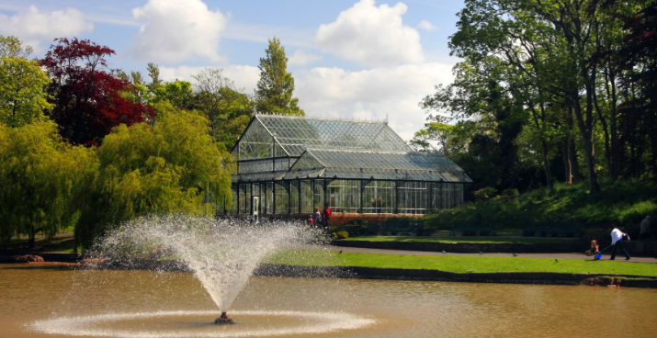

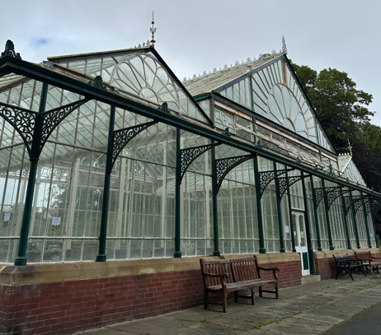

Summary:
Hesketh Park Conservatory is a beautiful Victorian glasshouse dating from the mid-to-late 19th century, set within Hesketh Park, one of Southport's most historic and popular parks. The conservatory is a Grade II listed building, recognising its important architectural and historical value and its significance as a local landmark. The internal floor dimensions are approximately: 21.2m x 11.6m.

Situated around one mile north of Southport Town Centre, it is easily accessible and close to local neighbourhoods, visitor attractions and public transport connections.

The Council is working closely with the Marks Family Trustees and The Hesketh Park Heritage Group to plan and manage the restoration, and improvement works to the park to ensure the donation is appropriately allocated. This reflects a comprehensive restoration-led approach, aimed at bringing the listed structure back into safe, functional public use while conserving its historic fabric. You can see more about the expected works taking place on the Hesketh Park Conservatory webpage.

Restrictions on use
Due to the Hesketh Park Café having exclusive catering rights to the park, the sale of food and drink to the general public cannot be permitted from the Conservatory.

However, for uses of the Conservatory as an events venue, the sale of food and drink would be permitted to event attendees, for consumption within the area detailed in the attached plan.

What work is taking place on the Conservatory?
The Council is working closely with the Marks Family Trustees and The Hesketh Park Heritage Group to plan and manage the restoration, and improvement works to the park to ensure the donation is appropriately allocated. This reflects a comprehensive restoration-led approach, aimed at bringing the listed structure back into safe, functional public use while conserving its historic fabric.

Summary of Proposed Works – Hesketh Park Conservatory
Drainage:
Full replacement and upgrade of the existing drainage system (above and below ground), including restoration of gutters and integration with the existing lake outfall.

Internal Floor:
Careful lifting, cleaning, and reinstatement of the existing York stone floor and planting bed edgings, alongside new sub-base and drainage improvements.

Structural Frame & Metalwork:
Significant repair and strengthening of the metal frame, including addressing corrosion, replacing/augmenting structural elements, and full removal of defective coatings and repainting.

Cast Iron Columns:
Cleaning, repair and conservation of existing columns as part of the overall metalwork restoration.

Glazing (Vertical & Roof):
Removal, repair and reinstatement of glazing systems, including overhaul of glazing bars, replacement of defective components, and full cleaning.

Clerestory Windows:
Removal and off-site restoration of high-level windows, returning them to operational condition, with introduction of new opening lights where required.

Canopy:
Full dismantling, off-site restoration, and reinstatement of the external glazed canopy structure.

Masonry:
Cleaning, repointing, and localised repairs to the brick plinth and stone copings.

Doors:
Replacement of principal timber doors and refurbishment of the boiler house door.

Boiler House:
Repairs to roof structure, rainwater goods, masonry, and internal elements.

Mechanical & Electrical:
Full replacement of services systems from the boiler house distribution point.

Please note that this summary is provided for Expression of Interest purposes and outlines the anticipated scope of works at this stage. The final scope will be confirmed following tender returns and may be refined through ongoing design development and contractor engagement.

Site Visits:
Site visits have been scheduled for interested parties to attend the property. Relevant members and colleagues will be present to answer your questions and queries regarding the property and the Community Asset Process.

- Date: 5th November 2026, 10:00am-12:00noon
- Date: 9th November 2026, 10:00am-12:00noon

Any enquiries please contact: Community.assets@sefton.gov.uk

