Duke Street Park Toilet Block, Formby – Information Pack
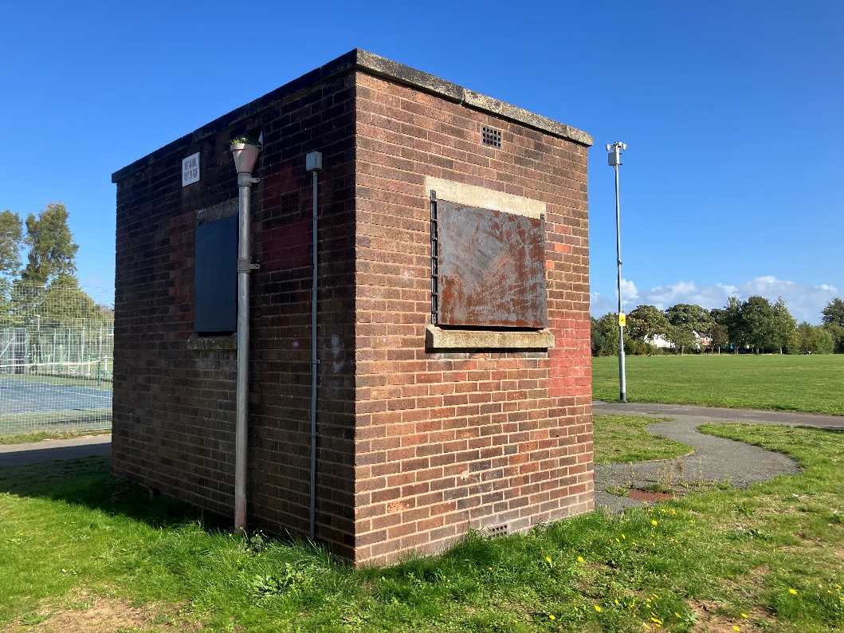

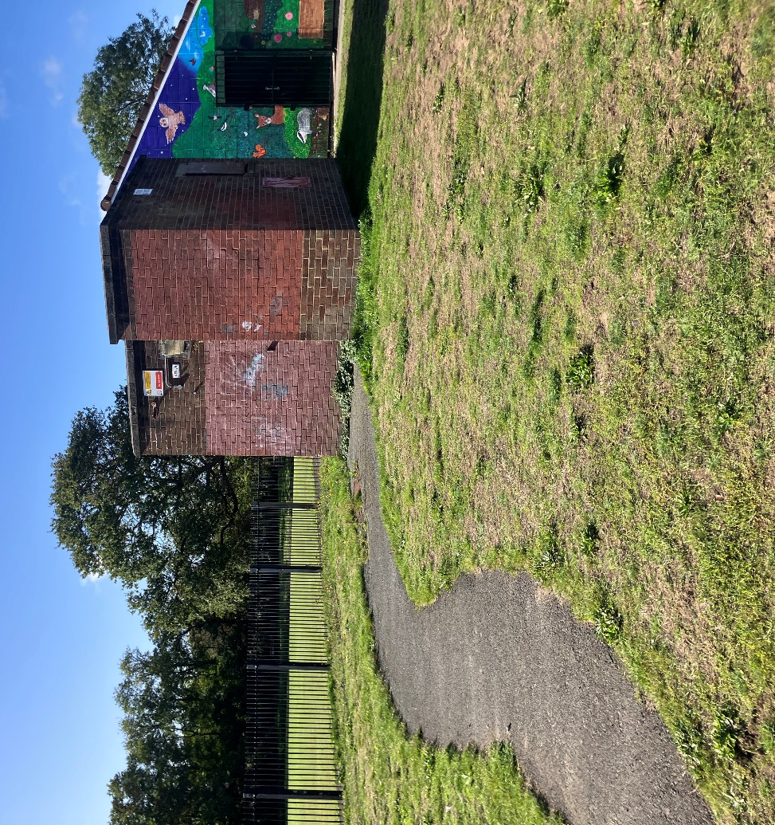

Summary:
Located within Duke Street Park in Formby, close to Formby Village, this opportunity comprises a former toilet block and surrounding grassed area (outlined in red on the site plan below).
It is a detached purpose-built public convenience block of traditional load bearing brick construction beneath flat roofs, Constructed c. 1950This building has been vacant for 15 years. The block extends to approximately 100 sq.ft gross internal area (GIA).
The site benefits from good accessibility, being located adjacent to Formby railway station and served by local bus routes. The Council is seeking a sustainable community organisation proposal that supports and adds value to the wide range of recreational activities already taking place across the park, while delivering lasting community benefit.

Restrictions on use
It should be noted that there are two former toilet blocks located within Duke Street Park. One block forms part of the Sefton Padel proposal, while the other (outlined in red on the site plan) will be offered as part of Phase 2 of the Community Assets Process. The toilet block associated with the Sefton Padel proposal will be retained and restored for use by padel court users.

Site Visits:
Site visits have been scheduled for interested parties to attend the property. Relevant members and colleagues will be present to answer your questions and queries regarding the property and the Community Asset Process.

- Date: 10th November 2026, 2:00pm-4:00pm
- Date: 18th November 2026, 2:00pm-4:00pm

Any enquiries please contact: Community.assets@sefton.gov.uk

