Cambridge Community Kitchen – Community Asset Information Pack
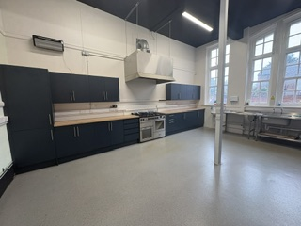

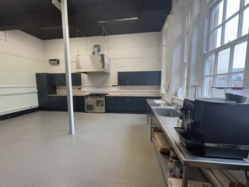

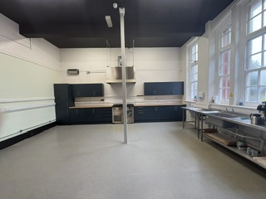

Summary:
Based within the Cambridge Road Adult Learning Centre, Cambridge Kitchen is being developed as an inclusive community space that combines affordable food provision with learning, volunteering and social connection opportunities. Working in partnership with the Community Learning Service, the successful operator will manage the day-to-day running of the kitchen while supporting learners to develop practical employability skills and confidence through real-life work experience opportunities.
The vision is to create a welcoming community hub that helps tackle food insecurity, reduces social isolation and promotes wellbeing, while supporting sustainability through partnerships that reduce food waste and make best use of surplus food.
The Council is seeking a partner with experience in community food provision, catering, or a similar service who can demonstrate a commitment to community impact, partnership working, equality, inclusion and long-term sustainability.
Interested organisations will be invited to submit an Expression of Interest outlining how they would deliver the service and contribute to the wider aims of Cambridge Kitchen and the Community Learning Service.
The kitchen space extends to approximately 928.46 sq.ft gross internal area (GIA).

Restrictions on use

- Due to the access to the space being through the main college entrance, there are restrictions on working and training hours in line with the opening hours of the college. For more information, contact: Community.assets@sefton.gov.uk
- Must obtain and maintain required food hygiene and environmental health standards.
- Responsible for staffing, volunteer management and supervision.
- Responsible for fire risk assessments, operational risk assessments and safe systems of work.
- Responsible for pest control and waste segregation requirements.
- Must align with equality, diversity, inclusion, safeguarding and community learning values.

Site Visits:
Site visits have been scheduled for interested parties to attend the property. Relevant members and colleagues will be present to answer your questions and queries regarding the property and the Community Asset Process.

- Date: 10th November 2026, 10:00am-12:00noon
- Date: 18th November 2026, 10:00am-12:00noon

Any enquiries please contact: Community.assets@sefton.gov.uk

