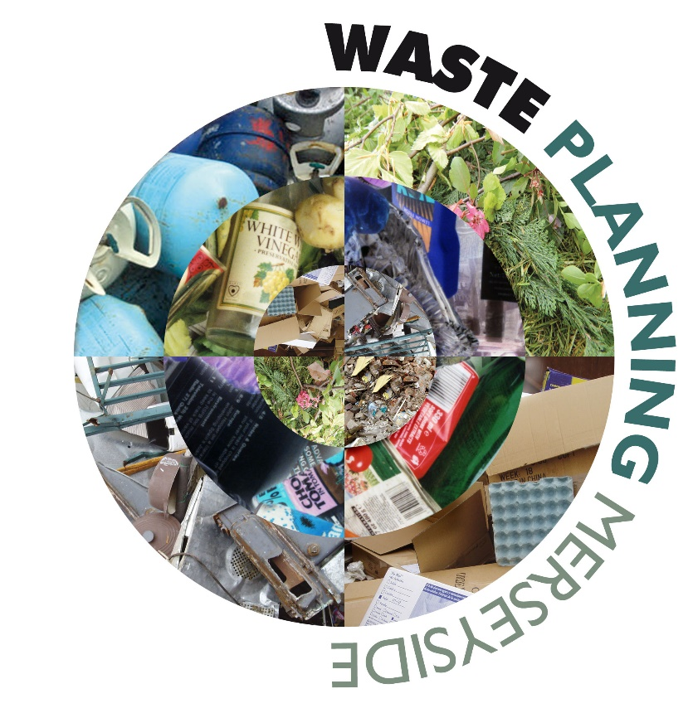

Review of the Merseyside and Halton Joint Waste Local Plan
Paper 4: Duty to Cooperate Engagement
February 2025
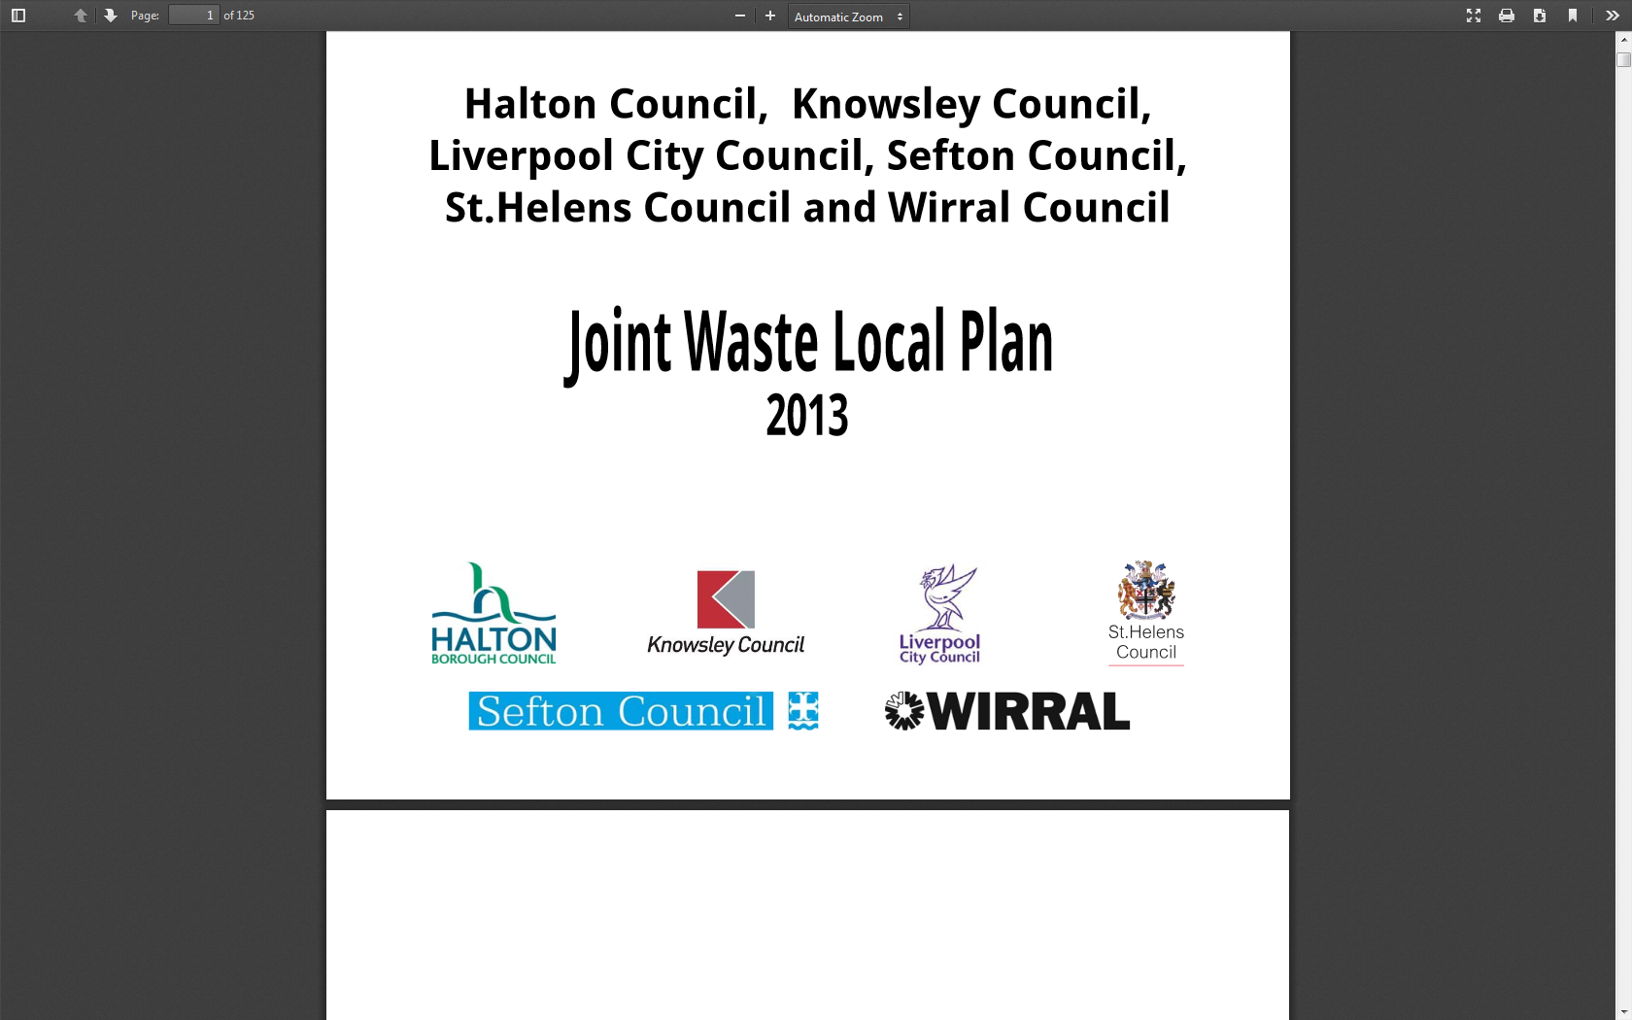

Paper 4: Duty to Cooperate Engagement
Introduction
- Planning Practice Guidance paragraph 62 requires duty to cooperate engagement during the review process. As waste is a strategic matter this requires working with not only immediate neighbouring authorities but also any local authorities with which there are movements of significant quantities of waste.

- This report outlines the Duty to Cooperate engagement that has been undertaken.
Methods of Engagement
- MEAS has coordinated the review process with the support of officers from constituent authorities, Halton Borough Council, Knowsley Council, Liverpool City Council, Sefton Council, St.Helens Council and Wirral Council. This has included regular reporting to the Liverpool City Region (LCR) Planning Policy Managers (PPMs) Group and Chief Planners Officers Group, with a sub group of PPMs overseeing the WLP Review process.

- Regular liaison meetings have been held with Merseyside Recycling and Waste Authority (MRWA) and the LCR Waste Partnership during the WLP review process. This has been via in-person and virtual meetings.

- Regular liaison meetings are held with North West Waste Network (formerly NW Regional Technical Advisory Body on Waste).

- Engagement on the review has also been undertaken with other Waste Planning Authorities in the North West, along with other relevant planning authorities. Engagement with these authorities has been via email or virtual meetings.

- The engagement for the review has largely related to sharing import and export data and checking whether there are any reasons why these movements should not continue.

- The following organisations have been engaged in this way:
- Cheshire East Council;
- Cheshire West and Chester Council;
- Greater Manchester Combined Authority;
- Lancashire County Council;
- Newport City Council;
- North Wales Minerals and Waste Advisory Group;
- Teesside Council

- MRWA and the Liverpool City Region Waste Partnership are some of the implementation bodies for the WLP, therefore draft review papers have been shared with them for comment to ensure that they agree with the data relevant to their organisations and that their needs continue to be met by the WLP.

- In addition to this, MEAS has responded to a variety of duty to cooperate requests from waste planning authorities around the country in relation to their Plan-making processes. Details of these can be found in the AMRs.
Cross Boundary Movements and Responses
- Responses received are shown in Appendix 1.

- Cross boundary movement of waste is recognised as being common and reflective of the way the waste industry operates. During development of the

- WLP, an assessment was made of cross boundary movement at which point the LCR was a net exporter of waste. Over the years since adoption of the plan, the balance has tipped and now the LCR is a net importer of waste, by quite significant amounts.

- No significant issues were raised regarding cross boundary movements of waste. All of the neighbouring authorities send more waste into the LCR than the LCR is sending to them, therefore, concerns were not anticipated.

- A formal response was received from Teesside, but again no concerns raised regarding the continued movement of significant amounts of residual waste from the LCR to Teesside. This is part of a long-term contract between MRWA and Suez and therefore, issues were not anticipated.

- Responses from the North Wales authorities and Newport City Council have simply referred us to Natural Resources Wales to access the Welsh equivalent of the Waste Data Interrogator. No concerns or issues were raised. Welsh data has subsequently been obtained and factored into the review.
Conclusion
- Duty to Cooperate duties have been fulfilled during this review process. No issues have been raised that affect the review.

Appendix 1 - Duty to Cooperate Meetings/Correspondence
Authority | Date | Discussions/Conclusions
Cheshire East | 12/11/2024  (Teams Meeting) | More imports from Cheshire East to LCR than vice versa. 2022 WDI Data was shared ahead of the meeting. CE checked the information and thought the 2022 figures were quite low. CE shared comparison information for 2021/2023 which showed imports from CE to be approximately one third higher. This is unlikely to cause significant issues to the LCR. CE have a problem going forward with regard to landfill as they were reliant on Kinderton Lodge in CWaC coming forward and the planning permission has now expired, not known if this will come through or not. Uncertain whether this will affect the LCR.
Greater Manchester Combined Authority | 19/11/2024  (Teams Meeting) | Significantly more imports from Greater Manchester to LCR than vice versa, as a result of the GMWDA contract at Runcorn EfW. 2022 WDI Data was shared ahead of the meeting. GM indicated that this contract may have recently been extended to 2034. Agreed that there wasn’t much that we could influence from this perspective.
Lancashire CC | 27/06/2024  (Teams Meeting) | Meeting was set up to discuss the Lancashire Minerals and Waste Local Plan, waste movements between LCC and Merseyside and Halton were discussed. No issues raised ‘Current approach acceptable to both parties and provides for strategic cross boundary issue.’
Warrington | 19/11/2024  (Teams Meeting) | More imports from Warrington to LCR than vice versa, although not huge volumes. 2022 WDI Data was shared ahead of the meeting. Discussed this was likely a result of the Warrington household waste contract. Warrington thought this had recently been renewed but didn’t have a date. Also, indicated that there had been discussions about having a waste transfer station located within Warrington, but the site identified had resulted in too much objection. Not sure if this is being progressing further. LCR indicated there is capacity at the facility that Warrington’s waste goes to, and that it is then transferred on elsewhere.
Redcar & Cleveland | 27/11/2024  (Letter response) | ‘Thank you for your consultation under the Duty to Co-operate. We have no reason to believe that the data within the Waste Interrogators is incorrect. We are unaware of any planning related reasons which would affect the continued movement of waste in the future.’
Newport | (remail response) | Response directed to NRW dataset.
North Wales | (email response) | Response directed to NRW dataset.

