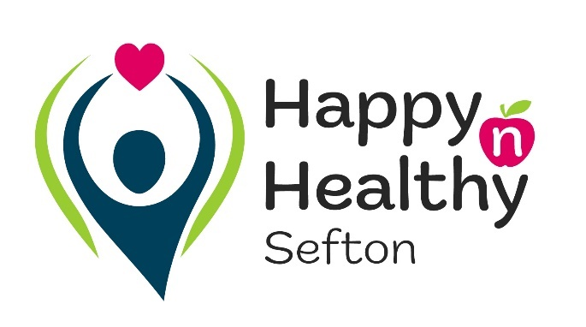
Registration form

Personal details
Full name of child/young person (CYP)

First name |  | Last name
Age |  | DOB

Gender
Male☐ Female ☐ Prefer not to say☐ Prefer to self-describe☐
If ‘Prefer to self-describe’ has been selected, please enter details in this box

Address including post code
Please enter address details in this text box
Early Years setting/School/College
GP practice

Is the CYP/Are you a Child in Care?
Is the CYP/Are you caring for someone?

Yes ☐ No☐
Yes☐ No☐
Contact details
These can be the young person’s contact details or a family members/responsible adult. If it’s a family member/responsible adult, please specify their relationship.
Telephone:
E-mail
Whose are these contact details?
Relationship to the young person

We may need to discuss this referral further, so if the most appropriate person for us to do this with is different to that above, please share the name, contact details and their relationship to the young person.

Name, contact details and their relationship to the young person to be entered here

Ethnicity

Asian or Asian British
Indian☐ Pakistani☐ Bangladeshi☐ Chinese☐ Any other Asian background ☐
Black, Black British, Caribbean or African
Caribbean☐ African☐ Any other black, black British or Caribbean background☐

Mixed or Multiple Ethnic groups
White and Black Caribbean☐ White and Black African☐ White and Asian☐
Any other mixed or multiple ethnic background☐

White
English, Welsh, Scottish, Northern Irish or British☐ Irish☐ Gypsy or Irish Traveller☐
Roma☐ Any other white background☐

Other Ethnic group
Arab☐ Any other ethnic group☐

Sexual identity/Sexual orientation

Please use this space to provide any details on medical information, such as asthma, ADHD, behavioural disorders or any SEND

Basic Referral details
Please note that Happy ‘n’ Healthy Sefton is a universal service which supports with CYP accessing low-level health and well-being support, covering the topics below.

What support is needed? Please tick as many as required:
Mental Health & Well-Being ☐
Physical Activity ☐
Sexual Health ☐
Smoking and/or Vaping ☐
Substance use (drug and alcohol) ☐
Weight management ☐

Why is the above support needed? Please enter details in this box

Are you receiving support from any other service? If yes, enter details in this box

If there are any safeguarding concerns that have been mentioned in this referral, please confirm how they are being actioned and who by

How did you hear about our service?
Parent/Carer☐ Early Help☐ Online☐ Poster or leaflet☐
Social Media☐ GP/Medical professional☐ Hospital☐ Other☐

If you have ticked other, please type it in this box

Additional Referral Details
Depending on the support needed, there may be some service specific questions that need to be answered for us to submit the relevant referral. Please only complete the additional questions for the support that is needed.

Mental Health & Well-Being

The following questions will allow us to make a referral into the Active Sefton 1-2-1 programme, designed to use physical activity as a method of increasing confidence, self-esteem, and general mental well-being.

What is their preferred leisure centre to attend sessions at?
Bootle Leisure Centre☐ Crosby Lakeside Adventure Centre☐ Dunes Splash World☐
Litherland Sports Park☐ Meadows Leisure Centre☐ Netherton Activity Centre☐

What days are they available to attend a session?
Monday☐ Tuesday☐ Wednesday☐ Thursday☐ Friday☐

What timeslots are they available?
9am-1pm☐ 1pm-4pm☐ 4pm-7pm☐

Do they have a preferred gender for their mentor?
Female☐ Male☐ No preference☐

Sexual Health

The following questions will allow us to make a referral into the Sefton Sexual Health service, designed to provide support regarding healthy and safe relationships.

Have they previously accessed Sefton Sexual Health services?
Yes☐ No☐

Is an interpreter required?
Yes☐ No☐

Are there any issues that may potentially affect staff safety in the home i.e. domestic violence, pets
Please enter any relevant details here

Smoking and/or Vaping

The following questions will allow us to make a referral into the Smoke free Sefton service, which supports young people in reducing and stopping their smoking and vaping habits.

What type of support would be best?
In person with an advisor☐ Telephone☐ Virtually via Zoom☐ Text☐
A mixture of the above☐ No preference☐ Other☐

Number of cigarettes smoked
Enter the number of cigarettes smoked, and frequency, here

Are they smoking cannabis with tobacco?
Yes☐ No☐

Does the parent/carer know of the young person’s smoking/vaping habits?
Yes☐ No☐

Substance use (drug and alcohol)

The following questions will allow us to make a referral into the Rise Up service, which supports young people in reducing and stopping their substance use habits.

Does the parent/carer know of the young person’s substance habits?
Yes☐ No☐

Weight management

The following questions will allow us to make a referral into the Active Sefton Move It programme, designed to use physical activity as a method of promoting healthier habits to support with maintaining a healthy weight.

What is their preferred leisure centre to attend sessions at?
Bootle Leisure Centre☐ Crosby Lakeside Adventure Centre☐ Dunes Splash World☐
Litherland Sports Park☐ Meadows Leisure Centre☐ Netherton Activity Centre☐

Consent statement
This data will be held by Sefton Metropolitan Borough Council and Mersey Care Foundation Trust in accordance with the UK GDPR and Data Protection Action 2018. The referred young person or the parent/ guardian must consent to the conditions of service outlined below:

I give permission to be contacted by Happy ‘n’ Healthy Sefton to be made aware of any other support that may be beneficial to the health and wellbeing of my child/myself.
Happy ‘n’ Healthy Sefton will share your information with the following parties, where you have consented to us doing so. You can find out more about how the service uses your information by reading the Privacy Notice https://www.sefton.gov.uk/happy-n-healthy/privacy-notice/

Please tick those that you consent to your information being shared with:
0-19 Service (Health Visitors/School Nurses) ☐
ABL Health (Smoke Free Sefton) ☐
Active Sefton (mental and physical health, weight management) ☐
Change Grow Live (CGL) (substance use) ☐
Kooth (mental health) ☐
Sefton Sexual Health Service ☐

If you have ticked any of the above services:
Do you consent to them being informed that a referral to the other services has been made?
Yes ☐ No ☐

Do you consent to the person making this referral to be contacted by Happy n Healthy or any of the services you have ticked, to provide feedback?
Yes ☐ No ☐

I consent to the above ☐ I do not consent to the above ☐

Enter signature here Verbal Consent Gained: ☐

Enter print name of signature hereEnter date here

For professional use only
Name of Referrer: Name of Referring Organisation:

Please return the completed form to happynhealthy@sefton.gov.uk

To discuss anything on this referral form, you can also contact us on 0151 459 9406

