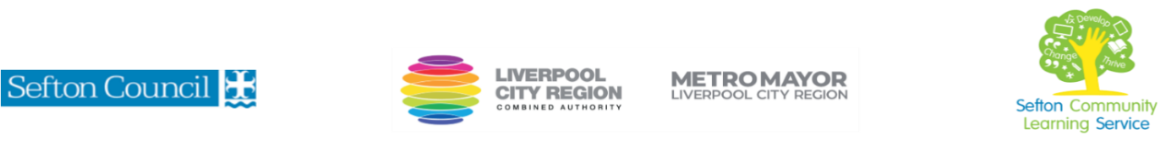

|  |  |
| --- | --- |
| **Introduction to Equality and Diversity**  leading to a **Level 1 Award**  (Courses are offered subject to viable numbers.) | |
| This course is for: | Anyone who is looking for an introduction to the concepts of Equality and Diversity. You will gain theoretical knowledge on equality and diversity and look a case studies relating to these subjects.  **The programme is split into two parts, the first week is an introductory course, that leads to a Level 1 qualification course to extend your skills and knowledge in equality and diversity.** |
| What will I learn: | Course content below is subject to change based on prior knowledge and skills of each cohort.  **Introduction**  You will be introduced to subjects on equality and diversity  What the terms equality and diversity mean  What is diversity?  What is discrimination?  **Qualification**  **What is Equality?**  -Equality  -Diversity  -Fairness  -Identity  -Equality Act 2010  -Discrimination  -Stereotyping  -Protected Characteristics  **What is Diversity?**  -The importance of gender equality  -The UK Think Act Report campaign and its impact on equality at work  -Disability and the Access to Work scheme  -Public bodies and their duties under the Equality Act 2010  -Ways in which people may feel discriminated against because of their race  -Inclusive and anti-racist language  **How the law impacts on equality and diversity**  -The Equality Act 2010 and the way in which this legislation protects people from discrimination  -Different ways in which people can be discriminated against  -Positive action that can be taken by employers to promote opportunities for people who have protected characteristics  -Disability and reasonable adjustments in the workplace  **Best practice within the organisation**  -Using the Golden Rule principle to encourage operating in a fair way and respecting diversity  -The importance of using respectful language  -Useful sources of information about equality and diversity  **Discrimination**  Unfair treatment of groups of people with particular characteristics.  Types of discrimination based on:  Racism, Ageism, Sexism, Homophobia, Transphobia, Discrimination on the grounds of disability, Discrimination on the grounds of religion and belief  and Discrimination on the grounds of pregnancy and maternity |
| Knowledge and skills needed: | You will need some basic computer knowledge - using a keyboard, mouse/touchpad, logging on to a computer and Internet searching.  Level 1 literacy skills needed. On this course you will need to be able to:   * follow verbal and written instructions and work through them at your own pace * listen and join in group discussions * jot down notes to record relevant information * keep your work organised in a file * use a PC/laptop or tablet for research/present your work and to undertake the e-assessment. |
| Materials needed: | At enrolment, you will need your NI number and proof of benefits (if applicable).  Your tutor will provide most of the learning resources, but you will need to come prepared to the lessons with an A4 pad; pen and folder or file to keep your work organised.  It will be an advantage, but not essential, if you have access to the internet at home to extend your learning. |
| How will I learn: | Each session will consist of a dynamic tutor presentation followed by a range of activities including demonstrations, discussion and using computers/iPads.  There will be plenty of revision and practice to build on previous learning. You will receive regular verbal and written feedback from the tutor to help you make good progress and prepare you for the end of course examination.  Your progress will be monitored by informal assessment tasks during the course. In order to gain the qualification awarded by Ascentis, you will need to successfully complete a 40 minute e-assessment consisting of 20 multiple choice questions.  It is expected that you complete some work at home between sessions to consolidate and extend learning. |
| Progression routes: | On completion of this course, SCLS offers you progression to qualifications in Level 1 Award in Awareness of Social Media and Online safety, Employment, Business and Enterprise or Introduction to Customer Service.  Alternatively, you can progress to other non-accredited courses including: employability courses, education and training or ICT.  Ask your tutor for advice and a copy of the progression ladder.  SCLS offers a range of Functional Skills courses from Entry 1 up to Level 2 if you need to brush up your maths and English skills or require a qualification to support you with your career path.  Sefton @ Work will be able to provide independent information, advice and guidance to support you making informed choices for progression into further education, volunteering or employment. |