Sefton’s Climate Change Emergency Implementation Plan
Phase 2 : 2023-2026
Sefton Council are coming to the end of phase 1 delivery (2020 –2023) of the Climate Change Emergency Plan. A huge amount of work has been undertaken during this phase to create the foundations for success in future stages and undertake initial work which has already resulted in significant carbon savings.
As Phase 2 is due to begin, this document highlights the challenges and opportunities associated with the next stage of work to ultimately reach net zero by 2030.
There is increasing commitment through government policy, law and voluntary commitment across the Uk to a net zero carbon target. Sefton Council have an operational target of meeting net zero by 2030. However, as part of the Liverpool City Region, we have a target for the whole borough to be net zero by 2040, ten years ahead of the national target.
The work undertaken by the Council will be aligned to the delivery of the Sefton 2030 Vision and the Council’s Core Purpose with the aim of making Sefton a great place to be.
We will achieve this by following the below principles as set out in our climate strategy:
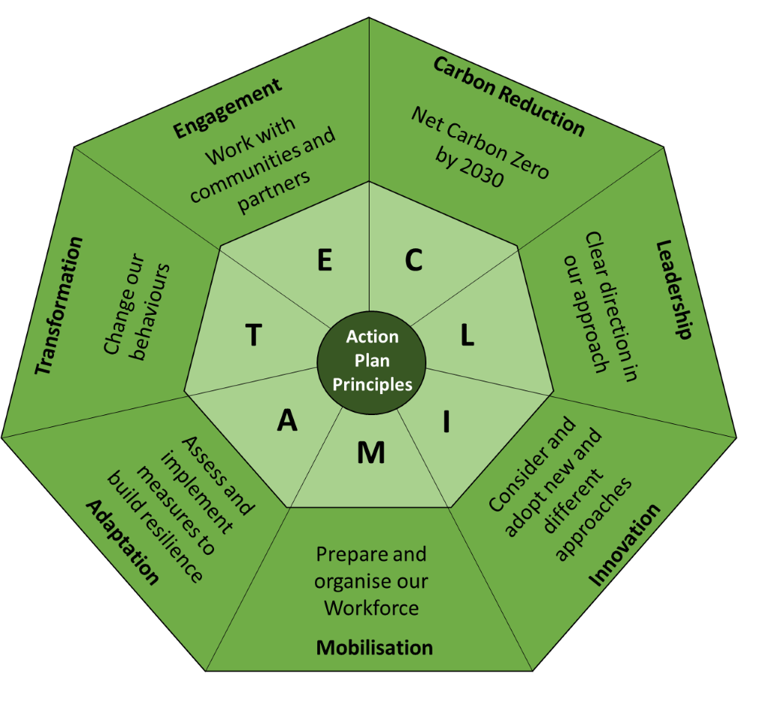

The Council’s action plan includes both mitigation and adaptation measures. This recognises that some impacts of a changing climate cannot be changed in the short/medium term. Some impacts, such as future sea level rises and an increase in summer temperatures will pose risks and opportunities to how we live and work, so we must alter our approach via adaptation measures. Offsetting is included within mitigation and is the practice of increasing carbon capture to compensate for carbon release that cannot be avoided.
We have defined our organisation as, Council depots, leisure centers, libraries, fleet vehicles and office spaces. We have defined our emissions according to the Greenhouse Gas Protocol. This will include the most direct emissions Scope 1 and Scope 2, with some additional emissions captured within Scope 3, namely business travel and commuting.

Phase 1 Summary
Phase 1 work included much of the groundwork for management, governance and monitoring of the Council’s commitment. This included measuring carbon emissions, training staff, introducing climate assessments in decision making, reporting to a cross party elected Member Reference Group and engaging the community.
In this period the Council’s carbon footprint has fallen 13% since 2019/20, based on the last review in 2021/2 with an additional fall expected for 2022/23 which is positive.
The reduction in emissions during this period was driven by
- the Council continuing with an agile working policy
- the continued roll out of energy efficient street lighting across the Borough
- improvements to the national energy mix (greener electricity coming through the grid).
- Upgrade of Bootle and Southport Town Halls (insulation and windows)
There has been significant work assessing and responding to a changing climate including adoption of a Flood Risk Strategy, updated surface water flood model maps and a coastline future prediction report has been produced and the potential impacts assessed.
There have been many significant challenges during this time including the Covid 19 pandemic and the recent extreme energy price rises which has made the need to reduce energy use more urgent but at the same time made funding the interventions more challenging.

Phase 2 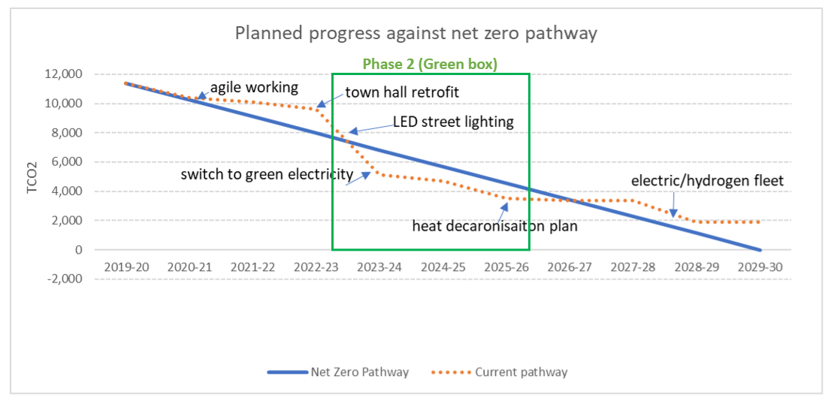

The chart above shows the Council’s planned progress to reach net zero in 2030. Phase 2 is highlighted as a period, by the green box. Sefton Council start this period on track with above 13% reduction expected for 22/23, and an expected reduction in emissions of ~60% by the end of phase 2.
The chart overleaf demonstrates some of the key actions needed over the next three years which include;
- The switch to ‘green’ electricity (100% renewable or zero carbon electricity). Electricity accounts for around a third of the Councils carbon footprint, and so switching to zero carbon electricity will have a significant impact. As you can see from the chart below, the cost of this significant reduction represents value for money.
- The heat decarbonisation of buildings (reducing gas use). Gas usage is the second most significant element of Council emissions. If electricity emissions are removed, then this rises to around 40% of remaining emissions. However, there is no easy low carbon alternative to gas usage and a full change to building fabric and heating system will be required. Hence below the significant cost to reduce gas emissions.
- Ongoing reduction of transport commuting and home working costs. As Scope 3 emissions, the Council has less control of this area, however, travel accounts for around 10% of the carbon footprint.
This phase of activity will require significant investment which is shown in the chart below (using 2022 data).
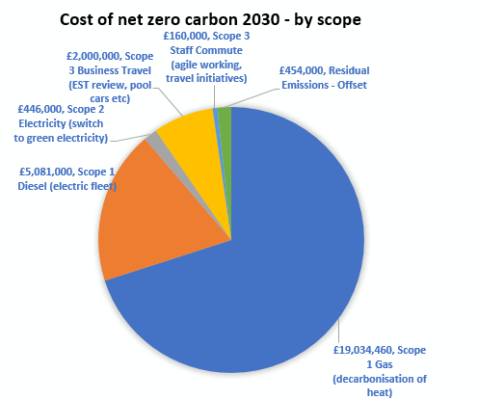

During Phase 2 specifically includes action on
- decarbonisation of heat (through switching away from gas for space and water heating) with an estimated cost of £19M (2022 prices). The cost of this is substantial and an estimate for work to decarbonise heat from 18 buildings is £19M (2022 prices). External funding from sources such as the government “Public Sector Decarbonisation Fund” will be required, which necessitates a match funding contribution. It will also require additional staff to deliver the building retrofit works.
- Switch to green 100% renewable electricity which incurs an annual cost determined at market rates, estimated cost £200K (2022 prices) the cost of which will be met from existing budgets and reviewed annually.
- Action to reduce emissions from business travel / commuting – costs in phase 2 could include investment in electric vehicle charging facilities. Estimated cost £1M (2022 prices). External funding would also be required from sources such as the governments “Workplace Charging Scheme” which provides 75% of the costs.
- Energy efficiency measures – information and behaviour change to encourage a reduction in fuel use. Any reduction will have a positive impact on Council finances and costs can be met from within existing budgets.

Previous work on carbon reduction has focused on energy reduction alone, which has an associated direct financial saving. Whilst this work, to reduce consumption, will continue through communications, reducing carbon emissions to zero will require investment that will not necessarily achieve a financial saving but will save carbon.
Additionally work will continue to engage the public, train staff, assess operational risks and secure external funding. As well as the usual monitoring and reporting.
In order to achieve success during this phase, the Council will require support to be available from external funding sources such as the Public Sector decarbonisation fund and expertise to be made available through programmes such as the NW net Zero hub and LCR collaborative groups. If funding and other support is not available, the risk of not meeting net zero targets increases. Officers will continue to provide information to senior officers and elected members, MPs on opportunities and potential barriers to ensure external organisations such as central government are aware of the importance of this support.

The 2040 Liverpool City Region Target
The Liverpool City Region Strategy ‘Pathway to net zero’ sets out an ambitious plan to reduce carbon emissions across the entire LCR to net zero by 2040. Sefton officers are working with other LCR members to realise these aims.
Actions will be needed across all sectors including business & industry, domestic properties, transport. Some of the key actions include;
- Retrofit of housing stock (domestic emissions account for a third of LCR emissions)
- Delivery of the Mersey tidal electricity generation project
- Delivery of the Hynet hydrogen and carbon capture network
It is estimated that Liverpool City Region needs around £45bn investment over the next 20 years to deliver the carbon reductions needed, which will bring economic benefits (e.g. green jobs).
To reach the net zero carbon 2040 goal, the area needs to halve the amount of energy that is used from any source. All remaining energy will be from, renewable energy sources that don’t produce any carbon emissions at all. This will require considerable early action across all sectors

