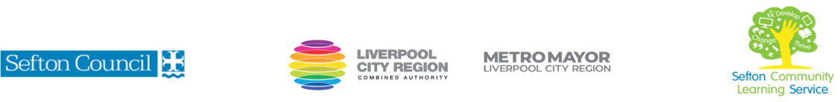

|  |  |
| --- | --- |
| **Family Learning: Recycled Crafts** | |
| This course is for: | Parents/guardians with their children who want to help develop their children’s literacy and numeracy skills through activities and crafts associated with recycling.  Maximum 2 children per adult.Recommended age range 4-11years old |
| What will I learn: | Course content below is subject to change based on prior knowledge and skills of each cohort. Each week will contain activities designed to develop literacy and numeracy skills in children and provide parents with ways in which to help with development of these skills. Crafts activities are subject to change depending on the cohort.  **Week 1**  Intro to recycling, start creating an advent wreath  **Week 2 & 3**  Decorate glass jar/bottle with a chosen theme, continue with advent wreath  **Week 4**  Recycling and nature impacts , create a winter bird feeder  **Week 5**  Research own craft ideas and create a celebration card from recycled cards and craft items . Completion of advent wreath Course evaluation  You will have the opportunity to discuss and set your individual learning targets with your tutor and discuss the support you might need to ensure you have an enjoyable and meaningful learning experience**.** |
| Knowledge and skills needed: | No prior subject knowledge or skills are required.  However, on this course you will need to be able to:   * follow health and safety guidelines. * follow written and verbal instructions. * take part in discussion and keep a record of achievement.   **Note: Parents/guardians must attend with their child. All children must be supervised by their parent/ guardian.** |
| Materials needed: | At enrolment, you will need your NI number and proof of benefits (if applicable).  Your tutor will provide most of the learning resources, but you will need to come prepared to the lessons with an A4 pad; pen and folder or file to keep your work organised. |
| How will I learn: | Each session is set in an informal relaxed and friendly atmosphere.    You will be working together as a family group, working to create a range of craft activities. Your tutor will provide you with support and guidance throughout the session.  Your progress will be monitored by informal assessment tasks and you will receive verbal and written feedback from the tutor to help you make good progress. |
| Progression routes: | On completion of this course, you can progress to a wide range of courses including creative crafts; Intro to Teaching assistant qualification; a course to support your children with literacy and numeracy; Functional Skills English & maths qualifications.  Ask your tutor for advice and a copy of the progression ladder.  SCLS offers a range of Functional Skills courses from Entry 1 up to Level 2 if you need to brush up your maths and English skills or require a qualification to support you with your career path.  Sefton @ Work will be able to provide independent information, advice and guidance to support you making informed choices for progression into further education, volunteering or employment. |