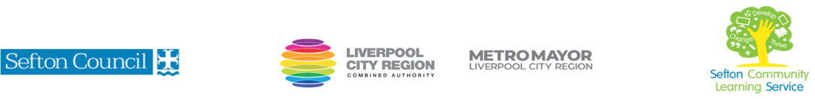

|  |  |
| --- | --- |
| **Everyday Literacy Skills**    (Courses are offered subject to viable numbers.) | |
| This course is for: | Adult learners who need to develop skills to read, write and verbally communicate for everyday life. |
| What will I learn: | Course content below is subject to change based on prior knowledge and skills of each cohort.   * Reading texts * Some common spelling rules and spelling strategies * Punctuation and grammar * Reading and selecting the main points and ideas * Writing for different purposes * Speaking and listening, exploring the importance of communication.   You will have the opportunity to discuss and set your individual learning targets with your tutor and discuss the support you might need to ensure you have an enjoyable and meaningful learning experience |
| Knowledge and skills needed: | This course is for adults who need to develop literacy skills to support independent living and everyday life skills.   * Some basic reading and writing skills are required. * IT skills would be useful but not essential * You need to be able to follow verbal instructions and some basic written instructions |
| Materials needed: | At enrolment, you will need your NI number and proof of benefits (if applicable).  Your tutor will provide many of the learning resources, but you will need to come prepared to the lessons with an A4 pad; pen and folder or file to keep your work organised. |
| How will I learn: | Each session will consist of a dynamic tutor presentation/demonstration followed by a range of interactive activities.  There will be plenty of revision and consolidation and learning will build on previous learning.  Your progress will be monitored by informal assessment tasks, and you will receive verbal and written feedback from the tutor to help you make good progress. |
| Progression routes: | On completion of this course, you can progress to a Functional skills qualification, other community learning courses, a budgeting course or IT courses to become more confident using digital technology for everyday life or employment.  Ask your tutor for advice and a copy of the progression ladder.  SCLS offers a range of Functional Skills courses from Entry 1 up to Level 2 if you need to brush up your maths and English skills or require a qualification to support you with your career path.  Sefton @ Work will be able to provide independent information, advice, and guidance to support you making informed choices for progression into further education, volunteering, or employment. |

V- July 23