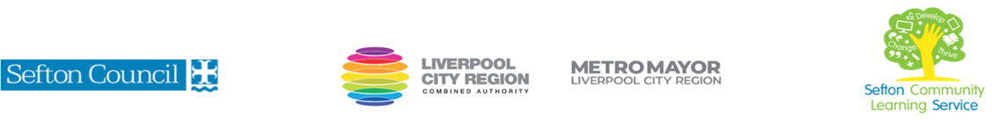

|  |  |
| --- | --- |
| **Create and Use Story Sacks to Support Children’s Literacy**  (Courses are offered subject to viable numbers.) | |
| This course is for: | Adult learners who want to develop their child’s reading skills by creating and using story sacks to explore well known children’s books. |
| What will I learn: | Course content below is subject to change based on prior knowledge and skills of each cohort.   * Induction * Initial and diagnostic assessment and setting of personal targets * Exploring the content and purpose of story sacks * Introduction to literacy skills. * Plan for creation of a story sack * Discussion of relevant literacy skills that can be developed with story sacks. * Exploration of fiction/non-fiction stories that can be used. * Creating Story Sacks * Quiz regarding prior knowledge * Justification for components of story sacks * Skills Showcase * End of course quiz * Review of course   You will have the opportunity to discuss and set your individual learning targets with your tutor and discuss the support you might need to ensure you have an enjoyable and meaningful learning experience**.** |
| Knowledge and skills needed: | **This is a course for complete beginners and no prior subject knowledge or skills are required.**  **A basic level of literacy needed (L1)**  On this course you will need to:   * follow verbal and written instructions and work through them at your own pace * listen and join in group discussions * jot down notes to record relevant information * keep your work organised in a file * use a PC/laptop or tablet for research or to present your work and to access our learning platform * have some dexterity using your hands |
| Materials needed: | At enrolment, you will need your NI number and proof of benefits (if applicable).  Your tutor will provide most of the learning resources, but you will need to come prepared to the lessons with an A4 pad; pen and folder or file to keep your work organised.  It will be an advantage, but not essential, if you have access to the internet at home to extend your learning. |
| How will I learn: | Each session will consist of a dynamic tutor presentation followed by a range of interactive activities.  There will be plenty of revision and consolidation and learning will build on previous learning.  Your progress will be monitored by informal assessment tasks and you will receive verbal and written feedback from the tutor to help you make good progress. |
| Progression routes: | On completion of this course, you can progress to:   * Family Learning craft courses (delivered by SCLS) * Craft courses for adults (a wide range of courses are delivered by SCLS) * Additional Literacy and Numeracy development courses (delivered by SCLS) * Level 1 in Supporting a Child’s Learning and Development   Ask your tutor for advice and a copy of the progression ladder.  SCLS offers a range of Functional Skills courses from Entry 1 up to Level 2 if you need to brush up your maths and English skills or require a qualification to support you with your career path.  Sefton @ Work will be able to provide independent information, advice and guidance to support you making informed choices for progression into further education, volunteering or employment. |