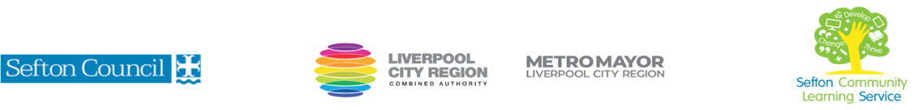

|  |  |
| --- | --- |
| **Family Learning Cooking on a Budget**    (Courses are offered subject to viable numbers.) | |
| This course is for: | Parents/guardians with their children who want to help develop their children’s literacy and numeracy skills through cooking skills.  Maximum 2 children per adult. Recommended age range 6-13 years old |
| hat will I learn: | Course content below is subject to change based on prior knowledge and skills of each cohort.  Parents/guardians work with their child/children to   * plan and cook meals on a budget. * understand budgeting when shopping for food and best places to shop. * understand how sustainability can be incorporated to cooking.   You will have the opportunity to discuss and set your individual learning targets with your tutor and discuss the support you might need to ensure you have an enjoyable and meaningful learning experience |
| Knowledge and skills needed: | No prior subject knowledge or skills are required.  However, on this course you will need to be able to:  • follow health and safety guidelines.  • follow written and verbal instructions.  • take part in discussion and keep a record of achievement.  **Note: Parents/guardians must attend with their child. All children must be supervised by their parent/ guardian.** |
| Materials needed: | At enrolment, you will need your NI number and proof of benefits (if applicable).  Your tutor will provide many of the learning resources, but you will need to come prepared to the lessons with an A4 pad; pen and folder or file to keep your work organised. |
| How will I learn: | Each session will consist of a dynamic tutor presentation/demonstration followed by a range of interactive activities.  There will be plenty of revision and consolidation and learning will build on previous learning.  Your progress will be monitored by informal assessment tasks, and you will receive verbal and written feedback from the tutor to help you make good progress. |
| Progression routes: | On completion of this course, you could progress to a variety of courses delivered by Sefton Community Learning Service, including: creative crafts; a course to support your children with literacy and numeracy; Functional Skills English & maths qualifications; L1 Food Safety & Hygiene qualification; Supporting Teaching & Learning qualification at Level 2 or Preparing to Work in Schools at Level 1.  Ask your tutor for advice and a copy of the progression ladder.  SCLS offers a range of Functional Skills courses from Entry 1 up to Level 2 if you need to brush up your maths and English skills or require a qualification to support you with your career path.  Sefton @ Work will be able to provide independent information, advice, and guidance to support you making informed choices for progression into further education, volunteering, or employment. |

V- July 23