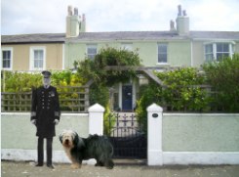
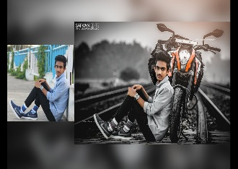
Photo Editing for Beginners

(Courses are offered subject to viable numbers.)
This course is for: | Adult learners who would like to gain some basic skills to edit their own photos
What will I learn: | Course content below is subject to change based on prior knowledge and skills of each cohort.  Week 1  - Induction, course information  - Initial and diagnostic assessment and setting your personal targets  - Accessing the photo editing software to be used during the course, Pixlr  - Identifying some of the different icons, palettes and menus.  Adding text – changing font styles, size and colour.  Week 2  - Cropping images – discussing the reasons for cropping an image.  - Saving images - using file names and file types.  Preparing images for printing.  Week 3  - Utilising the clone tool – to remove unwanted parts of images  - Using copy and paste to add people or things to images.  Applying image effects  Week 4  - Applying a colour tint to a monochrome image  - Using layers effectively – with blending techniques  Utilising the paint tool – adjusting brush sizes  Week 5  - Creating a combined image using a variety of different images.  - Developing skills learnt in previous weeks.  Course evaluation and discussion of your next steps  You will have the opportunity to discuss and set your own learning targets with your tutor and discuss the support you might need to ensure you have an enjoyable and meaningful learning experience
Knowledge and skills needed: | This is a course for complete beginners and no prior subject knowledge or skills are required. You need to be able to:  - follow verbal and written instructions and work through them at your own pace  - listen and join in group activities  - keep your work organised in a file  - have basic IT skills. eg: Log on and off, use a mouse and keyboard independently  - jot down notes to record relevant information
Materials needed: | At enrolment, you will need your NI number and proof of benefits (if applicable). Your tutor will provide most of the learning resources, but you will need to come prepared to the lessons with an A4 pad; pen and folder or file to keep your work organised.  We suggest you bring your own camera, if you have one, but if you don’t, the tutor will provide you one for the lesson (please note, you cannot take this home).  It will be an advantage, but not essential, if you have access to the internet at home to extend your learning.
How will I learn: | Each session will consist of a dynamic tutor presentation followed by a range of interactive activities. There will be plenty of revision and consolidation and learning will build on previous learning.  Your progress will be monitored by informal assessment tasks and you will receive verbal and written feedback from the tutor to help you make good progress.
Progression routes: | On completion of this course, you can progress onto an accredited photo editing course (at the City of Liverpool College / Hugh Baird), or you might want to try a non-accredited Digital Photography course with us.  We have a range of media and digital skills courses available at SCLS. Ask your tutor for advice and a copy of the progression ladder.  SCLS offers a range of Functional Skills courses from Entry 1 up to Level 2 if you need to brush up your maths and English skills or require a qualification to support you with your career path.  Sefton @ Work will be able to provide independent information, advice and guidance to support you making informed choices for progression into further education, volunteering or employment.

