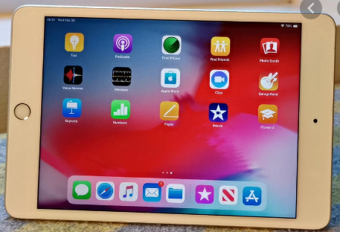

iPad's Next Steps
(Courses are offered subject to viable numbers.)
This course is for: | If you already know the basics of using an iPad and want to take this to the next level by learning how to use additional features, this is a suitable course for you.
What will I learn: | Course content below is subject to change based on prior knowledge and skills of each cohort.  Week 1  - Induction, course information and discussion of your personal goals following Initial assessment.  - Brief recap of previous course (the basics)  - Adding to the Contacts App  Week 2  - Using the ipad camera  - Adjusting the point of focus  - Organising your photos into folders  Week 3  - Installing Apps  - Organising Apps into folders  - Moving Apps and deleting  Week 4  - Sending and replying to e-mails  - Attaching images/photos  - Organising your messages  Week 5  - Searching websites for information  - Printing from websites  - Course evaluation  You will have the opportunity to discuss and set your own learning targets with your tutor and discuss the support you might need to ensure you have an enjoyable and meaningful learning experience
Knowledge and skills needed: | To join this course you will need to have some basic knowledge of using an IPad including, i.e.: Using the touchscreen keyboard; connecting to the Wi-Fi; taking a screenshot; downloading apps and eBooks; how to share information and photos.  On this course you will need to:  - follow verbal and written instructions and work through them at your own pace  - listen and join in group activities  - jot down notes to record relevant information and keep your work organised  - have some dexterity with your hands
Materials needed: | At enrolment, you will need your NI number and proof of benefits (if applicable).  Your tutor will provide most of the learning resources, but you will need to come prepared with an A4 pad; pen and folder or file to keep your work organised. The iPads will be provided to use during the lesson only and will be wiped-down before and after every session.  It will be an advantage, but not essential, if you have access to the internet at home to extend your learning.
How will I learn: | Each session will consist of a dynamic tutor presentation followed by a range of interactive activities to practise.  There will be plenty of revision and consolidation and learning will build on previous learning.  Your progress will be monitored by informal assessment tasks and you will receive verbal and written feedback from the tutor to help you make good progress.
Progression routes: | On completion, you can progress onto another I.T course, provided by SCLS, ie: Photo Editing, Internet and email for beginners, Microsoft Word, etc…  At SCLS we also offer Digital Skills qualifications at Entry level 3  Hugh Baird and Southport college offer a number of Digital Skills qualifications  Ask your tutor for advice and a copy of the Digital Skills progression ladder.  SCLS offers a range of Functional Skills courses from Entry 1 up to Level 2 if you need to brush up your maths / English skills or require a qualification to support you with your career path.  Sefton @ Work will be able to provide independent information, advice and guidance to support you making informed choices for progression into further education, volunteering or employment.

