
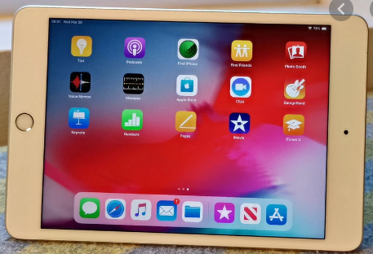
iPads for Beginners

(Courses are offered subject to viable numbers.)
This course is for: | Adult learners who would like to learn to use the basic functions of using an iPad.
What will I learn: | Course content below is subject to change based on prior knowledge and skills.  Week 1  Initial assessment, induction and setting of personal targets for what you need to learn.  Identifying the different parts of the iPad  Turning on/off  Introduction and familiarisation with iPad functions  Week 2  Using the touchscreen keyboard  Familiarity with keyboard functions  Swipe and navigate  Type a note  Accessing Wi-Fi  Week 3  Drawing and using camera  Sharing (text & images) via email  Using the camera to take a picture  Week 4  Downloading an e-book from Apple store  Taking a screenshot photo  Sharing screenshot/photo via email  Week 5  Downloading an application (App) from Apple Store  Taking a screenshot photo  Sharing screenshot/photo via email  Recap course  Course evaluation and discussion of your next steps  You will have the opportunity to discuss and set your own learning targets with your tutor and discuss the support you might need to ensure you have an enjoyable and meaningful learning experience.
Knowledge and skills needed: | This is a course for complete beginners and no prior subject knowledge or skills are required. You will need good English literacy skills to be able to:  - follow verbal and written instructions and work through them at your own pace  - listen and join in group activities  - keep your work organised in a file  - jot down notes to record relevant information
Materials needed: | The iPad will be provided but cannot be taken home.  At enrolment, you will need your NI number and proof of benefits (if applicable). Your tutor will provide most of the learning resources, but you will need to come prepared to the lessons with an A4 pad; pen and folder or file to keep your work organised.  It will be an advantage, but not essential, if you have access to an iPad and the internet at home to extend your learning.
How will I learn: | Each session will consist of a dynamic tutor presentation followed by a range of interactive activities to practise what you have learnt. There will be plenty of revision and consolidation and learning will build on previous learning.  Your progress will be monitored by informal assessment tasks and you will receive verbal and written feedback from the tutor to help you make good progress.
Progression routes: | On completion of this course, you can progress onto the Next Steps iPad course or to another course to further develop your Digital Skills. We offer a wide range of non-accredited courses such as Internet & Email, Shopping Online, Staying Safe Online or Microsoft Office or Windows 10.  We also offer Digital Skills qualifications at E3 or L1. Ask your tutor for advice and a copy of the progression ladder.  SCLS offers a range of Functional Skills courses from Entry 1 up to Level 2 if you need to brush up your maths and English skills or require a qualification to support you with your career path.  Sefton @ Work will be able to provide independent information, advice and guidance to support you making informed choices for progression into further education, volunteering or employment.

