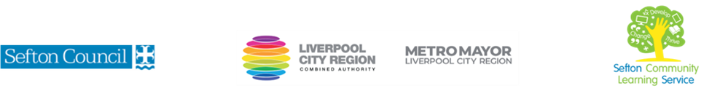

Brush Lettering Calligraphy
(Courses are offered subject to viable numbers.)
This course is for: | Anyone who has an interest in lettering and is open to exploring the creative possibilities of the various forms and techniques of calligraphy
What will I learn: | Course content below is subject to change based on prior knowledge and skills of each cohort.  Week 1  - Induction, course information, ILP’s, etc. (1hr approx.)  - Discussion of materials used during the course  - Introduction to using the Whimsical Print font  Week 2  - Further font styles  - Creating a poster or motivational slogan  Week 3  - A look at traditional calligraphy techniques  - How to re-create the Roman font  Week 4  - Introduction to the brush lettering font  - Using brush pens to create thick and thin lines  Week 5  - Drawing embellishments: vines, flowers, banners, scrolls, etc  - Incorporating them with brush lettering  Week 6  - Creating coasters, a bookmark or a front cover page.  - Or creating your own slogan/design using skills learnt during the previous weeks  - Course evaluation  You will have the opportunity to discuss and set your own learning goals with your tutor and discuss any support you might need to ensure you have an enjoyable and meaningful learning experience
Knowledge and skills needed: | It would be beneficial to have an existing interest in art or craft.  On this course you will need to:  - follow verbal and written instructions and work through them at your own pace  - listen and join in group activities  - use a PC/laptop or tablet for research  - jot down notes to record relevant information and keep your work organised  - Have some dexterity with your hands
Materials needed: | Depending on numbers and availability, all calligraphy materials needed for the course will be supplied each week by the tutor, but must be returned at the end of each session.  In order to practice at home, you may want to purchase your own – the tutor will discuss what materials are required on the first week.  You will also need to come prepared with a file to keep your work organised.  It will be an advantage, but not essential, if you have access to the internet at home to extend your learning* (see below)
How will I learn: | Each session will consist of a dynamic tutor presentation followed by a range of interactive activities to practise.  There will be plenty of revision and consolidation and learning will build on previous learning.  Your progress will be monitored by informal assessment tasks and you will receive verbal and written feedback from the tutor to help you make good progress.
Progression routes: | On completion, you could progress onto a one-day workshop or an art and craft course or, such as Traditional Festive Origami Cards for Beginners.  Join a Calligraphy workshop (St Johns Road)  *If you would like to further your I.T. skills, you might be interested in some of the computer courses that we offer.  SCLS offers a range of Functional Skills courses from Entry 1 up to Level 2 if you need to brush up your maths / English skills or require a qualification to support you with your career path.  Sefton @ Work will be able to provide independent information, advice and guidance to support you making informed choices for progression into further education, volunteering or employment.

