Education and Supporting Resources for Direct Payments Recipients and their Personal Assistants

Introduction

Hello
We want to support you in whatever way we can during this COVID-19 period and one of the ways was to develop this document to highlight key areas where there are free education and supporting resources available for you and your personal assistants not only on a national level but what’s available locally here in Sefton.
This document and the electronic version will be regularly reviewed to include updates as we receive them however if you have any suggestions as to what else needs to be included please let us know by emailing Louise Kearney, Learning and Development Officer at louise.kearney@sefton.gov.uk

Deborah Butcher
Executive Director of Adult Social Care
Sefton Council

Latest updates
Skills for Care https://www.skillsforcare.org.uk and Social Care Institute for Excellence https://www.scie.org.uk have a wealth of resources, webinars and links to the latest government guidance on their websites.

Infection Prevention and Control

Putting on and taking off Personal Protective Equipment, although the video focusses on care homes the information is still applicable to all settings. https://www.youtube.com/watch?v=ozY50PPmsvE&feature=youtu.be

Skills for Health free Coronavirus (COVID-19) Awareness Course, 2 hours, covering infection prevention, PPE, sampling and testing.
https://www.skillsforhealth.org.uk/covid-19-course

COVID-19: personal protective equipment use for non-aerosol generating procedures. Guidance on the use of personal protective equipment (PPE) for non-aerosol generating procedures (APGs).
https://www.gov.uk/government/publications/covid-19-personal-protective-equipment-use-for-non-aerosol-generating-procedures

Hand washing video and resources
https://www.nhs.uk/video/pages/how-to-wash-hands.aspx

Moving and Handling

If you would like training in Proportionate Care (Single Handed Care) then please contact Anthony McDonald, Occupational Therapist, Anthony.mcdonald@sefton.gov.uk

Look After You and Your Personal Assistants

The Cheshire & Merseyside Resilience Hub is an NHS funded project to help support staff members in the NHS, Social Care (local authority or CCG funded) and the Emergency Services through the pandemic and beyond. We are a 9am-5pm service and offer a range of psychological interventions and therapeutic access for staff members needing some extra help and support through covid and beyond. Most of our service is offered in house – however, if we can’t offer in an house service we will refer you on to one of our partners. The services offered are 100% free and confidential.
Outreach – Our Assistant Psychologists (APs) can attend your workplace signpost staff members to our service. We can also run a ‘basic listening’ service to understand staff needs. When visiting, we can also provide your workplace with a range of wellbeing goodies (pens, tote bags, lip balls, stress balls etc) This can be booked via our website on the contact us lozenge (green tab)
Self-Referral – Staff members can self-refer into our service to seek 1-2-1 support and intervention. A clinician will contact them at a time that suits them and look at the issues at hand to determine what intervention route is best. Staff members can refer via our website (pink tab)
Team Systemic intervention – If organisations are experiencing team issues, a manager and leader can request an intervention from a clinician for the whole team, this can be a ‘one off’ or a package. More information is available in the systemic attachment. Managers and leaders can book this via our website (blue tab)
Workshops – CMRH run a range of monthly workshops based around psychoeducational rather than therapeutic. These are free to attend and are run via zoom. The current workshops we offer are: Covid19 & Burnout – the Perfect Storm. Team Self Care & Psychological self-care for staff. You can book onto these via our website – light green tab.

Psychological Self-care for teams – 27th April 2022 – 12.30pm-1.30pm https://www.eventbrite.com/e/272006949107

Pastoral Support – As well as psychological interventions, the hub also has a pathways advisor who can help with a range of issues surrounding finance, housing, debt, social engagement etc. This is a dedicated service and we will provide help and support via our third sector partners. Staff members can request this on our website (lime green tab) As well as the pastoral offer, we also offer a range of wellbeing events too – from martial arts to samba drumming & Yoga. These are free to attend (at the moment we’re currently setting these back up as we was recently in business continuity due to omicron) More information will be sent via our mailing list & twitter.

Relationship Support – For a limited time, we have partnered with Relate – the relationships people, to offer 1-2-1 support and therapy for staff members going through a tough time in their relationship. Staff members will receive 1x 30 min introductory phone call and 6 x counselling sessions. We have a dedicated landing page and phone number should staff members want to self-refer. NHS Live Chat | Relate or they can call 0300 303 4477

We are on Twitter also and have a monthly newsletter that can be shared around.

Coronavirus (COVID-19): health and wellbeing of the adult social care workforce
https://www.gov.uk/government/publications/coronavirus-covid-19-health-and-wellbeing-of-the-adult-social-care-workforce?utm_medium=email&utm_campaign=govuk-notifications&utm_source=83369eba-1acc-44ce-8cc5-6adeb6c325d0&utm_content=daily

QWELL – Online Counselling and Well-being for Adults.
The QWELL online platform provides free access to counsellors, forums and articles to help people with their recovery. There is a link below to a video explaining the service and how to access it. It shows the sign-up screen which is where your staff can choose their profession and set up their username. The video then walks staff through the different areas of the site: https://vimeo.com/394910786/e6b8684fd2
To access QWELL, please visit www.qwell.io

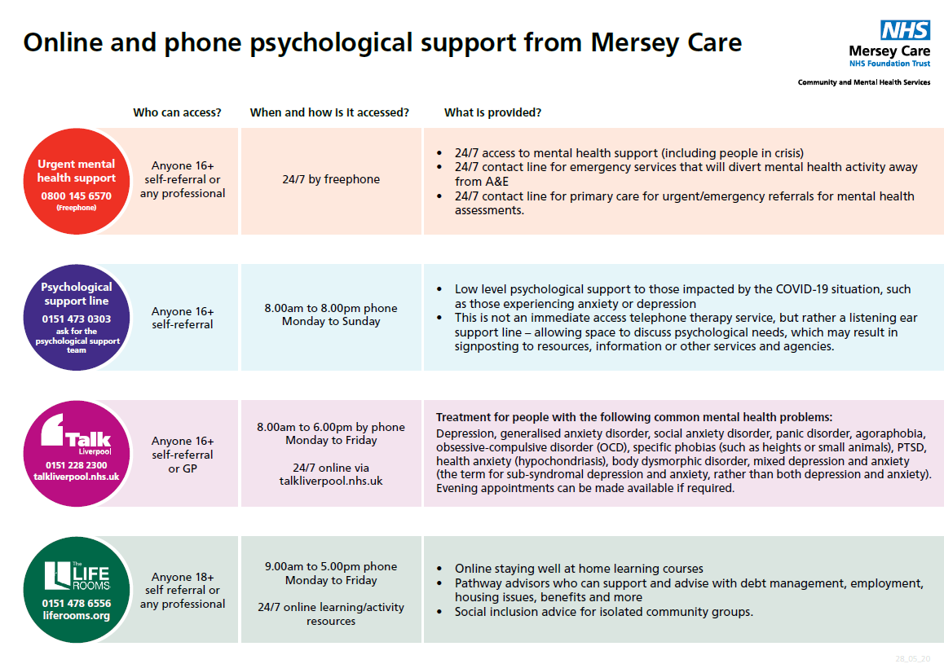

Access Sefton is a free, confidential service, commissioned by the NHS. The service is available to anyone aged 16+ and registered with a Sefton* GP.

To self-refer to Access Sefton phone 0300 303 2708
​

There is also a 24/7 support phoneline to support anyone who needs help https://kindtoyourmind.org/support-near-me/
The helpline for Sefton Adults is: 0151 330 7332

Frontline19 is a UK nationwide service delivering supervision, debriefing and emotional support to frontline workers during times of crisis. It is free and confidential.
https://www.frontline19.com/

Further Sources of Support

Easy read – Employing personal assistants toolkit booklets
The ‘Employing personal assistants toolkit' which provides guidance, templates and resources about recruiting, training and managing personal assistants is now available in easy read.
https://www.skillsforcare.org.uk/Employing-your-own-care-and-support/Information-for-individual-employers/Information-for-individual-employers.aspx?_cldee=bG91aXNlLmtlYXJuZXlAc2VmdG9uLmdvdi51aw%3d%3d&recipientid=contact-c4d60b7a3eaee61194120050568779ad-3e808286a80642f08598feeed6effb09&esid=69e05f8e-bded-ea11-80e3-005056877cb9

Think Local Act Personal
https://www.thinklocalactpersonal.org.uk/covid-19/

Disability News Service

https://www.disabilitynewsservice.com/

How to do a COVID-19 Self Test (rapid antigen test)
https://www.youtube.com/watch?v=S9XR8RZxKNo&list=PLvaBZskxS7tzQYlVg7lwH5uxAD9UrSzGJ

Frailty e-learning programme launched
A new e-learning programme about frailty is available through Health Education England’s (HEE) e-Learning for Healthcare, and aligns with the national and regional Ageing Well strategies for improvement.

Vaccine Fact Cards

COVID-19 and Dual Sensory Impairment (DSI)
Please read and share the free resources about COVID-19 and people with DSI: http://hi-vis.org/covid-19/

Social Care Institute for Excellence
Access to free recorded webinars on Safeguarding Adults and the Mental Capacity Act.
https://www.scie.org.uk/care-providers/coronavirus-covid-19/virtual-courses?utm_campaign=11734349_SCIELine%2011%20August&utm_medium=email&utm_source=SOCIAL%20CARE%20INSTITUTE%20FOR%20EXCELLENCE%20&utm_sfid=003G000002FsdtMIAR&utm_role=Educator%2F%20Trainer&dm_i=4O5,6ZIA5,JRX35H,S4Y56,1

Books Beyond Words
Coping with Coronavirus, free picture stories and illustrated guides to support people with learning disabilities and autism through the coronavirus pandemic.

https://booksbeyondwords.co.uk/coping-with-coronavirus

Skills for Care
https://www.skillsforcare.org.uk/Home.aspx
Priority training identified by Skills for Care to ensure a skilled and competent workforce during the Covid-19 crisis.

https://www.skillsforcare.org.uk/About/News/COVID-19-Essential-training.aspx

Social Care Institute for Excellence
https://www.scie.org.uk/care-providers/coronavirus-covid-19

Health Education England
The e-learning for healthcare website is freely accessible and has a multitude of COVID-19 related training resources readily available for staff to access, this is the link;
https://www.e-lfh.org.uk/

