Deborah Butcher
Executive Director for Adult Social Care and Health

Magdalen House
Trinity Road
Bootle
L20 3NJ

0151 934 3105
www.sefton.gov.uk

commissioningandcontracts@sefton.gov.uk

Date: 1st April 2022

Dear Care Home Provider
RE: Sefton Council Annual Consultation on Care Home Fees
I am writing in order to remind you that the consultation period runs until Midnight on Sunday 10th April 2022, so please ensure that all responses are returned by this time in order for them to be taken account of in our decision-making process.

Please return your responses by e-mail to commissioningandcontracts@sefton.gov.uk

In addition, as part of the ongoing consultation exercise we have arranged an additional Microsoft Teams event with Care Home Providers on Wednesday 6th April 2022 – 10am to 11am. The link to this meeting is;

Click here to join the meeting

Once again, I would like to take the opportunity to thank you for taking the time to consider this matter and to respond to this consultation.
Yours Faithfully
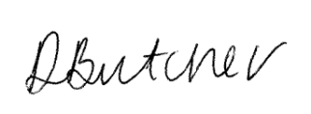
Deborah Butcher
Executive Director of Adult Social Care and Health

