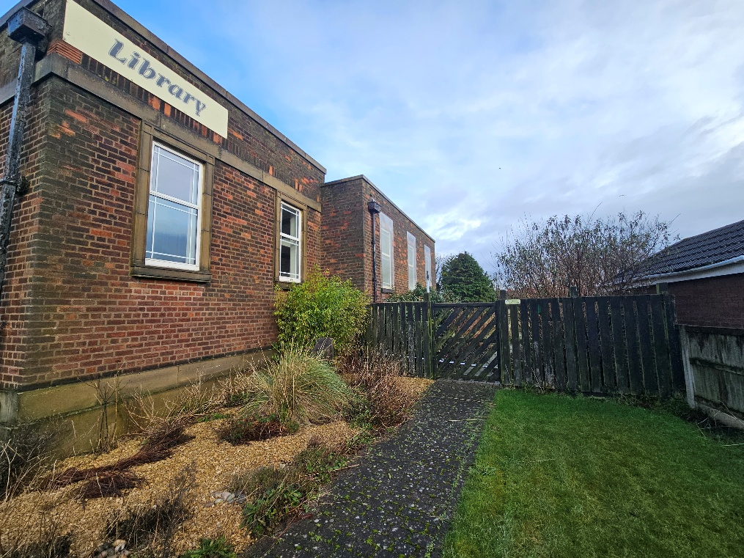
Ainsdale Library, Ainsdale – Information Pack

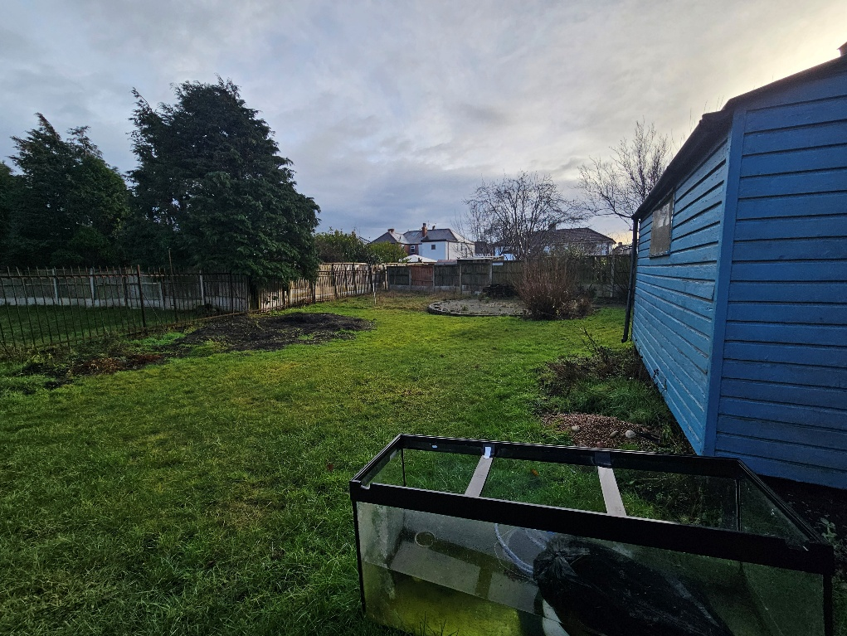
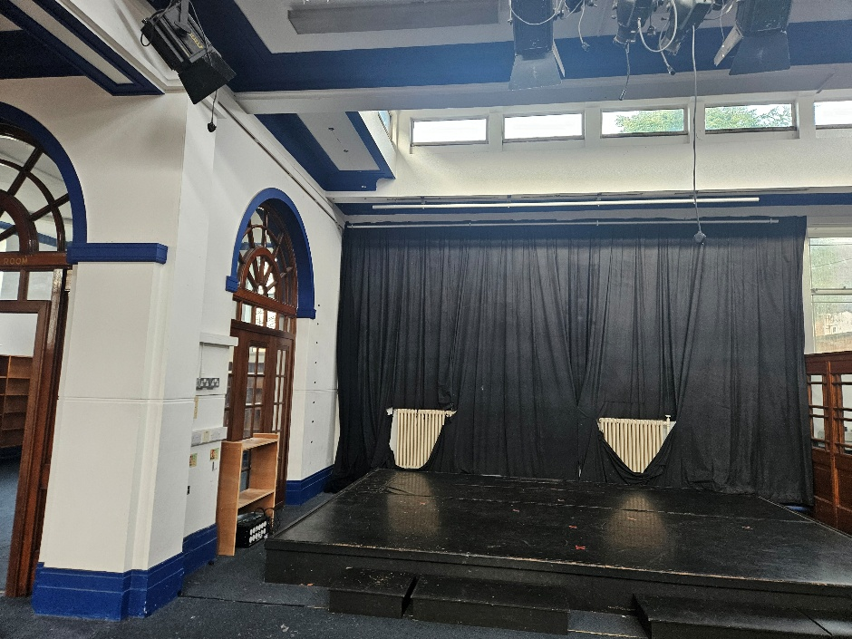

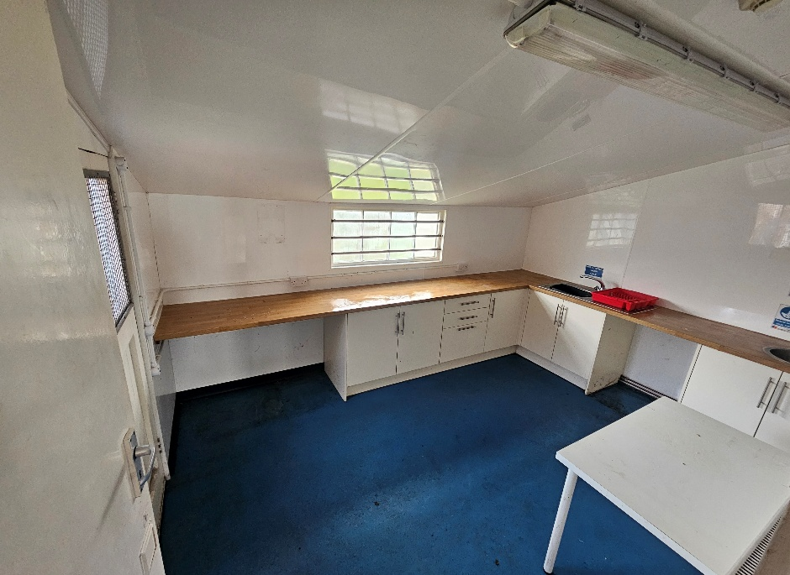

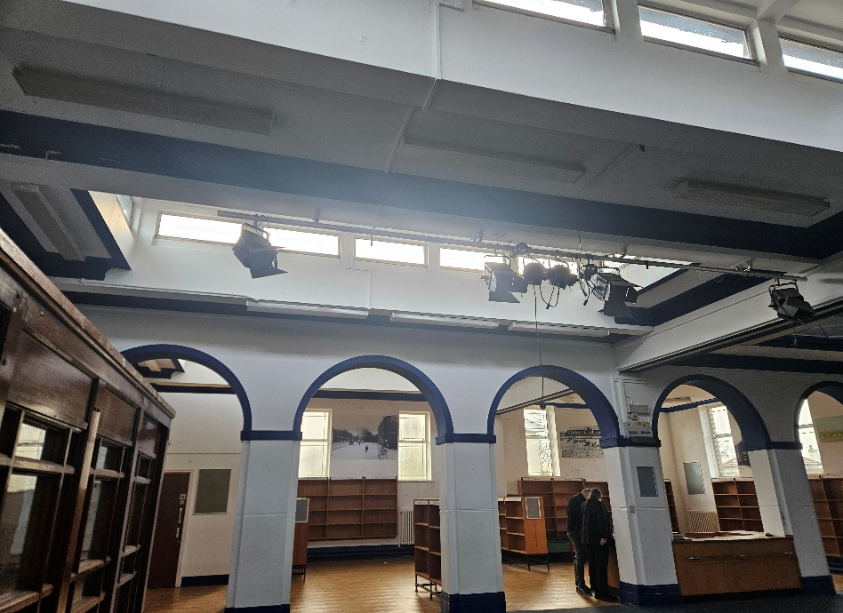

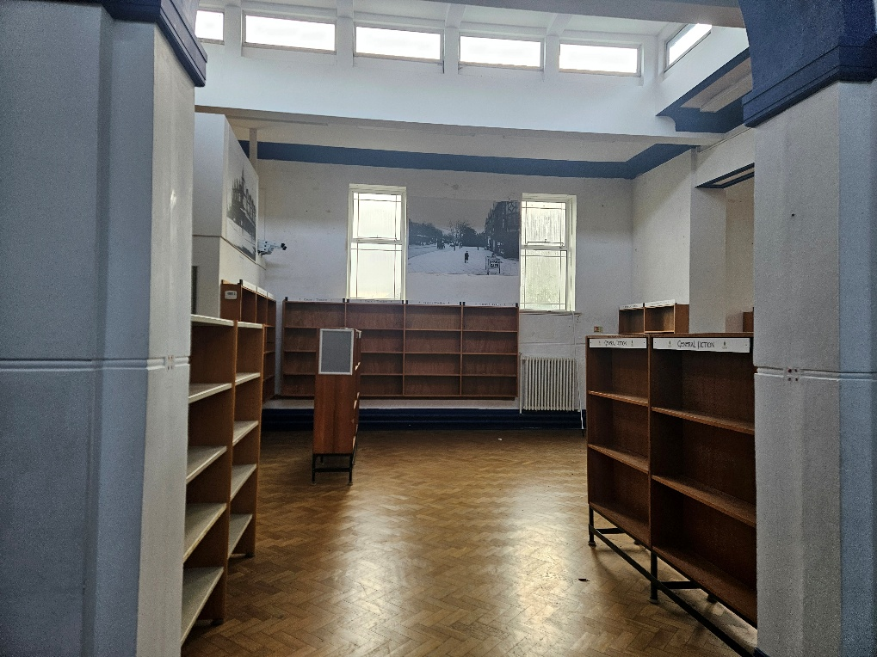

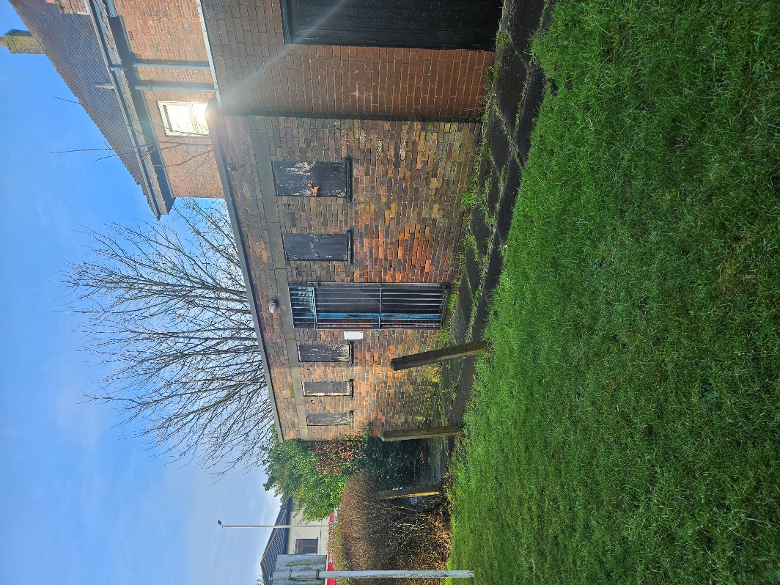

Summary:
Located within Ainsdale, fronting Liverpool Road, this opportunity comprises a library and community space (outlined in red on the site plan below).

The building is of traditional brick construction with stone relief, Constructed c. 1929. Internally, it retains many of the original features. The property closed as a library in 2013 but has more recently been run as a community centre. The building extends to approximately 2,766 sq.ft gross internal area (GIA).

The site benefits from good accessibility, closely situated to Ainsdale railway station, providing access to Southport and Liverpool. The Council is seeking a sustainable community organisation proposal that maximises the potential of this prominent asset, delivering enhanced community services and activities, while creating lasting social, economic and wellbeing benefits for local residents.

Site Visits:
Site visits have been scheduled for interested parties to attend the property. Relevant members and colleagues will be present to answer your questions and queries regarding the property and the Community Asset Process.

- Date: 5th November 2026, 2:00pm-4:00pm
- Date: 9th November 2026, 2:00pm-4:00pm

Any enquiries please contact: Community.assets@sefton.gov.uk

