Education and Supporting Resources for Community Support Provision (Including Domiciliary Care and Day Care)

Version | Version Date | Revised By
18 | 6th November 2020 | Louise Kearney
19 | 4th December 2020 | Louise Kearney
20 | 8th January 2021 | Louise Kearney
21 | 5th February 2021 | Louise Kearney
22 | 5th March 2021 | Louise Kearney
23 | 9th April 2021 | Louise Kearney
24 | 24th May 2021 | Louise Kearney
25 | 18th June 2021 | Louise Kearney
26 | 16th July 2021 | Louise Kearney

Introduction

Dear Community Support Partners

We want to support you in whatever way we can during this COVID-19 period and one of the ways was to develop this document to highlight key areas where there are free education and supporting resources available for you and your staff not only on a national level but what’s available locally here in Sefton.
The resources contained within this document are also available online and can be accessed via Sefton Council’s Learner Management System. Further information explaining how to access the online version can be found on page 15 of this document.
This document and the electronic version will be regularly reviewed to include updates as we receive them however if you have any suggestions as to what else needs to be included please let us know by emailing Louise Kearney, Learning and Development Officer at louise.kearney@sefton.gov.uk

Deborah Butcher
Executive Director of Adult Social Care
Sefton Council

Latest updates
NHS England – upcoming online events
https://www.england.nhs.uk/events/

COVID-19: Support and guidance for the adult social care sector
https://www.skillsforcare.org.uk/Home.aspx

COVID 19 Vaccinations

Every Vaccination Gives us HOPE
https://prod.cms.coronavirusresources.phe.gov.uk/covid-19-vaccine/resources/hope-pr-film/

How to do a COVID-19 Self Test (rapid antigen test)
https://www.youtube.com/watch?v=S9XR8RZxKNo&list=PLvaBZskxS7tzQYlVg7lwH5uxAD9UrSzGJ

On 18 December 2020 the Autonomy Project and the National Mental Capacity Forum held a webinar to discuss Capacity, Consent and Covid Vaccinations and this link will take you to a recording of the webinar
http://autonomy.essex.ac.uk/covid-19/

The attached document is an Essex Autonomy Project document only and it does not represent the views of the National Mental Capacity Forum, the Department of Health and Social Care, or the Ministry of Justice.

Vaccine Fact Cards

Infection Prevention and Control
Skills for Care - new infection prevention and control resources
The Department of Health and Social Care (DHSC) has adapted the 'Every Action Counts' suite of resources to support adult social care providers achieve excellence in infection prevention and control. The resources include posters, digital key cards and hints and tips, supporting compliance and awareness, leadership, morale and wellbeing, training and operational interventions.
⇨ Download the resources.

Top tips getting a COVID swab from a person living with dementia.

Guidance COVID-19: how to work safely in domiciliary care in England.

https://www.gov.uk/government/publications/covid-19-how-to-work-safely-in-domiciliary-care?_cldee=bG91aXNlLmtlYXJuZXlAc2VmdG9uLmdvdi51aw%3d%3d&recipientid=contact-c4d60b7a3eaee61194120050568779ad-09ae69d94fcf4ebcb9d5d639303625cc&esid=0c4c5603-41b1-ea11-80e0-005056877cb9

Guidance Coronavirus (COVID-19): provision of home care.
https://www.gov.uk/government/publications/coronavirus-covid-19-providing-home-care/coronavirus-covid-19-provision-of-home-care

PPE guide for community health and social care settings
Public Health England has produced an illustrative PPE guide for community health and social care settings.
https://assets.publishing.service.gov.uk/government/uploads/system/uploads/attachment_data/file/911188/PHE_PPE_guide_for_community_and_social_care_settings_AUG_2020.pdf

Putting on and taking off Personal Protective Equipment, although the video focusses on care homes the information is still applicable to all settings. https://www.youtube.com/watch?v=ozY50PPmsvE&feature=youtu.be

Skills for Health free Coronavirus (COVID-19) Awareness Course, 2 hours, covering infection prevention, PPE, sampling and testing.
https://www.skillsforhealth.org.uk/covid-19-course
Videos:
Hand washing video and resources.
https://www.nhs.uk/video/pages/how-to-wash-hands.aspx

End of Life Care

One Step free programme – online, self-led training on End of Life Care
This programme is aimed at care homes and domiciliary care organisations and their staff. Individuals can complete at their own pace and all resources are fully accessible without any cost. The programme comprises of four units: Identification, Assessment, Discussion and Engagement. For further information about the programme, please email lynne.partington@eolp.org.uk or visit the Six Steps website.

Palliative Care Institute Liverpool have training available on Advanced Communication Skills. There is possibly a cost involved but for all enquiries please contact Karen Ross, Learning and Teaching Administrator and her contact details are on within the attached flyers.

End of Life Care Partnership, Advance Care Planning Resources.

http://www.cheshire-epaige.nhs.uk/document-library/?top-category=advance-care-planning-dnacpr
http://www.cheshire-epaige.nhs.uk/wp-content/uploads/2020/06/FINAL-Guidance-Notes-for-remote-Advance-Care-Plans-V1.4.pdf

Skills for Care, End of Life Care Webinar (30 minutes) covering Advance Care Planning, Care in the Final Days, Care After Death and Further Sources of Support

https://www.skillsforcare.org.uk/Leadership-management/support-for-registered-managers/COVID-19-webinars.aspx?utm_source=email&utm_medium=enews&utm_term=21may&utm_content=webinars&utm_campaign=rmrapid2020#Endoflifecare14May2020

Macmillan Cancer Support
https://www.macmillan.org.uk/coronavirus/end-of-life-care-and-coronavirus

Bereavement

Managers and Staff Support:
NHS England and NHS Improvement have put together a suite of compassionate resources that aim to help you access support during what will be a difficult time for you and your staff, given the restrictions and changes to normal grieving patterns and processes. In recognition of this, the suite of resources includes practical support and will signpost you appropriately to additional resources.
https://people.nhs.uk/guides/bereavement-support-during-covid-19/

Cruse Bereavement Care
https://www.cruse.org.uk/get-help/coronavirus-dealing-bereavement-and-grief

Hospice UK have launched an Bereavement and Trauma line. You can speak to a specialist counsellor at 0300 303 4434. They are available between 8am and 8pm, 7 days a week to support you if you have experienced a bereavement, have witnessed traumatic deaths as part of your work or need to discuss any other anxiety or emotional issues you are experiencing as a result of the COVID-19 pandemic.

At a Loss provides signposting to other services across the UK that can provide resources and support to those that are bereaved.
https://www.ataloss.org/Pages/FAQs/Category/coronavirus-pandemic

Moving and Handling

Videos:
At this challenging time it is critical that all carers are given as much support as is possible to enable them to safely carry out their role. In recognition of this Sefton Council has purchased a six-month subscription to A1 Risk solutions website which will allow access for significant number of users.

A1 have an evidence based online Moving and Handling system, containing over 341 videos and accompanying safe systems of work, specifically designed for Health and Social Care organisations.

This is a unique opportunity to access the videos that are available for the next six months and there will be no cost to your organisation.

The videos demonstrate clearly how to use the equipment that is issued by Sefton Local Authority and the Hospital Occupational Therapy staff for the moving and handling of people.

For access to the videos you will need to register with the following information:

- The name of your organisation
- The type of organisation for example Care Agency, Care Home, Hospital
- Details of a contact person, including an Email address and a phone number
- The number of staff who will have access to the videos (we have registered for a lot of usage)

Please send this information to Admin.sc@sefton.gov.uk and we will send a log in and password to the contact person.

Look After You

Coronavirus (COVID-19): health and wellbeing of the adult social care workforce
https://www.gov.uk/government/publications/coronavirus-covid-19-health-and-wellbeing-of-the-adult-social-care-workforce?utm_medium=email&utm_campaign=govuk-notifications&utm_source=83369eba-1acc-44ce-8cc5-6adeb6c325d0&utm_content=daily

QWELL – Online Counselling and Well-being for Adults.
The QWELL online platform provides free access to counsellors, forums and articles to help people with their recovery. There is a link below to a video explaining the service and how to access it. It shows the sign-up screen which is where your staff can choose their profession and set up their username. The video then walks staff through the different areas of the site: https://vimeo.com/394910786/e6b8684fd2
To access QWELL, please visit www.qwell.io You may also wish to also add the link to access the services on your intranet/internet site.
Care Homes can book QWELL awareness sessions for their Homes by contacting Emily on ehawley@kooth.com

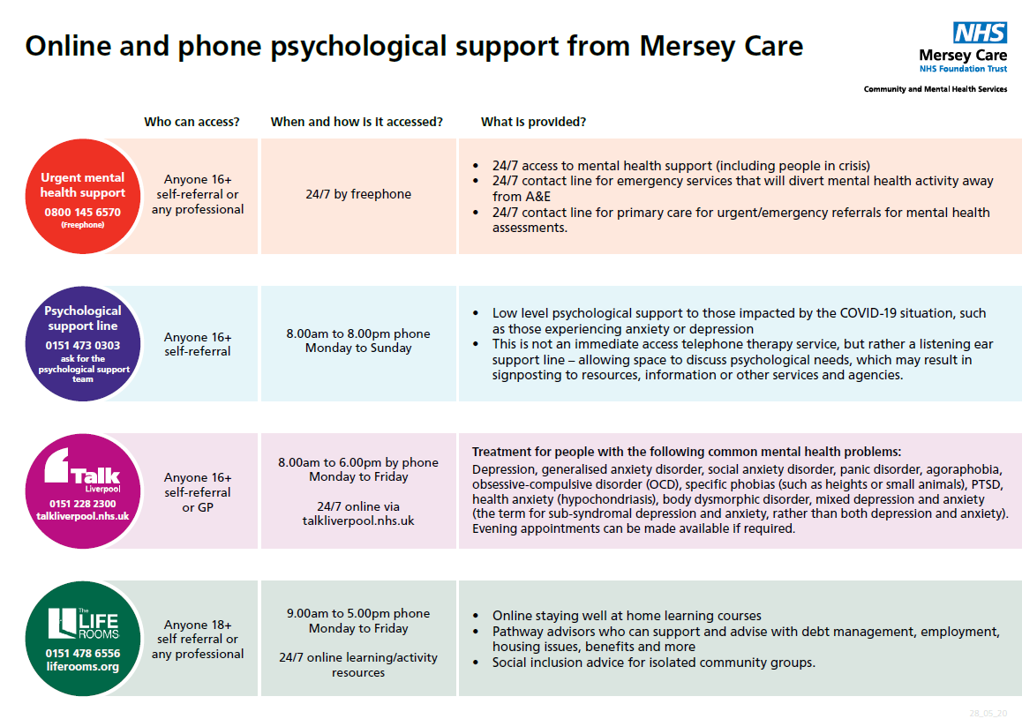

Access Sefton is a free, confidential service, commissioned by the NHS. The service is available to anyone aged 16+ and registered with a Sefton* GP.

To self-refer to Access Sefton phone 0300 303 2708

There is also a 24/7 support phoneline to support anyone who needs help https://kindtoyourmind.org/support-near-me/
The helpline for Sefton Adults is: 0151 330 7332

Frontline19 is a UK nationwide service delivering supervision, debriefing and emotional support to frontline workers during times of crisis. It is free and confidential.
https://www.frontline19.com/

Further Sources of Support
Frailty e-learning programme launched
A new e-learning programme about frailty is available through Health Education England’s (HEE) e-Learning for Healthcare, and aligns with the national and regional Ageing Well strategies for improvement.

https://www.digitalsocialcare.co.uk/about/

Case Study - Benridge Care Group: building a bespoke online system
https://www.digitalsocialcare.co.uk/success-story/benridge-care-group-building-a-bespoke-online-system/

Delivering Safe, Face-to-Face Adult Day Care
https://www.scie.org.uk/care-providers/coronavirus-covid-19/day-care/safe-delivery

COVID-19 and Dual Sensory Impairment (DSI)
Please read and share the free resources about COVID-19 and people with DSI: http://hi-vis.org/covid-19/

Sefton’s Medicines Management Team can be contacted on Seftonmm.hub@nhs.net to discuss any training requirements regarding medication.

Guidance: Supported living services during coronavirus (COVID-19)
Guidance for providers of supported living settings.
https://www.gov.uk/government/publications/supported-living-services-during-coronavirus-covid-19/covid-19-guidance-for-supported-living

Health Education England
The e-learning for healthcare website is freely accessible and has a multitude of COVID-19 related training resources readily available for staff to access, this is the link;
https://www.e-lfh.org.uk/

Sefton Corporate Learning Centre
The following are all available in our Learner Management System (MeLearning) and are free to access:
- Bereavement Electronic Resources
https://seftonclc.melearning.university/course_centre/course_details/102

- Coronavirus Awareness eLearning (10 Minutes) https://seftonclc.melearning.university/course_centre/course_details/97

- End of Life Electronic Resources
https://seftonclc.melearning.university/course_centre/course_details/101

- Further Sources of Support https://seftonclc.melearning.university/user/course_library/course_details/106

- Infection Prevention and Control Electronic Resources
https://seftonclc.melearning.university/user/multi_level/view/100

- Looking after You Electronic Resources
https://seftonclc.melearning.university/course_centre/course_details/103
- Moving and Handling Electronic Resources
https://seftonclc.melearning.university/course_centre/course_details/104

- Safeguarding Adults Awareness free virtual briefing https://seftonclc.melearning.university/course_centre/course_details/108

- Safeguarding Children/Young People Awareness free virtual briefing https://seftonclc.melearning.university/course_centre/course_details/111

- Skype Electronic Resources https://seftonclc.melearning.university/user/course_library/course_details/99

- Working at Home Mental Health Video
https://seftonclc.melearning.university/course_centre/course_details/114

If you haven’t registered with us before, please go to:

https://seftonclc.melearning.university/course_centre and click the “Self Register” button.

For existing users, you will be asked to log in using your username and password. If you have forgotten your password please click the “forgot your password” button and you will receive an email prompting you to change your password.
If you can’t remember your username and/or password, please contact Sefton Corporate Learning Centre on 0151 934 2872 or email training.services@sefton.gov.uk

Skills for Care
https://www.skillsforcare.org.uk/Home.aspx

Social Care Institute for Excellence
https://www.scie.org.uk/care-providers/coronavirus-covid-19

United Kingdom Homecare Association
https://www.ukhca.co.uk/news.aspx?newsID=235474

Care Provider Alliance
https://careprovideralliance.org.uk/coronavirus-and-workforce

Care Quality Commission
https://www.cqc.org.uk/guidance-providers/all-services/coronavirus-covid-19-pandemic-information-providers

Information Commissioners Office
Data protection and coronavirus information hub to help individuals and organisations navigate data protection during this unprecedented time.
https://ico.org.uk/global/data-protection-and-coronavirus-information-hub/

