Education and Supporting Resources for Direct Payments Recipients and their Personal Assistants

Introduction

Hello
We want to support you in whatever way we can during this COVID-19 period and one of the ways was to develop this document to highlight key areas where there are free education and supporting resources available for you and your personal assistants not only on a national level but what’s available locally here in Sefton.
This document and the electronic version will be regularly reviewed to include updates as we receive them however if you have any suggestions as to what else needs to be included please let us know by emailing Louise Kearney, Learning and Development Officer at louise.kearney@sefton.gov.uk

Deborah Butcher
Executive Director of Adult Social Care
Sefton Council

Government Guidance

Coronavirus (COVID-19): guidance for people receiving direct payments. Advice for people who buy care and support through a direct payment, as well as local authorities, clinical commissioning groups and those who provide care and support.

https://www.gov.uk/government/publications/coronavirus-covid-19-guidance-for-people-receiving-direct-payments

Coronavirus (COVID-19): guidance for care staff supporting adults with learning disabilities and autistic adults. This guidance is for care workers and personal assistants who provide support to adults with learning disabilities and autistic adults.
https://www.gov.uk/government/publications/covid-19-supporting-adults-with-learning-disabilities-and-autistic-adults/coronavirus-covid-19-guidance-for-care-staff-supporting-adults-with-learning-disabilities-and-autistic-adults

Easy read – Employing personal assistants toolkit booklets
The ‘Employing personal assistants toolkit' which provides guidance, templates and resources about recruiting, training and managing personal assistants is now available in easy read.
https://www.skillsforcare.org.uk/Employing-your-own-care-and-support/Information-for-individual-employers/Information-for-individual-employers.aspx?_cldee=bG91aXNlLmtlYXJuZXlAc2VmdG9uLmdvdi51aw%3d%3d&recipientid=contact-c4d60b7a3eaee61194120050568779ad-3e808286a80642f08598feeed6effb09&esid=69e05f8e-bded-ea11-80e3-005056877cb9

Think Local Act Personal
https://www.thinklocalactpersonal.org.uk/covid-19/

Disability News Service

https://www.disabilitynewsservice.com/

Infection Prevention and Control

Putting on and taking off Personal Protective Equipment, although the video focusses on care homes the information is still applicable to all settings. https://www.youtube.com/watch?v=ozY50PPmsvE&feature=youtu.be

Skills for Health free Coronavirus (COVID-19) Awareness Course, 2 hours, covering infection prevention, PPE, sampling and testing.
https://www.skillsforhealth.org.uk/covid-19-course

COVID-19: personal protective equipment use for non-aerosol generating procedures. Guidance on the use of personal protective equipment (PPE) for non-aerosol generating procedures (APGs).
https://www.gov.uk/government/publications/covid-19-personal-protective-equipment-use-for-non-aerosol-generating-procedures

Hand washing video and resources
https://www.nhs.uk/video/pages/how-to-wash-hands.aspx

Moving and Handling

At this challenging time it is critical that all carers are given as much support as is possible to enable them to safely carry out their role. In recognition of this Sefton Council has purchased a six-month subscription to A1 Risk solutions website which will allow access for significant number of users.

A1 have an evidence based online Moving and Handling system, containing over 341 videos and accompanying safe systems of work, specifically designed for Health and Social Care organisations.

This is a unique opportunity to access the videos that are available for the next six months and there will be no cost to you.

The videos demonstrate clearly how to use the equipment that is issued by Sefton Local Authority and the Hospital Occupational Therapy staff for the moving and handling of people.

For access to the videos you will need to register with the following information:

- Your name
- Direct Payment Recipient
- Details of a contact person, including an Email address and a phone number
- The number of personal assistants who will have access to the videos (we have registered for a lot of usage)

Please send this information to Admin.sc@sefton.gov.uk and we will send a log in and password to the contact person.

Look After You and Your Personal Assistants

Coronavirus (COVID-19): health and wellbeing of the adult social care workforce
https://www.gov.uk/government/publications/coronavirus-covid-19-health-and-wellbeing-of-the-adult-social-care-workforce?utm_medium=email&utm_campaign=govuk-notifications&utm_source=83369eba-1acc-44ce-8cc5-6adeb6c325d0&utm_content=daily

QWELL – Online Counselling and Well-being for Adults.
The QWELL online platform provides free access to counsellors, forums and articles to help people with their recovery. There is a link below to a video explaining the service and how to access it. It shows the sign-up screen which is where your staff can choose their profession and set up their username. The video then walks staff through the different areas of the site: https://vimeo.com/394910786/e6b8684fd2
To access QWELL, please visit www.qwell.io You may also wish to also add the link to access the services on your intranet/internet site.
Care Homes can book QWELL awareness sessions for their Homes by contacting Emily on ehawley@kooth.com

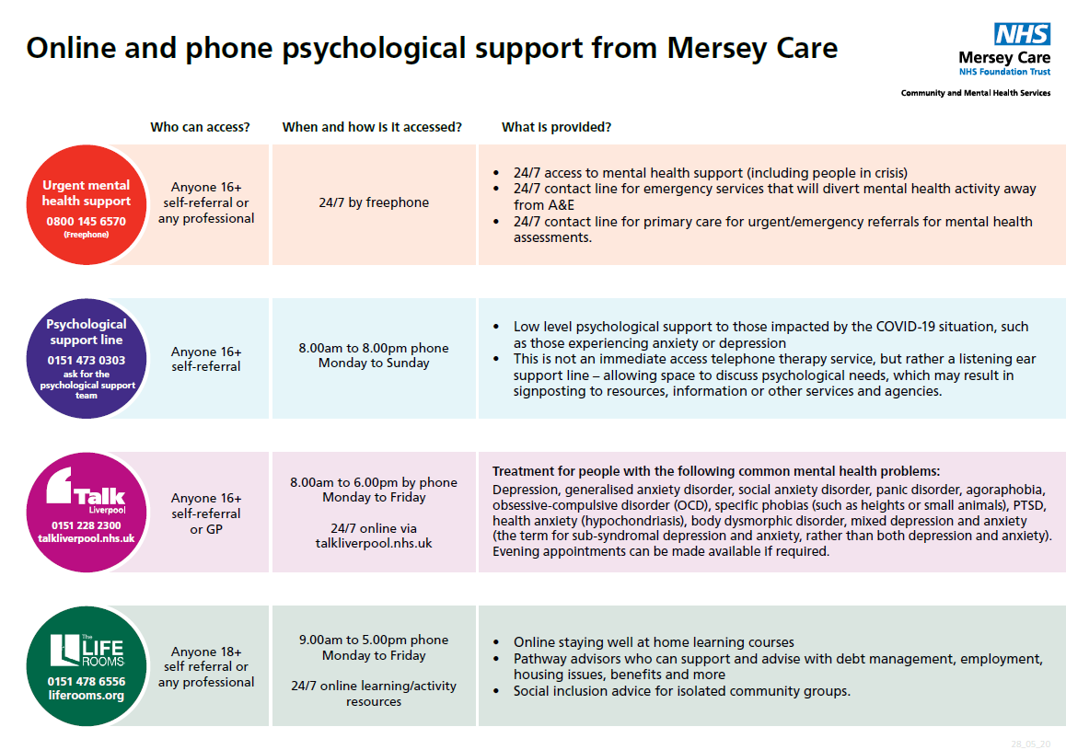

Access Sefton is a free, confidential service, commissioned by the NHS. The service is available to anyone aged 16+ and registered with a Sefton* GP.

To self-refer to Access Sefton phone 0300 303 2708
​

There is also a 24/7 support phoneline to support anyone who needs help https://kindtoyourmind.org/support-near-me/
The helpline for Sefton Adults is: 0151 330 7332

Frontline19 is a UK nationwide service delivering supervision, debriefing and emotional support to frontline workers during times of crisis. It is free and confidential.
https://www.frontline19.com/

Further Sources of Support

Every Vaccination Gives us HOPE
https://prod.cms.coronavirusresources.phe.gov.uk/covid-19-vaccine/resources/hope-pr-film/

How to do a COVID-19 Self Test (rapid antigen test)
https://www.youtube.com/watch?v=S9XR8RZxKNo&list=PLvaBZskxS7tzQYlVg7lwH5uxAD9UrSzGJ

Frailty e-learning programme launched
A new e-learning programme about frailty is available through Health Education England’s (HEE) e-Learning for Healthcare, and aligns with the national and regional Ageing Well strategies for improvement.

Vaccine Fact Cards

COVID-19 and Dual Sensory Impairment (DSI)
Please read and share the free resources about COVID-19 and people with DSI: http://hi-vis.org/covid-19/

Skills for Care

https://www.skillsforcare.org.uk/Documents/About/News/email/Newsletter-for-individual-employers-and-those-who-support-them-August-2020.html

Social Care Institute for Excellence
Access to free recorded webinars on Safeguarding Adults and the Mental Capacity Act.
https://www.scie.org.uk/care-providers/coronavirus-covid-19/virtual-courses?utm_campaign=11734349_SCIELine%2011%20August&utm_medium=email&utm_source=SOCIAL%20CARE%20INSTITUTE%20FOR%20EXCELLENCE%20&utm_sfid=003G000002FsdtMIAR&utm_role=Educator%2F%20Trainer&dm_i=4O5,6ZIA5,JRX35H,S4Y56,1

Books Beyond Words
Coping with Coronavirus, free picture stories and illustrated guides to support people with learning disabilities and autism through the coronavirus pandemic.

https://booksbeyondwords.co.uk/coping-with-coronavirus

Sefton Corporate Learning Centre
The following are all available in our Learner Management System (MeLearning) and are free to access:
- Safeguarding Adults Awareness free virtual briefing https://seftonclc.melearning.university/course_centre/course_details/108

- Safeguarding Children/Young People Awareness free virtual briefing https://seftonclc.melearning.university/course_centre/course_details/111

If you haven’t registered with us before, please go to:

https://seftonclc.melearning.university/course_centre and click the “Self Register” button.

For existing users, you will be asked to log in using your username and password. If you have forgotten your password please click the “forgot your password” button and you will receive an email prompting you to change your password.

If you can’t remember your username and/or password, please contact Sefton Corporate Learning Centre on 0151 934 2872 or email training.services@sefton.gov.uk

Skills for Care
https://www.skillsforcare.org.uk/Home.aspx
Priority training identified by Skills for Care to ensure a skilled and competent workforce during the Covid-19 crisis.

https://www.skillsforcare.org.uk/About/News/COVID-19-Essential-training.aspx

Social Care Institute for Excellence
https://www.scie.org.uk/care-providers/coronavirus-covid-19

Health Education England

The e-learning for healthcare website is freely accessible and has a multitude of COVID-19 related training resources readily available for staff to access, this is the link;
https://www.e-lfh.org.uk/

