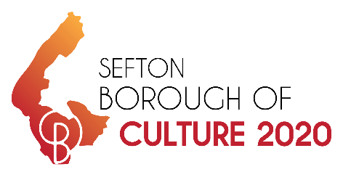 | Funding BID Application  £0 - £5,000
Please complete the below form to request funding for your event to be included as part of the Borough of Culture 2020 programme. All grant applications will be considered against the funding criteria and all successful applications will be subject to evaluation to measure the success of the programme post 2020. Maximum funding available per application is £5,000.

Organisation or Group Name
(If Applicable)
Lead Contact Name
Contact Address
Telephone Number
Email Address
Please provide a short description of your group or organisation and the type of work it does.
Please describe your project or event – What do you want the funding for?
Please include as much detail as possible including the location or venue of the event or activity. The date/s and time this will be hosted.

How will you promote this project or event?
Please include any social media, posters, leaflets etc

What help/support do you need from the Council to make this happen?
Please be as specific as possible including all requests for funding, space i.e. use of a park or Council building, equipment, contacts, promotion, research and evaluation etc.

If you are requesting funding, please give a breakdown of total cost of the project or event below.
Item |  |  |  |  |  | Amount
Total
How much funding are you requesting from Sefton Council for this project or event?
If the amount requested from Sefton Council is less than the total required for this project or event, please detail below how the funding gap will be met.
Please detail all match funding including donations, fund raising and successful funding applications

Please tick which objectives your project will meet and outline how they will be met?
Your project must support at least 2-3 objectives.
Objective |  | Check |  | Detail
Children and Young People – Increase engagement with children and young people.

Positive Outcomes - Improving health and wellbeing through access to cultural activities.

Communities – Increase participation, particularly from the ageing society.

Distinctiveness of Place – Promote the creative and cultural offer.

Infrastructure – Leaving a legacy through better infrastructure for culture and creativity.

How will you evaluate your project?
Event postcards (provided)
Comment Cards
Social Media Stats
Online survey (provided)
Case Study Form (2-3 to be provided)
Schools Feedback
Visitor Numbers (in comparison to previous events)
Volunteers
Other (please detail):

Internal Use Only
BoC Objective(s) Met |  |  | Evaluation Method
Funding Granted  (delete as applicable) |  |  | Amount
Yes/No

Please email all completed forms to BOC2020@seftoon.gov.uk

