Sefton Early Help Assess – Plan - Review Practitioner Guidance

Date: October 2018
Author: Sefton Early Help, Localities Teams

Contents
1. Rationale 3
The Assessment 4
Demonstrating impact 4
2. Assessment Guidance Notes 5
The Lead Practitioner 5
Early Help Assessment 5
Assessing needs 5
6 Step Assessment 6
3. Team Around Family – Action Plan, Review and Closure 11
5 Step Review 11
Timescales 12
Closing a Plan 12
Appendix A 15
Discussion points to consider in each assessment domain 15
Factors to consider when completing the Early Help Assessment 15
Education 15
Health and Wellbeing 17
Families where children need help 19
Economic Wellbeing 21
Relationships 22
Community engagement 23
Appendix B 26
Example questions - Early Help Assessment 26
Education 26
Health and Wellbeing 27
Families where children need help 29
Economic Wellbeing 31
Relationships 31
Community engagement 32
Appendix C 34
TAF Meeting Structure 34

1. Rationale

This document is to provide guidance to practitioners from any service in completing an Early Help Assessment when they identify potential additional needs or concerns for a child or family. It also provides guidance around putting a plan in place for a family, executing that plan and reviewing progress, as illustrated in Figure 1. This document should be used for reference and accompanies the Early Help Assess – Plan – Review training, Early Help Module training (and guidance), Lead Practitioner guidance and further online guidance.

Figure 1: Assess – Plan – Review cycle

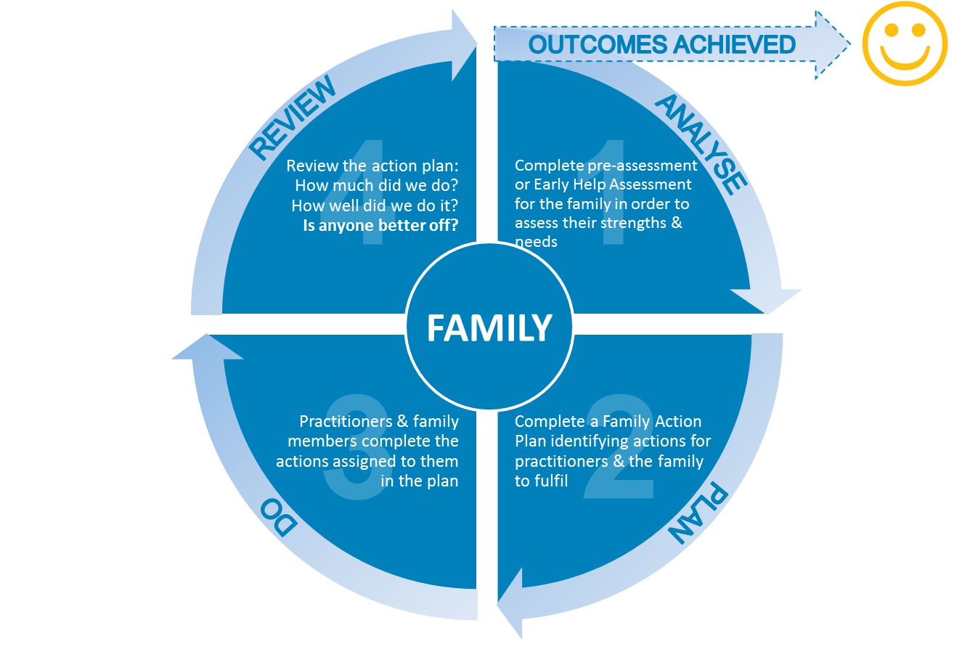

Sefton’s Early Help Service is committed to supporting practitioners to identify needs earlier and provide appropriate early intervention for families.

Identifying needs at an early stage using the Early Help Assessment gives agencies working with children, young people and their families a common tool to understand the needs of the child or young person and their family. It is only once the full needs are identified that the appropriate support can then be put in place.

To help practitioners know when family support might be appropriate please refer to Sefton’s LSCB (Local Safeguarding Children’s Board) Levels of Need which provides illustrative examples of needs that may be observed and trigger the need for completing the Early Help Assessment.

The Early Help Assessment is not to be used when there are significant or immediate child protection concerns. For any safeguarding concerns follow Sefton’s LSCB Safeguarding procedures or contact Sefton MASH on 0845 140 0845.

The Assessment

The Early Help Assessment covers 6 key areas of need that should be assessed:

- Education
- Health and wellbeing
- Families where children need help
- Economic wellbeing
- Relationships
- Community engagement

Within the assessment it is important to highlight the strengths and resources within the family. This is a useful focus when agreeing the action plan and helping other agencies to understand the protective factors within the family and identify how they can facilitate change. The more strengths present, the lower the risk will be and as support progresses it would be expected that risk factors decrease and strengths increase.

It is not expected that practitioners will be experts in all areas of the assessment. During the assessment stage the Team Around the Family (TAF) can begin to be established. The practitioner completing the assessment will act as the Lead Practitioner until their role in supporting the family comes to an end. The Lead Practitioner can call upon their colleagues supporting the family to assist in the assessment process.

Demonstrating impact
By following the above cycle (Figure 1) we should be able to evidence the positive impact we have had since we started working with a family. The 3 key questions we should ask ourselves prior to closing a plan are:

- How much did we do?
- How well did we do it?
- Is anyone better off?

Sustained impact can be measured in many ways once a plan has been completed and there are a number of tools and resources available to help you. However, if you can confidently answer ‘Yes’ to the final question above then the evidence should be contained within the family’s case file in EHM.

2. Assessment Guidance Notes

Before starting the assessment it is important that you should check the Early Help Module (EHM) to ensure that there is not already a plan in place for the family. If you do not have access to EHM you can contact the Early Help Gateway who can do this for you. Send your request to EIP.Gateway@sefton.gov.uk. If there is a current plan in place for the family you should contact the Lead Practitioner for that family and request to become part of the TAF.

The Lead Practitioner

When there is not already a plan in place you can then progress to completing the assessment. All children and young people who require integrated support from more than one practitioner should experience a seamless and effective service. This is delivered most effectively when one practitioner – a Lead Practitioner – takes a primary role to ensure frontline services are coordinated, coherent and achieving intended outcomes.
Start Episode

The practitioner initiating the Early Help assessment will act as the Lead Practitioner until the first TAF review where, along with the plan, the Lead Practitioner role can be reviewed and, if necessary, a new Lead Practitioner can be appointed.

The role includes three core functions which can be carried out by a range of practitioners across the children and young people's workforce:

- act as a single point of contact for the child, young person, or family, who they can trust and who can engage them in making choices, navigating their way through services and effecting change;
- coordinate the delivery of agreed actions in the Team Around the Family (TAF) meetings to ensure that children, young people and families receive an effective service that is regularly reviewed. These actions will be based on the outcome of the common assessment and recorded in the Early Help delivery plan;
- reduce overlap and inconsistency in the services received by children, young people and families.

Early Help Assessment

Assessing needs

This involves working with the child or young person and their family and undertaking the assessment with them. You will need to make sure they understand what information you are recording and what is going to happen to it. You should consider the child or young person within their family relationship. It will help to use plain, jargon-free language that is appropriate to the age and culture of each person, explaining any unavoidable technical and professional terms.

Remember, the discussion does not have to be highly formal or presented as a ‘big event’. You will want to use a method and style that suits you, the child or young person, their parent/carer, and the situation. Apart from a pre-natal assessment, it is not possible to do an Early Help assessment without seeing or involving the child or young person.

The Early Help assessment is a way of recording your discussions with the child or young person and their family, and other knowledge and observations.
Start Consent

The key points to remember about your discussion are:
- it is collaborative – you are working with the child or young person and their family to find solutions, and they will often know better than you
- you should consider the child or young person’s and family’s strengths as well as needs, and these should be recorded
- you should make use of information you have already gathered from the child or young person, parent or other practitioners so they don’t have to repeat themselves
- if the child or young person and/or their parent/carer don’t want to participate, you can’t force them – it is a voluntary assessment
- if you are concerned about the safety or welfare of a child or young person, you should follow Sefton’s LSCB procedures or talk to your safeguarding lead
- if you are worried about your own safety, act accordingly. If you are not sure, seek immediate advice
- at the end of the discussion, you should be able to understand better the child or young person’s and family’s strengths and needs, and what can be done to help

6 Step Assessment

Step 1
Explain the purpose of the assessment
- explain why you are recording information and what will happen to it
- make sure the child or young person and family understand who else will see their information
- make sure they understand that the assessment is a resource to help them when accessing services
- check they fully understand and consent to undertaking an Early Help assessment and recording the information (either on paper or electronically)
- you should always encourage children or young people under 16 to involve their parent/carer as appropriate
- do not assume that children and young people with a disability or learning disabilities are not capable of understanding

Step 2
Identifying details
- Gather the basic details about the child or young person and their family. This is the minimum information that must be captured as identifying details.
- It may be helpful to include the relationship to the child or young person of any person listed in the section ‘People present at assessment.’
Family Details
Step 3
Current family and home situation
- This is a free-text section which you can use to record the child or young person’s family and home situation (e.g. who they do and don’t live with – parents, siblings and other significant adults).
- You may also wish to include addresses and contact numbers, where appropriate.

Step 4
Services working with the family
- Complete the details of the person conducting the assessment.
- Complete details of the universal services working with the child or young person and their family.
- Also complete the details of other services working with the child or young person that are relevant to the assessment.
Assessment Details
Step 5
Key Early Help assessment areas
Go through the main assessment areas. You should consider each of the 6 broad groups separately (where a field is not completed, you must indicate that it is not applicable, i.e. why you have left it purposely blank). Also consider the risk factors from the assessment triangle (see Figure 2):
- Development of child or young person: how well are they developing, including their health and progress in learning.
- Parents and carers: how well parents are able to support their child or young person’s development and respond appropriately to any needs.
- Family and environmental: the impact of wider family and environmental elements on the child or young person’s development and on the capacity of their parents.

Figure 2: Assessment Triangle
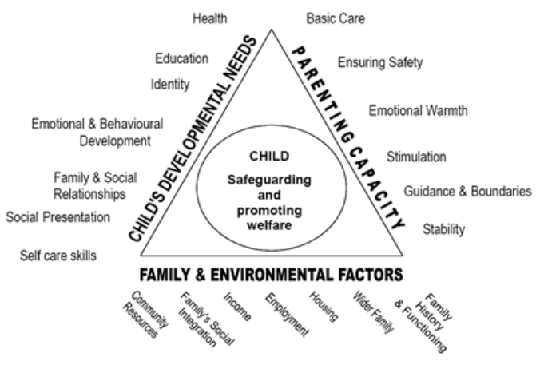

Note: See Appendix A for examples of what to information to include in the assessment groups and Appendix B for some example questions to initiate discussion.

For each broad group:
- You should explore areas around your immediate concern, so as to look behind the presenting issues and come up with a more holistic view.
- You do not need to comment on every element; include only what is relevant.
- You are not expected to diagnose problems in a professional field other than your own. But you must consider the whole child or young person, not just your own service focus.
- You should also focus on areas of strength in the family, not just needs.
- The discussion should be supportive and non-threatening.
- Don’t be put off by the language in which some of the elements are expressed.
- Wherever possible, you should base the discussion and your comments on evidence, not just opinion.
- Evidence would be what you have seen, what the child or young person, and family members, have said.
- Opinions should be recorded and marked accordingly (for example ‘Michael said he thinks his dad is an alcoholic’). In recording information on the form, you should be mindful of how the information will be used and who will see it.
- You should include what is relevant to your assessment, but you should not include confidential information (e.g. from health records) unless it is directly relevant and the child or young person/parent explicitly agrees that you should.

Step 6:
Conclusions, solutions and actions
The final section of the assessment outlines the support plan, which must be agreed with the family. This is based on the conclusions of the assessment. Practitioners must ensure that the plan is SMART (Specific, Measurable, Achievable, Realistic and Time bound). Once the assessment and conclusions/solutions/actions have been completed the family should be asked to sign the document and they should also be provided with their own copy. When signing the document they can also add any comments in relation to information they may disagree with or particular agencies they do not wish to share their information with.
- With the child or young person, or parent/ carer, record your overall conclusions and the evidence behind them.
- Agree what you say with the child or young person, or parent/carer, and record any major differences of opinion.
- With the child or young person and parent/carer identify what changes are wanted, what is going well, how change can happen and what actions the family and practitioners supporting them need to undertake.
- Focus on what the child or young person and family can do for themselves.
- If they need more support, think about where they could find it; if it is appropriate to your role, see if you can provide it. Or see if targeted support is provided within your service.
- If the child or young person and family would benefit from support from other agencies, use The Sefton Directory or Sefton CVS Service Directory to see what is on offer, and try to broker this support by engaging these agencies as part of the TAF.
- Agree a review date with the family.
- Share the assessment with the TAF.

Note: The assessment includes an action plan. This is an initial action plan which identifies the immediate actions that people present at the assessment will take (including the child or young person and family). Where a multi-agency response is required, a TAF will be formed and a delivery plan will be agreed by the TAF members. Both the initial action plan and final delivery plan should be agreed to by all those involved, including the child or young person, family and partners. The consent statement should also be signed by the child or young person or parent/carer on the final version of the form. See section 3 (below) of this document for more information.

- Do not make any promises of support on behalf of other services.
- Agree who will do what, and when you will review progress.
- Record the child or young person’s or parent/carer’s consent to record the assessment information and to share the assessment information with other agencies. Record any agencies that are specifically included or excluded as agreed with the child/family or young person.
- Make sure they understand what is proposed.
- Use your own judgement to define what should be recorded and who should see it, within the limits of the consent given.
- Give a copy of the assessment to the child or young person or their parent/ carer and explain that they can show it to other services if they wish to, so they don’t have to keep repeating their stories.

Information Sharing and Consent

It is essential to complete this section of the form otherwise the information in the assessment cannot be shared with other agencies. Please note that for the family sections, consent must be gained from each member of the family whose information is contained in the assessment. If one family member does not consent – their information cannot be shared. It is still possible for support to be provided by the practitioner the information was revealed to but they are unable to share any information without consent unless it falls under the safeguarding procedures where consent is overridden.

Working with unborn babies

All pregnant women should have a midwife she knows and trusts to co-ordinate her pregnancy care. If you are not that person, this will be a key person to consult if undertaking an Early Help assessment with a pregnant woman.

Working with young people

You should try to involve and work directly with infants and very young children in a way that is most appropriate for them; for example, through observation, play and thoughtful conversations. Most infants and their parents will have at least some contact with the midwife, health visitor and/or GP. If you are completing an assessment for an infant, and the parent agrees, you should contact these practitioners.

The Early Help assessment is generally used with children and young people up to the age of 18, but its use can be extended beyond 18 where appropriate, to enable the young person to have a smooth transition to adult services. In the case of the Connexions service, the Early Help assessment can be used with young people up to the age of 19, and up to the age of 24 where a young person has a learning difficulty or disability.

For older young people, you should consider possible current and future needs for adult services, and transitional arrangements. For example, you may need to think about whether adult services are more appropriate to a young person in their late teens or, if a young person is already accessing children’s services, you may need to help manage their transition into adult services.

The possibility that a teenage boy is a father is a question that should be considered when assessing teenage boys, as their needs can be as complex as those of a teenage mother and are often not addressed.

Engaging with fathers and father figures

Fathers or father figures sometimes find it difficult to engage with services. It is important to make it clear that you welcome their involvement as much as that of mothers.

3. Team Around Family – Action Plan, Review and Closure
Record Review

5 Step Review

Now that the assessment and plan have been completed the next step is to review the plan with the support of the TAF. The TAF is a model of multi-agency service delivery. Members of the TAF are jointly responsible for developing and delivering the SMART plan. The purpose of this plan is to meet the needs of the child or young person and achieve the intended outcomes identified in the Early Help assessment. Each member of the TAF is responsible for delivering the activities they agreed to carry out as part of the SMART plan. Each member of the TAF is responsible for keeping the other members of the team informed about progress in their area of responsibility, providing reports promptly and attending meetings when requested.

Delays in information sharing adds delay to families accessing support. Good communication between TAF members, including family members, is critical. All TAF members should contribute to the plan and take on associated tasks as necessary. TAF members should support the lead practitioner by providing information, offering guidance and advice. They should also contribute actively and positively to problem solving or resolving difficulties.

The plan can be reviewed by either arranging a meeting where by all TAF members and the family can attend, or, collating information from the TAF members and reviewing the plan with the family without holding a TAF meeting.

If a TAF review meeting is required it is important all family members are included. Where a child is unable to attend the meeting their views should be gathered beforehand and presented at the meeting. In this instance the child should also be informed updated about the outcome of the meeting afterwards.

TAF meetings should be flexible and friendly, where everyone is viewed as having an equal contribution and equal responsibility. They should stay solution focussed with the outcomes for the family being the priority. Information about the structure of the TAF is in Appendix C.

TAF review meetings provide an opportunity for all relevant agencies to attend in order to discuss and contribute towards the family TAF plan.

Example action plan:
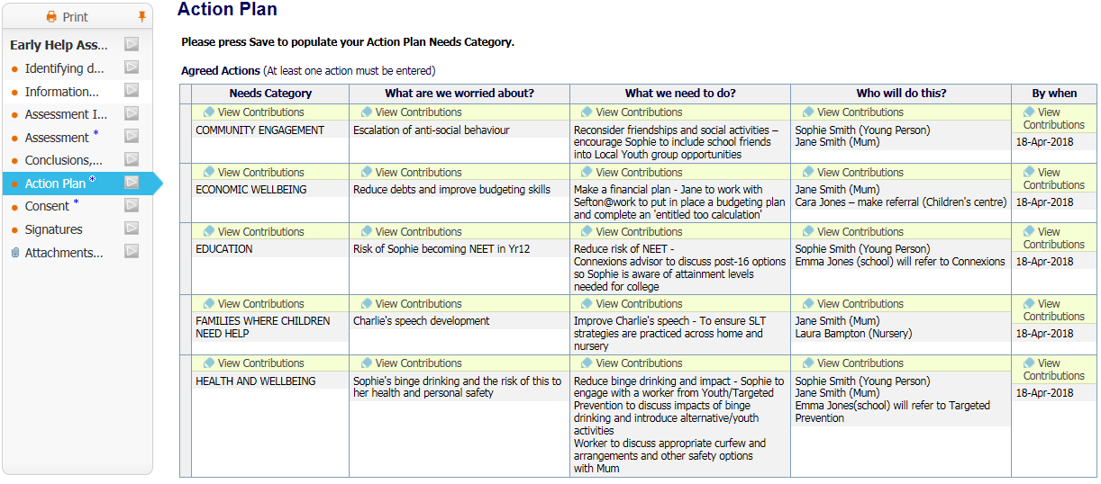

Timescales

The initial review period should be no longer than 6 weeks following the assessment being completed. Subsequent reviews should take place within a 3 month period. Below is an overview of the timescales.

Action | Timescale
- EHM search completed search to see if there is a plan of support already in place or not. | 48 hours of identifying need
- Complete the Early Help Assessment steps 1-5. | Within 10 working days
- Completion of conclusions, solutions and actions – provide family with their own copy. | Within 15 working days
- Share information with family | Within 15 working days
- Set a date to review the plan either with the family or through a TAF review meeting. | Within 6 weeks of completing assessment
- Continually review plan | Within 3 months of each other
- If outcomes have not been achieved re-assess the family using the Early Help Assessment in order to take into account any change in needs. | 12 months from start of intervention

Closing a Plan
Once work has been completed and outcomes have been achieved Early Help process should be recorded as closed. This should be agreed with the child/young person and parent/carer(s) and other practitioners involved at the team around the family. Ensure that the Closure Form is completed in the EHM system.

An Early Help Plan may be closed for a number of reasons:
- the family’s needs are now well understood, and the appropriate intervention has taken place to demonstrate that the family have achieved their outcomes (in most cases this should be within a year)
- the family has withdrawn their consent to Early Help support
- the children have reached adulthood
- the family, or significant family members have left the Borough (if moving to another local authority within England, the family should be transferred and offered equivalent support.
- if the issues are escalating and it is decided that a Specialist or statutory assessment is required

A final summary must be included in the closure and can be completed using the Closure Form in EHM. This must include information about the reasons for closing the plan and any ongoing actions for the family or practitioners in Universal services. A final copy of the action plan must be given to the family. It is the responsibility of the Lead Practitioner to ensure the case is closed by their manager using EHM.

Early Help Locality Pathway

Appendix A

Discussion points to consider in each assessment domain

This section aims to provide practitioners with some discussion points to facilitate the conversation with families about their needs in section 2 and 3 of the assessment. It is not intended as a script but as a guide to approaching wider issues. In each section practitioners should focus on the families’ strengths and consider how to manage the risk of support needs escalating.

Gathering this information is crucial to ensure that Sefton is doing all it can to serve the families who are most in need of early help and to identify any patterns of need which may be addressed through developing our services. This information makes it quicker to locate assessments and for other agencies to search for information which may be help on their own recording systems which may be useful for the Team Around the Family review.

Practitioners are reminded that other professionals can contribute to this assessment so where more relevant professionals are involved with the family it might be requested that they complete particular parts of the assessment or they may utilise the expertise within multi agency teams by asking for support and guidance on sections of the assessment which are not their 'usual' area of work. Outlined below are the sub headings from the assessment to support practitioners to fully understand the types of information which might be discussed under each of the headings.

Factors to consider when completing the Early Help Assessment

Education
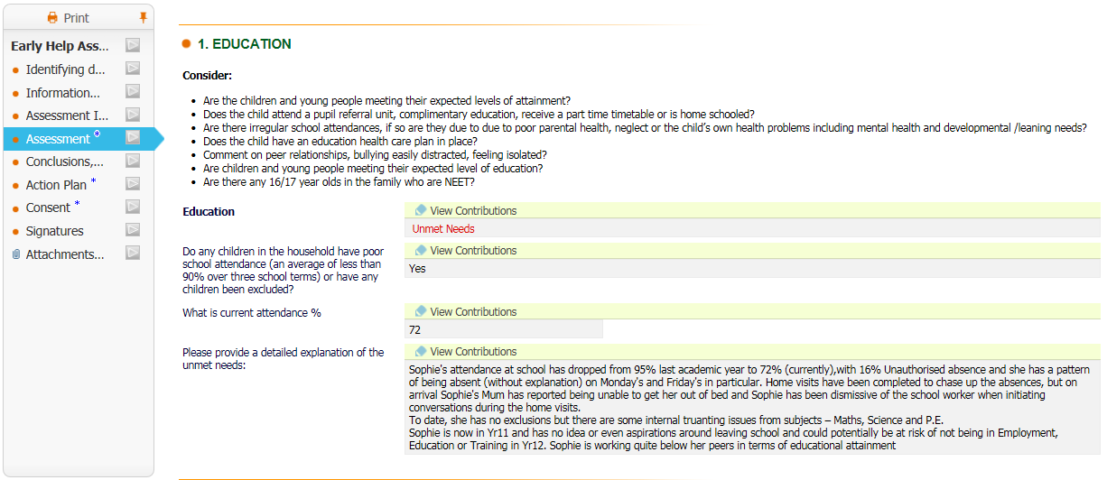

Understanding, reasoning and problem solving – the ability to understand and organise information, reason and solve problems. Also includes consideration of:
- the impact of any disability or impairment, or special needs, and of any potential for these outcomes
- making connections through the senses and movement, finding out about the environment and other people, becoming playfully engaged and involved, making patterns, comparing, categorising, classifying
- being creative; exploring and discovering; experimenting with sound; other media and movement; developing competence and creativity; being resourceful
- being imaginative, imitating, mirroring, moving, imagining, exploring and re‑ enacting, playing imaginatively with materials using all the senses, pretend play with gestures and actions, feelings and relationships, ideas and words
- exploring, experimenting and playing, discovering that one thing can stand for another, creating and experimenting with one’s own symbols and marks, recognising that others may use marks differently
- play and interaction
- demonstration of a range of skills and interests
- numbers as labels and for counting
- calculating
- shape, space and measures
- progress in learning, including any special educational needs identified
- knowledge and understanding of the world
- saying and using number names in order in familiar contexts
- using and developing mathematical ideas and methods to solve practical problems
- using language such as ‘more’ or ‘less’
- recognising and recreating simple patterns

Progress and achievement in learning
The child or young person’s educational achievements and progress, including in relation to their peers. Also includes consideration of:
- adult interest in the child or young person’s educational activities and achievements • progress; for example, measured against the early learning goals in the Early Years Foundation Stage; prior attainment in learning; national curriculum levels achieved; and their peers
- basic skills – the ability to read, write and speak in English and use mathematics at a functional level
- key skills – the ability to learn, work with others, carry out tasks
- participation in activities in the community; development of particular strengths or skills; for example, in sports, arts or vocational training
- special educational needs – whether the child or young person has significantly greater difficulty in learning than the majority of children or young people of their age
- whether the child or young person needs help to catch up when education has been disrupted
- disability – whether the infant, child or young person has a disability, and reasonable adjustments are being made to support their access to the curriculum and school life generally
- aspirations – the ambitions of the child or young person, whether their aspirations are realistic and they are able to plan how to meet them

Note: there may be barriers to a child or young person’s achievement of their aspirations; for example, the child or young person’s other responsibilities in the home. Also includes consideration of:
- the child or young person’s view of progress
- the family background
- motivating elements
- the child or young person’s level of self confidence
- perseverance

Participation in learning, education and employment
The degree to which the child or young person has access to and is engaged in education and/or work-based training and, if they are not participating, the reasons for this. Also includes consideration of:
- attendance
- the degree to which prior nonparticipation has led to current needs and circumstances
- access to appropriate and consistent adult support
- access to appropriate educational resources; for example, books

Health and Wellbeing
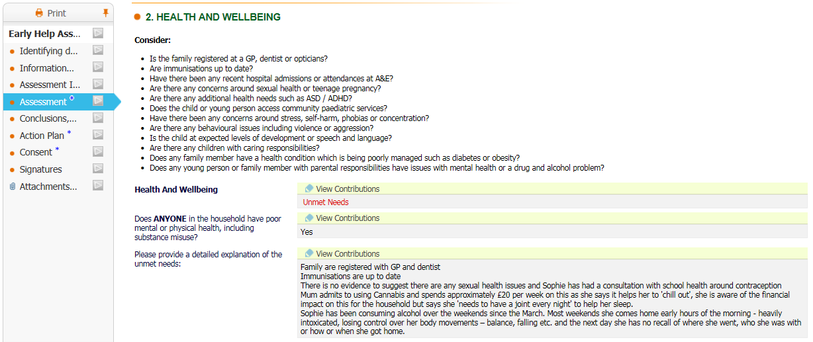

General health
The infant, child or young person’s current health condition (for example, growth, development, physical and mental well-being). Also includes consideration of:
- health conditions or impairments which significantly affect everyday life functioning whether chronic or acute, including obesity
- access to and use of appropriate health services, such as those provided by a GP/dentist optician, immunisations and appropriate developmental checks
- number and frequency of hospital admissions and accidents
- access to and use of appropriate health advice and information; for example, diet, sexual health and contraception, and management of any health condition such as diabetes or asthma

Physical development
The infant, child or young person’s means of mobility, level of physical or sexual maturity/delayed development. Also includes consideration of:
- being well nourished; being active, rested and protected; gaining control of the body; acquiring physical skills
- vision and hearing
- fine and gross motor skills including:
- crawling, balancing, walking, running and climbing
- participation in football or other games
- ability to draw pictures, do jigsaws etc.
- show awareness of space, of themselves and of others
- recognise the importance of keeping healthy, and what contributes to this

Speech, language and communications development
The ability to communicate effectively, confidently and appropriately with others. Also includes consideration of:
- interaction with others, negotiating plans and activities and taking turns in conversation
- sustained, attentive listening; responding to what has been heard with relevant comments and questions
- using speech to organise sequences and clarify thinking, ideas, feelings and events
- extending their vocabulary, exploring the meanings and sounds of new words
- using their phonic knowledge to write simple regular words
- showing an understanding of the elements of stories, such as main character, sequence of events and openings, and how information can be found in non-fiction texts to answer questions about where, who, why and how
- using a pencil and hold it effectively to form recognisable letters
- using first language
- ability to gain attention and make contact, access positive relationships, be with others, encourage conversation
- the impulse to communicate, exploring, experimenting, labelling and expressing, describing, questioning, representing and predicting, sharing thoughts, feelings and ideas
- listening and paying attention to what others say; making playful and serious responses; enjoying and sharing stories, songs, rhymes and games; learning about words and meanings
- ability to communicate meaning, influence others, negotiate and make choices, understanding of others
- vision and hearing
- language for communicating and thinking
- linking sounds and letters
- reading and writing
- willingness to communicate
- articulation skills and language structure
- vocabulary and comprehension
- fluency of speech and confidence
- appropriateness of social and communications skills; for example, body language
- excessive use of expletives or inappropriate language; for example, brusque manner

Emotional and social development
The emotional and social response the infant, child or young person gives to parents, carers and others outside the family. Also includes consideration of:
- the importance of being special to someone, being able to express feelings, developing healthy dependence, developing healthy independence
- nature and quality of early attachments
- self-harm or risk of self-harm
- phobias or psychological difficulties, fears or psychological difficulties such as persistent sadness or tearfulness
- temperament, coping and adjusting abilities; for example, after experiencing domestic violence, bereavement or family relationship breakdown
- disposition, attitudes and motivation to change
- confidence to try new activities, maintain attention, concentrate and sit quietly when appropriate
- form good relationships with adults and peers
- understanding what is right, what is wrong, and why
- work as part of a group or class, taking turns and sharing fairly
- the consequences of their words and actions for them and others

Identity, including self-esteem, self‑image and social presentation
The growing sense of self as a separate and valued person. Also includes consideration of:
- growing awareness of self, realisation of separateness and differences from others, recognition of personal characteristics and preferences, finding out what they can do
- importance of gaining self-assurance through a close relationship, becoming confident in what they can do, valuing and appreciating their own abilities, feeling self-assured and supported, having a positive view of themselves
- knowledge of personal and family history
- access to recognition, acceptance and comfort, ability to contribute to secure relationships, understanding they can be valued by and important to someone, exploring emotional boundaries
- sense of belonging, being able to join in, enjoying being with familiar and trusted others, valuing individuality and contributions of self and others, having a role and identity within a group, acceptance by those around them
- race, religion, age, gender, sexuality and disability – may be affected by bullying or discriminatory behaviour
- understanding of the way in which appearance and behaviour are perceived, and the impression being created
- understanding that people have difference needs, views, cultures and beliefs, and that they need to be treated with respect
- understanding that they can expect others to treat their needs, views, cultures and beliefs with respect
- have a developing respect for their own cultures and beliefs and those of other people

Families where children need help
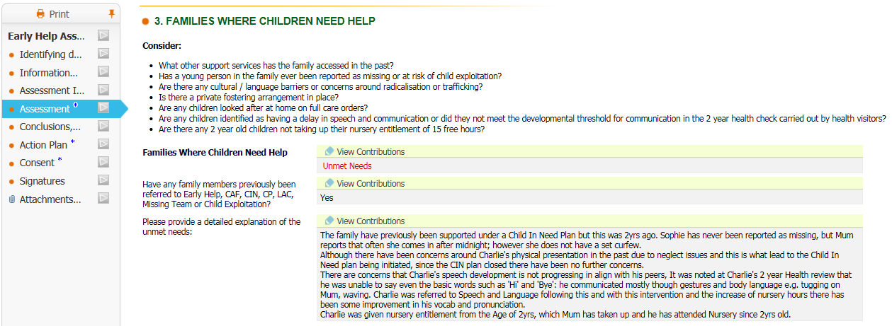

Self-care skills and independence
The acquisition of practical, emotional and communication competencies to increase independence. Also includes consideration of:
- discovering boundaries and limits, learning about rules, knowing when and how to ask for help, learning when to say no and anticipating when others will do so
- discovering and learning about their body, demonstrating individual preferences, making decisions, becoming aware of others and their own needs
- • early practical skills; for example, coping with routine such as washing, dressing and feeding (including swallowing, chewing and weaning, in the case of the very young)
- opportunities to gain confidence and practical skills to undertake activities away from the family
- independent living skills for older children; for example, appropriate use of social problem-solving approaches
- the readiness of older teenagers to make the transition from children and young people’s services to adult services

Basic care, ensuring safety and protection
The extent to which the infant, child or young person’s physical needs are met and they are protected from harm or danger, including self-harm. Also includes consideration of:
- provision of food, drink, warmth, shelter, clean and appropriate clothing, personal and dental hygiene
- level of engagement in securing universal services; for example, doctor, dentist, optician
- provision of a safe environment, where family members and other carers act to safeguard the safety and welfare of the infant, child or young person, and the infant, child or young person is not exposed to domestic violence, alcohol/ substance misuse, sexual exploitation or other abusive experiences
- recognition of hazards and danger both in the home and elsewhere
- quality of care
- parental substance misuse (includes alcohol and volatile substances, as well as illegal drugs)

Emotional warmth and stability
Provision of emotional warmth in a stable family environment, giving the infant, child or young person a sense of being valued. Also includes consideration of:
- parent or carer’s feelings about looking after this infant, child or young person
- ensuring the infant, child or young person’s requirements for secure, stable and affectionate relationships with significant adults are met, with appropriate sensitivity and responsiveness to the infant, child or young person’s needs
- appropriate physical contact, comfort and cuddling sufficient to demonstrate warm regard, praise and encouragement
- maintenance of a secure attachment to the primary caregiver(s) in order to ensure optimal development
- ensuring the infant, child or young person keeps in contact with important family members and significant others, when it is safe to do so
- frequency of moves of house and/or early years provision, school or place of learning or employment

Guidance, boundaries and stimulation
Enabling the child or young person to regulate their own emotions and behaviour while promoting their learning and intellectual development through encouragement and stimulation, and promoting social opportunities. Also includes consideration of:
- modelling appropriate behaviour and control of emotions and interactions with others
- provision of clear, consistent and appropriate guidance, boundaries and discipline such that a child or young person can develop a positive internal model of value and conscience
- appropriate stimulation of learning
- effective discipline
- ensuring the infant, child or young person’s safety while encouraging independence and avoiding overprotection
- encouraging the child or young person to participate in and benefit from education and leisure activities
- supporting the child or young person’s personal and social development so they are independent, self-confident and able to form positive relationships with others

Economic Wellbeing
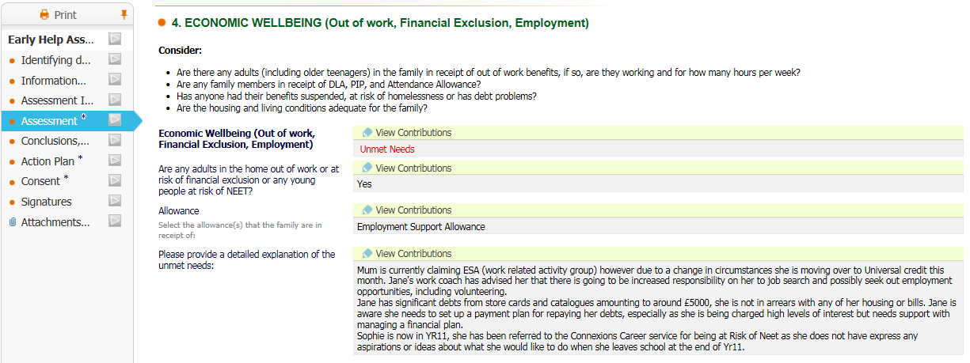

Housing, employment and financial considerations
Housing – what are the living arrangements? Does the accommodation have appropriate amenities and facilities? This includes consideration of:
- who the infant, child or young person has been living with
- the exterior of the accommodation and immediate surroundings
- the interior of the accommodation with specific reference to the infant, child or young person’s individual living arrangements
- water, heating, sanitation, cooking facilities, sleeping arrangements, cleanliness, hygiene, safety, security and privacy
- reasons for homelessness
Employment – Who is working in the household, the pattern of their work and any changes. This includes consideration of:
- the impact of work upon the infant, child or young person
- how work or absence of work is viewed by family members
- how work affects the family’s relationship with the infant, child or young person

Financial considerations – income available over a sustained period of time. This includes consideration of:
- the family’s entitlement to, and receipt of, benefits
- income to meet the family’s needs
- the ways in which the family’s income is used
- how the family’s financial circumstances affect the infant, child or young person; for example, inadequate legitimate personal income
- whether the family is suffering financial hardship due to an emergency; for example, loss of possessions/ homelessness
- whether there is serious debt or debt payments reducing income

Relationships
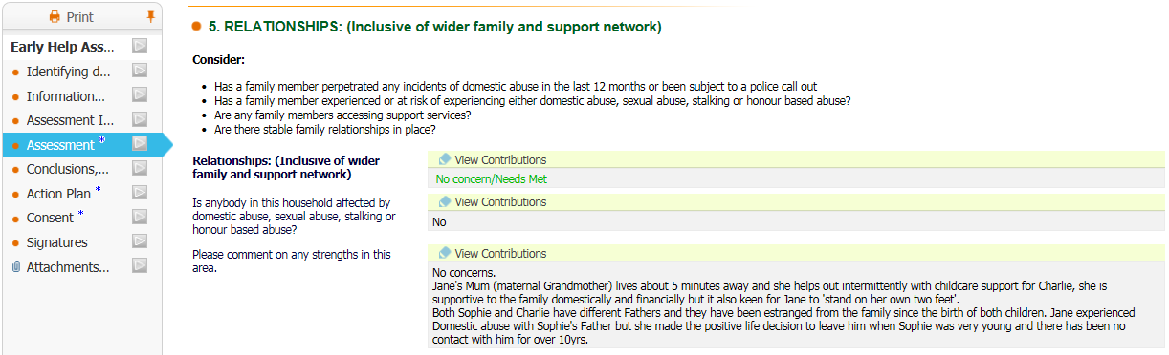

Family and social relationships
The ability to empathise and build stable and affectionate relationships with others, including family, peers and the wider community. Also includes consideration of:
- stable and affectionate relationships with parents or caregivers
- sibling relationships
- involvement in helping others
- age-appropriate friendships
- association with predominantly pro-criminal peers or lack of non-criminal friends
- understanding of others and awareness of consequences
- association with substance-misusing friends/peer groups

Family history, functioning and well-being
The impact of family situations and experiences. This includes consideration of:
- culture, size and composition of the household – including changes in the people living in the accommodation since the child’s birth
- family history – including any concerns about inheriting illnesses from a parent
- family routines
- disorganised/chaotic lifestyle
- failure to show care or interest in the infant, child or young person
- impact of problems experienced by other family members, such as physical illness, mental health problems, bereavement or loss
- whether the infant, child or young person is witness to violent behaviour, including domestic violence (both physical and verbal)
- involvement in criminal activity/anti-social behaviour
- experience of abuse
- family relationships – including all people important to the infant, child or young person; for example, the impact of siblings, absent parents and any serious difficulties in the parents’ relationship
- history of family breakdown or other disruptive events
- father or mother away from home through work, e.g. armed forces or in prison
- parental physical and mental health (including depression) or disability
- involvement in alcohol misuse
- involvement in substance misuse (includes alcohol and volatile substances as well as illegal drugs)
- whether anyone in the family presents a risk to the infant, child or young person

Wider family
The family’s relationships with relatives and non-relatives. This includes consideration of:
- formal and informal support networks for the infant, child or young person
- formal and informal support networks for the parents or carers
- wider family roles and responsibilities; for example, including employment and care of others
- appropriate level of support from family members

Community engagement
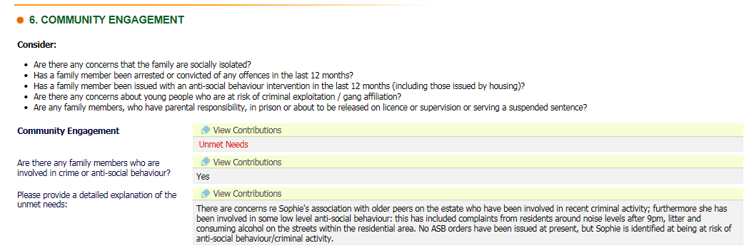

Behavioural development
The behaviour of the child or young person and whether behaviour occurs in a particular setting or all settings. Also includes consideration of:
- lifestyle and self-control (including participation in reckless activity and need for excitement)
- behaviour in nursery, class or other environments where the child or young person comes into contact with their peers
- whether undiagnosed conditions may be impacting behaviour (e.g. hearing or visual impairment)
- substance misuse (includes alcohol, volatile substance misuse and controlled drugs under the Misuse of Drugs Act 1971)
- anti-social behaviour; for example, destruction of property, aggression towards others, harm or risk of harm to others
- sexually inappropriate behaviour and attempts to manipulate or control others
- early sexual activity, unprotected sex, lack of reflection or positive decision making about sex and relationships, making them vulnerable to coercive or exploitative relationships
- offending behaviour and risk of reoffending
- violent or aggressive behaviour at home or school
- attitudes to offending
- over-activity, attentiveness, concentration and impulsive behaviour

Social and community elements and resources, including education
Explores the wider context of an infant, child or young person’s neighbourhood and its impact on the infant, child or young person, including details of the facilities and services available. Also includes consideration of:
- neighbourhood characteristics; for example, levels of crime, disadvantage, employment, high levels of substance misuse/trading, teenage pregnancy
- relationship with neighbours
- availability and accessibility of universal services, including schools/ colleges, schools offering access to extended services, youth service, early years settings, day care, primary healthcare, places of worship, transport, shops and leisure activities, and family support services
- quality of the learning environment and educational support services
- physical access to facilities and services
- degree of child or young person’s social integration or isolation
- the influence of peer groups, friendships and social networks; for example, substance or alcohol misuse.

Appendix B

Example questions - Early Help Assessment

Education
Understanding, reasoning and problem solving: The ability to understand and organise information, reason and solve problems.

How well for their age the infant, child or young person is able to understand and organise information, reason and solve problems.

- Tell me what you did yesterday?
- Are your friends mostly the same age as you, or are they mostly younger or older than you?
- Imagine someone treated you unfairly; what would you do?
- Do you like reading? If so what do you like to read?
- How are you at sorting out day to day problems?
- What types of resources/toys are provided for your baby?
- How does your baby respond to the environment around them?

Participation in learning, education and employment: The degree to which a child or young person has access to and is engaged in education and/or work based training and, if he/she is not participating, the reason for this.

How far the infant, child or young person is engaged in and attending learning appropriate to their age, whether through play, early years settings, school or college/employment.

- What school or college do you go to? How regularly do you attend?
- Do you enjoy school/college/training?
- What might stop you going to school/college?
- If you don’t go to school/college at all, why is that, and how long have you been out of school/college?
- What are you studying?
- What do you think you are good at doing?
- If you need help and advice about education and learning who can you go to?
- If you are working, what is your job? Do you enjoy your job?
- What do you want to do long term?
- Does the child attend a nursery or play group?
- How does your baby interact with others of a similar age?

Progress and achievement in learning: The child or young person’s educational achievements and progress, including in relation to their peers.

The infant, child or young person’s educational achievements and progress, including ability to read and write, compared with what would normally be expected from someone of their age.

- How well do you think you are doing at school/college/with your learning?
- What is your favourite subject and why?
- Is English your first language?
- Do you have any qualifications in maths or English?
- If you lack qualifications or confidence with reading, writing or maths, do you think that this is holding you back?
- If you think you need additional help, how would you like to get this?
- What learning opportunities does the child have?
- Do they have a favourite game or book?
- Does anyone read books to the baby/child?

Aspirations: The ambition of the child or young person, whether their aspirations are realistic and they are able to plan how to meet them. Note there may be barriers to a child or young person’s achievement of their aspirations, for example the child or young person’s other responsibilities in the home.

- What do you hope that learning will help you do?
- What help do you need with learning to make sure you do your best?
- Do you give up easily if you find something hard?
- What are your goals for the future?
- What do you want for your baby/child?

Health and Wellbeing
General health: The infant, child or young person’s current health condition (for example, conditions of relevance to an infant, child or young person including growth, development, physical and mental well-being).

How far the infant, child or young person appears healthy and well, is growing and developing normally and is accessing health services (such as GP, dentist or optician) appropriate to their age.

- Who is your family doctor? When did you last see them?
- Who is your family dentist? When did you last see them?
- Have you had all the immunisations and health checks you should have had?
- What food do you like to eat? What have you eaten today?
- Are you feeling well today? Do you usually feel well?
- Are you taking any medication at the moment? Do you regularly take medication?
- Would you describe yourself as having a disability or special need?
- Do you feel you are the right weight for your height?
- Are you presently receiving or waiting for specialist medical services like a hospital consultation or operation?
- Do you see any other doctors, therapists or nurses on a regular basis?
- Do you feel you are getting all the health services you need? If not, what do you think you are missing and why do you think you are not getting them?
- What things do you do to keep healthy?
- Are you seeing your midwife/health visitor regularly?
- Does anything concern you about the general health of your baby?

Physical development: The infant, child or young person’s means of mobility, level of physical or sexual maturity/delayed development.

How far the infant, child or young person’s physical skills seem to be developing normally for their age, for example whether they are crawling, walking and running as expected and whether their vision and hearing seems normal.

- Do you do any physical activities like walking, swimming, running or playing [wheelchair] sport?
- What activities do you like doing best?
- Do you need to wear glasses/hearing aids etc.. If so do you have them?
- Do you think you are a similar weight and height to others of your age?
- Does your baby, toddler, child have access to a play group or play facilities, for example a mother and toddler group or play area?
- What types of physical skills has your baby acquired?
- If your child has any form of developmental delay have any referrals been made so far?

Speech, language and communications development: The ability to communicate effectively, confidently and appropriately with others.

How far for their age the infant, child or young person seems able and willing to speak, communicate, read and write, and express their feelings.

- What is your address?
- How is your writing and reading?
- How are you at filling in forms?
- Do you sometimes worry that your spoken English lets you down?
- Do you sometimes find it hard to talk to people?
- Do you have enough support with speech, language and communication? If not, what would help you?
- How does the child communicate? Do they cry when unhappy? Are they making noises or words yet?
- How do you communicate with your child?
- If your child has a visual or hearing impairment or possible developmental delay difficulties have any referrals been made so far?

Emotional and social development: The emotional and social response the infant, child or young person gives to parents and carers and others outside the family.

How well the infant, child or young person copes with everyday life, e.g. their disposition, attitudes and temperament, any phobias or psychological difficulties.
- What makes you happy or sad? Tell me who you go to for help if you feel unhappy.
- When you are frustrated, angry or upset, how would people around you know that something was wrong?
- Do you ever do things because they are exciting without thinking about what might happen or that it might get you into trouble?
- Do you find it easy to talk to people about how you feel? How do you feel?
- Have you ever been bullied?
- Tell me who you spend most of your time with
- What sort of things do you do with other people?
- What do you like doing best?
- How much time do you spend on your own?
- Tell me who you feel close to.
- What types of sounds and facial expressions does your baby make in response to your attention?
- In what ways does your baby express their feelings?

Identity, including self-esteem, self-image and social presentation: The growing sense of self as a separate and valued person.

How far the infant, child or young person seems to be developing the right measure of confidence and self-assurance, and how far they have a sense of belonging.
- Who is the most important person in your life?
- If you had to name one special thing about yourself, what would that be?
- Is there anything about yourself that you don’t like?
- What do you think other people most like about you?
- Do you feel you are different from other people?
- Do you feel you “fit in” with family and friends?
- Can the child point to family on a picture or respond to their own name?
- Does the child respond differently to different family members or siblings?
- How does your baby demonstrate individual preferences?

Families where children need help
Self-care skills and independence: The acquisition of practical and emotional competences to increase independence.

How independent the infant, child or young person is for their age – how far they can do routine tasks for themselves and make their own decisions.

- How independent are you? What can you do for yourself?
- Do you need any help with day to day living? How do you feel about the help you receive?
- Who will help you learn to be more independent as you grow up?
- Do you get to do what you like to do?
- How do you cope with big changes in your life?
- How does your baby express their feelings or preferences?

Basic care, ensuring safety and protection: The extent to which an infant, child or young person’s physical needs are met and they are protected from harm or danger, including self-harm.

How far the infant, child or young person is safe from harm or sexual exploitation, is well-fed and cared for, and living in a safe, warm and clean home.
- Is the place where you live warm enough for you not to need to wear outdoor clothes (like coats and hats) when you are inside?
- Can you make warm food and drinks where you live?
- Can you keep yourself clean where you live?
- Do you have a least one other set of clothes, which are the right size for you, and suitable for this time of year?
- Is there anything about the place you live that makes you feel unsafe?
- If you share the place you live with others, can you be in private when you need to be?
- In an emergency how would you call the services you need?
- Do you feel able to look after your baby, toddler, child and make sure they’re safe?
- Do you feel your home is in good repair and a safe place to bring up children? If not, what would make your home a better place to live?

Emotional warmth and stability: Provision of emotional warmth in a stable environment, giving the infant, child or young person a sense of being valued.

How far the infant, child or young person is loved, in a stable environment, and in contact with those who are important to him/her.

- Who lives with you at home? How long have they lived there?
- Who cares for you and takes responsibility for you?
- If you were upset or frightened who would look after you, and make sure you were all right?
- If you do something well, who would be proud, and praise you?
- How long have you lived where you do now, and how many times have you moved home in the last year or so?
- How often do you give your baby, toddler a cuddle?
- How are you coping/managing at the moment?
- How are you coping with looking after your baby/toddler?

Guidance, boundaries and stimulation: Enabling the infant, child or young person to regulate their own emotions and behaviour while promoting the infant, child or young person’s learning and intellectual development through encouragement and stimulation and promoting social opportunities.

How far the infant, child or young person is subject to, and provided with, appropriate guidance and discipline at home and elsewhere, and helped to learn.

- In general are your parents/carers interested in you and involved in what you do?
- Do your parents/carers usually encourage you with your learning; for example, giving you the space and time you need to complete school or college work?
- Do you have a quiet place where you can do your college or school work?
- Do you think your parents/carers sometimes overprotect you, and treat you as younger and as less able than you are?
- If you do something wrong, what happens, and how do the people around you respond?
- How do you react when people ask you to do the things that you don’t want to do?
- Does the child respond to NO?
- What rules or boundaries do you think are important for young children?
- Who plays with the child?
- Do you enjoy playing with the child? If so, what do you play?
- What do you do to communicate with your unborn baby?
- Does your unborn baby respond to different music or noises or voices?

Economic Wellbeing
Housing, employment and financial considerations: What are the living arrangements? Does the accommodation have appropriate amenities and facilities? Who is working in the household, the pattern of their work and any changes. Income over a sustained period of time.

Whether the accommodation has everything needed for living safely and healthily, and the effect on the infant, child or young person of the work and financial situation of the family or household.

- What is it like to live in the area you do?
- At home, who is working and what do they do?
- Does anyone in your family work away from home or at night, such that you don’t see them very often?
- Does their work mean that your family are always too tired to give you the attention you need?
- Is there enough money, from work and any benefits, to meet your family’s needs?

Relationships
Family and social relationships: The ability to empathise and build stable and affectionate relationships with others, including family, peers and the wider community.

How far the infant, child or young person is building stable and affectionate relationships with others, including family, peers and the wider community.
- Whom do you call family? How often you see them?
- What do you enjoy doing with your family?
- How important are your friends to you?
- Do you have a ‘best friend’? If so, who is that and why are they so special for you?
- Do you have to help to look after anyone?
- Does the child respond to their name?
- Can the child identify their mother’s and/or father’s voice?

Family history, functioning and well-being: The impact of family situations and experiences.

Who lives in the household and how they relate to the infant, child or young person, including any changes since the child's birth; family routines; and anything about the family history, such as family breakdown, illnesses (physical or mental) or problems with alcohol or other substances that are having an impact on the child’s development.

- When you want to know something about your family, whom might you ask?
- Is there some predictable routine to your family life at home, for example, in relation to meal times, bed times and who will be at home when?
- Tell me what you did for your last birthday?
- Think about a really good time you enjoyed with your family. What was it, and what made it so special for you?
- Is there someone in your family that you know and trust that you could turn to for help if you needed to?
- Is there someone in your family that your parents/carers know and trust that they could turn to for help if they needed to?
- How does your baby indicate what he/she needs?
- How does your baby respond to different family members?

Wider family: The family’s relationships with relatives and non-relatives.

Whether there is an appropriate level of help for the infant, child, young person or parents/carers from relatives and others.

- Other than your family, who is important to you in your life?
- Are there people in your neighbourhood or community that you know and trust that you could turn to for help if you needed to?
- Are there people in your neighbourhood or community that your carers know and trust that they could turn to for help if they needed to?
- Can someone who is not really a member of your family, feel like family and be just as important, and do you have anyone like that in your family?

Community engagement
Behavioural development: The behaviour of the child or young person.

How well behaved the infant, child or young person is and, for example, any anti-social or aggressive behaviour.
- How would you describe your behaviour today/usually?
- How do you think other people would describe your behaviour today/usually?
- If you sometimes get into trouble because of your behaviour, tell me what happened last time.
- Can you tell me about a time when you helped somebody?
- How do you know what your baby likes and dislikes?
- Are you worried about any aspect of your baby or child’s behaviour?

Social and community elements and resources, including education: Explores the wider context of an infant, child or young person’s neighbourhood and its impact on them, including local services and facilities available.

Impact on the infant, child or young person of the local area, including crime levels, availability and quality of shops, schools/colleges etc. This includes how well the child or young person fits in with neighbours, friends and others.

- Tell me what local facilities you use (for example schools, day nurseries, sports, play and leisure centres, nurseries, libraries etc).
- Are there any local facilities that you would like to use but can’t for some reason?
- If so, why can’t you use these facilities (for example cost, transport, inaccessible to disabled people) ?
- When you are out and about locally with friends or family, what sort of things do you do?
- What is the best thing about living where you do?
- What is the worst thing about living where you do?
- Are you aware if drugs are bought and sold in your area?
- Do you think there is a lot of crime in your area?
- What local facilities like pre-natal clinics, child care services such as day nurseries or play schemes, support groups or Sure Start programmes are available? Do you use them?

Appendix C

TAF Meeting Structure

The structure TAF meetings has been designed to help Lead Practitioners run effective and efficient meetings. By the end of each meeting, all attendees should have participated with informing and guiding the plan to achieve the outcomes of the assessment for the family. The family, in turn, should feel confident that they are receiving the right coordinated support at the right time. There are a number stages in the meeting; these are listed below:

- Introductions
- Apologies
- Update from Family
- Update S.M.A.R.T. Plan
- Review or Close

1. Introductions

The introductions take place at the start of the meeting to ensure that everyone is aware of:

- the aims of the meeting
- how the meeting will be conducted
- who is in attendance
- how long the meeting will last

Meeting Introduction - Once the TAF has assembled, the Chair of the meeting (who normally would be the Lead Practitioner) should explain that the meeting’s aim is to discuss the plan to meet the identified aims in the assessment. The Chair will need to explain the format of the meeting to the family in a clear and concise way ensuring that they understand. An opportunity should be given to the family to ask for any further information and also to acknowledge that they are happy with what will happen in the meeting. This will help to remove any doubts or misconceptions that the family may have about the meeting, particularly if they have been subject to different multi-agency panels in the past.

Attendee Introduction - The attendees will then be invited to introduce themselves, starting with the family. Each attendee will say what their name and job role is as well as briefly explaining what their involvement with the family is. Subsequent review meetings may not need as comprehensive an introduction as this as the TAF become more familiar with each other, however it should always be offered, especially when there is a new member of the TAF present.

2. Apologies

TAF members should be present at all meetings. Any invited TAF members who are unable to attend should pass their apologies to the Lead Practitioner who can relay the information to the TAF at the meeting. In addition, a written report should be provided to the Lead Practitioner at least 2 days before the meeting, summarising activity and progress with the family in the review period.

The summary should be in relation to the plan and should use Signs of Support (what is going well? what are we worried about? and what needs to change?). Appointments attended / missed / due and relevant developments are also examples of information that could all be included.

3. Update from Family

Person-centred - Family members should be offered the opportunity to provide an update first as part of a person-centred approach. Some families may be reluctant to do so due to being daunted by the meeting; the Chair may need to give a little encouragement to get them started perhaps by asking open questions. If the family is still reluctant to start with their update the Lead Practitioner can provide an update first. The family should be encouraged to contribute throughout the meeting.

Voice of the Child – In particular, children in the family should be encouraged to attend the TAF meeting. This may require adaptations in order to make this possible. There are many creative tools available for gaining the voice of the child for children of all ages which can be utilised. If the children are not present, it is vital that their views and opinions are expressed in the meeting. This could be prepared beforehand, once it is known that the child or young person will not be present. The Lead Practitioner or TAF member should speak to child or young person about what they feel is going well, what concerns they have and what changes they would like to see happen.

4. Update SMART Plan

The TAF can expand on their involvement with the family as part of the discussion using Signs of Support to update and inform the plan. Updates from the TAF members should focus on the plan and aims identified in the assessment. The Chair should guide the updates so that the plan remains relevant and the same points are not repeated.

The Chair should also judge how best to manage the discussion so that everyone has the opportunity to contribute and the discussion is focussed. Again, bringing the voice of the child into the meeting is imperative and professionals should have this prepared where the child or young person will not be present.

Once the discussion has finished any existing action points should be updated. Any new action points that have come up during the course of the meeting should be agreed and be SMART. Once the family are happy with an action point, it will be assigned to, and acknowledged by, a member of the TAF and a date for completion agreed. The plan should be directly linked to meeting the needs identified in the assessment.

Plans should be updated in the light of progress made since the previous meeting. Plans will be outcome focussed in order to assist professionals in knowing when a goal has been reached or in measuring the progress towards a goal. Actions in the plan should be focussed on the family’s needs and should clearly show how the action would improve the family’s situation. Practitioners should continue to work with the family between review meetings and use the review update on the progress that has been made during that timeframe.

Plans should NOT be a list of actions but should clearly identify the outcome to be achieved for the family and show how the action would improve their circumstances.

Key areas of need have been identified as part of the plan and any actions should reflect how they are being tackled. Please tick any that have been identified in the plan. This will help monitor distance travelled and aid the commissioning of new services through reporting, data analysis and the Sefton Turnaround Programme (see section 13 for more information).

5. Review or Close

Review - The TAF Action Plan must be regularly reviewed to ensure progress towards the agreed outcomes identified in the assessment. The review identifies any unmet or additional needs.

The frequency of the review should take place in accordance with the complexity of the family’s needs. This should be based upon the actions agreed and the timeline for which they are to be completed. It is important that the process is not allowed to drift and that the case is reviewed regularly.

The review can take place in the form of a TAF meeting, but it also can be undertaken by the Lead Practitioner with the family with information provided by the other practitioners involved.

It may be that there is already a set review process in place in relation to the services involved, in which case it is important that there isn’t any duplication, but the existing process is used to review the Early Help action plan.

The review process should focus on:

- any changes in circumstances or emerging issues
- what support is currently being provided
- distance travelled since assessment, the initial plan and subsequent reviews
- what measurable progress has been made regarding each of the outcomes
- whether future action is still deemed necessary and whether the Early Help support needs to continue. If so, then additional outcomes, actions and review dates to be set
- the views of the family regarding Early Help support, making sure consent is up to date.

Close - Following completing the TAF Action Plan at each Review, a decision should be reached as to whether the Early Help support is still required.

Distribution of the plan – Once the meeting is complete it is important that all members of the TAF receive a copy of the plan. As a minimum, the plan should be completed in the TAF meeting, photocopied and distribute at the end of the meeting.

Members of the TAF who have access to EHM should update the meeting outcomes form in the system after the meeting. They should also keep a copy of the signed original forms securely within their own agency’s records. Finally, they must send the updated TAF Action Plan and / or updated assessment to the central Early Help Gateway email address (EIP.Gateway@sefton.gov.uk), password protecting the document, if they do not have access to EHM. Where the TAF plan has not been distributed after the meeting the Early Help Locality Leads will ensure this happens by email once the TAF Action Plan has been received.

