Briefing Note for the transformation in our parks and in particular:
The principles and general approach to changes in the management of grass areas and the creation of wildflower and wildlife meadows
Introduction

- Over the last 5 years the way in which we maintain our parks and their features has changed considerably; in part due to budget constraints but also as we develop smarter and more efficient ways of working.

- A Parks Transformation Project (PTP) process has now been developed in principal to inform further changes to which parks are managed. This is an evolution, and the enactment, of the ‘General Reduction in Standards’ change proposal which was accepted at Full Council.

- The PTP develops a hierarchical approach to the management of Sefton’s parks, and changing the style of management to differing degrees across the parks portfolio. For further information, see change proposal attached.

- The specific details of the implications for individual elements of each site are still being developed and will be discussed further in due course.

- This document provides an update on the positive changes to managing areas of grass and the creation of wildflower and wildlife meadows which are already taking place to achieve the savings target for 15/16

Background
- Traditionally parks were very ornamental – inherited to us since the Victorians first laid them out (when there were far greater labour and monetary resources allocated to parks). This included large areas of short, clipped grass which was mown, fed, weeded, aereated etc very regularly. On reflection, not all of these areas needed to be managed as they have been, and some areas seem very sterile when they look this way.
- The reduction of regular mowing of grass areas, and the introduction of areas of meadow and wildflowers have been consciously experimented with in our parks over recent years
Proposal
- Further areas of regularly mown grass will be reduced and larger areas of meadow and wildflowers will be introduced. These are to be designed in locations where they are most suitable – such as at less formal 'parks',the edges of formal parks, under tree canopies etc.
- It should be noted that some areas and sites will still be specified to be managed as close mown grass as they are existing – providing ornamental and recreational areas at appropriate locations so all communities can have access to both styles of park areas
- (This style of longer grass management will still require a cut in the autumn, to ensure woody and other emerging weeds are kept down).
- This approach will contribute towards our savings targets - in order to achieve the savings targets for the service, changes in management must take place.
Benefits
  - Sited appropriately and designed correctly wildflower and wildlife meadows have been found to add definition and to the attractiveness of a space.
- These managed habitat areas also have clear biodiversity benefits: as well as encouraging a wider range of grass and flower species, these areas encourage a massive variety of insects, invertebrates, bee’s and birds and other wildlife*.
- Meadows can also provide for greater community benefit, as more natural style play can take place, (making daisy chains, 'forest' style play and creating environmental art etc). This is in line with recent research which shows that children's development is encouraged more by 'natural play' than traditional equipped style play areas.
- In some areas we can also design mazes and other interesting features in the longer grass, see images attached. These can offer an innovative new play resource for families, schools and other groups, and can be redesigned at no cost each year
- Educational activities can also be enabled in a meadow including bug hunts, flower species identification, sketching flowers etc.
Potential public complaints
- Some residents may see this as a reduction in standards, but people must understand that these changes will make the parks look different, but that they will still be worth travelling to.
- It may be possible to consider any comments and queries that are received, and there may be some opportunities for minor tweaks to the proposals for a given site, but fundamentally the shift in management styles must take place
- A sample of common questions and responses are detailed on the following page.

Key points in answer to common responses/ questions
- The area has always been cut: this was historic, and not necessarily the correct approach just because it has always been done. Reduced budgets (over 50% reduction in parks) require a new approach, and NB the benefits outlined earlier in this document
- I pay my council tax – Response: reduced budgets (over 50% reduction in parks) require a new approach. Only a small fraction of what the council spends is on parks – there is far greater spend in other areas such as social care, schools, housing etc. Meadow grass management costs about half the amount as close mown areas
- Just cut all areas a bit less – response: that would result in a lowered standard everywhere – what we are proposing is meadow/ habitat creation in some areas, while others will remain as neat, close mown areas so people have the opportunity to access both types of open space
- dog faeces and glass is hidden and hazardous to people, children and dogs as they cant see it when running through the long grass – Response: Encourage people to walk on the natural walkways, and they should take responsibility for themselves, their children and pets
- cant find dog faeces to pick up – Response: Dogs should be under control and owners should have a good idea where their pets are – this is part of responsible dog ownership. Fundamentally, it is actually possible to still pick up after your dog – such as already happens on sand dunes on the coast
- Looks unsightly and unmanaged – Response: Areas will look different during summer. Most areas will be cut once per year in about Sept/ October. This is more naturalistic rather than mown grass, and wildflowers in particular can actually look great
- Make hayfever worse – response: it has been proven that close mowing grass in summer can have just as bad an impact on allergies etc as it kicks up dust etc.
- Risk of fires in hot weather - response: in our climate it is fairly rare for grass to become so dry that it is a real fire risk, however, these meadow areas will be designed to be away from vulnerable features, such as housing, and other buildings, and ultimately if there is a very dry spell and fires are experienced, it will be possible to instruct the contractor to undertake a cut as and when necessary
- Will encourage fly tipping - response: fly tipping is illegal. It should not occur whether grass is long or short. The council takes this seriously and colleagues in the environmental team can investigate and prosecute individuals as and when this occurs.
- getting feet wet - Response: people need to take responsibility for themselves and need to wear appropriate footwear

* Department for Environment, Food & Rural Affairs and Natural England,& North Merseyside Biodiversity Action Plan: The Biodiversity duty for public authorities states that : Public authorities can support biodiversity when managing green infrastructure by leaving some unmanaged areas to provide food for birds and animals.
* Plantlife is a national organisation that promotes a 'no mow' policy on the basis of the reduction in carbon footprint, and the richer mix of plant and insect species that these areas support.

some examples of long grass areas already established:

Beech Lawn Gardens, Waterloo: an example of a formal park, with a wildflower meadow that adds to the attractiveness of the site

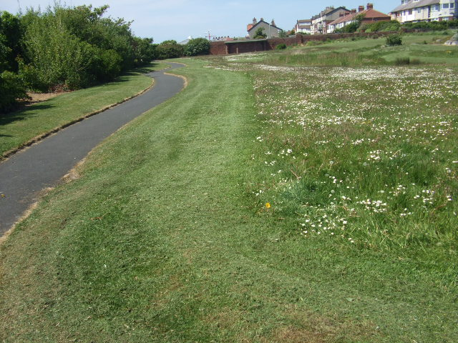

Bill Lane, Formby: a more natural looking site where longer grass fits with the character. Some short grass areas are still maintained to allow for walkways, balls games and other differing kinds of recreation
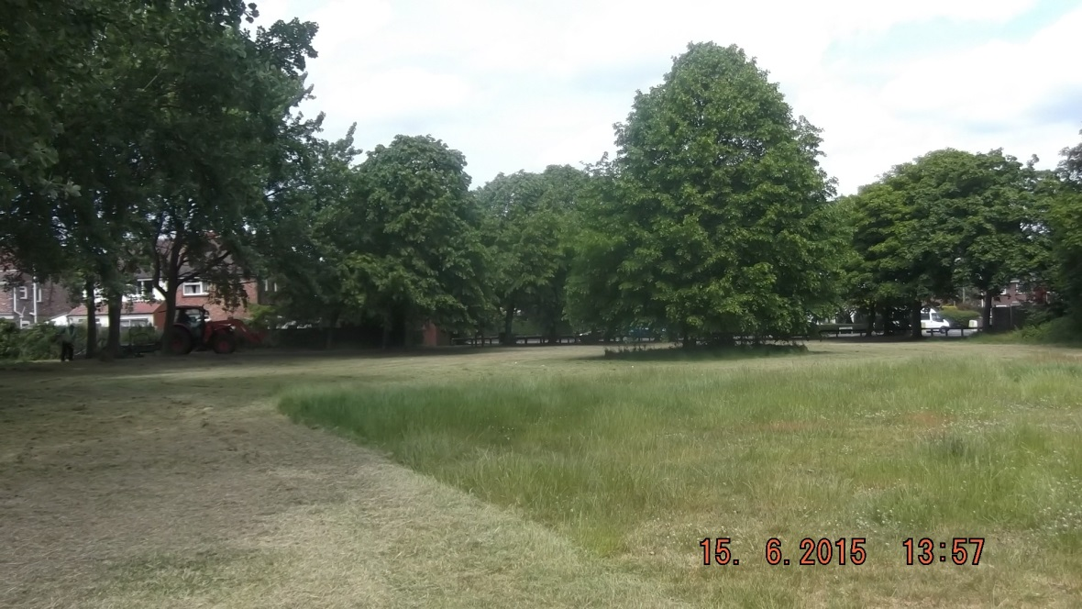

Crosby Coastal Park: infertile ( very sandy) soil ensures the grass areas stay low, but this habitat is entirely fitting for the Sefton coast

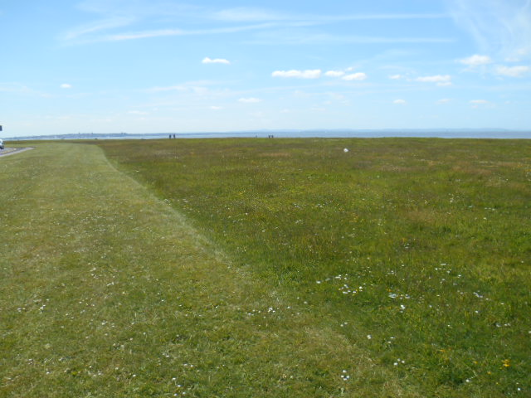

Marian Gardens, Netherton: a display of Oxeye Daisy's adds to the attractive as of the park, and it's appearance from the road

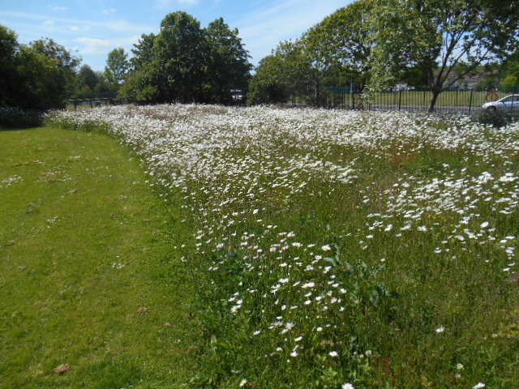

Victoria Park, Crosby: an explosion of wildflowers adds interest to an area that used to just be a field
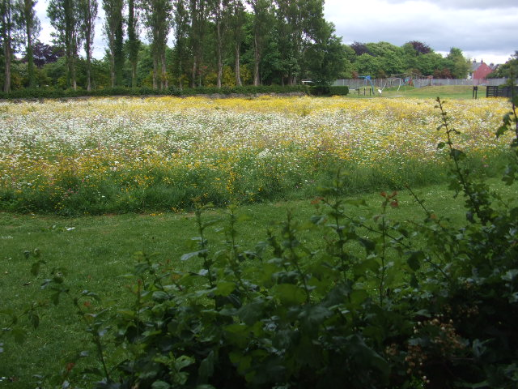
Botanic Gardens, Southport: a mown path though a meadow provides an interesting route (in an area of what used to be seen as a very formal/ traditional ornamental park and with no user complaints)
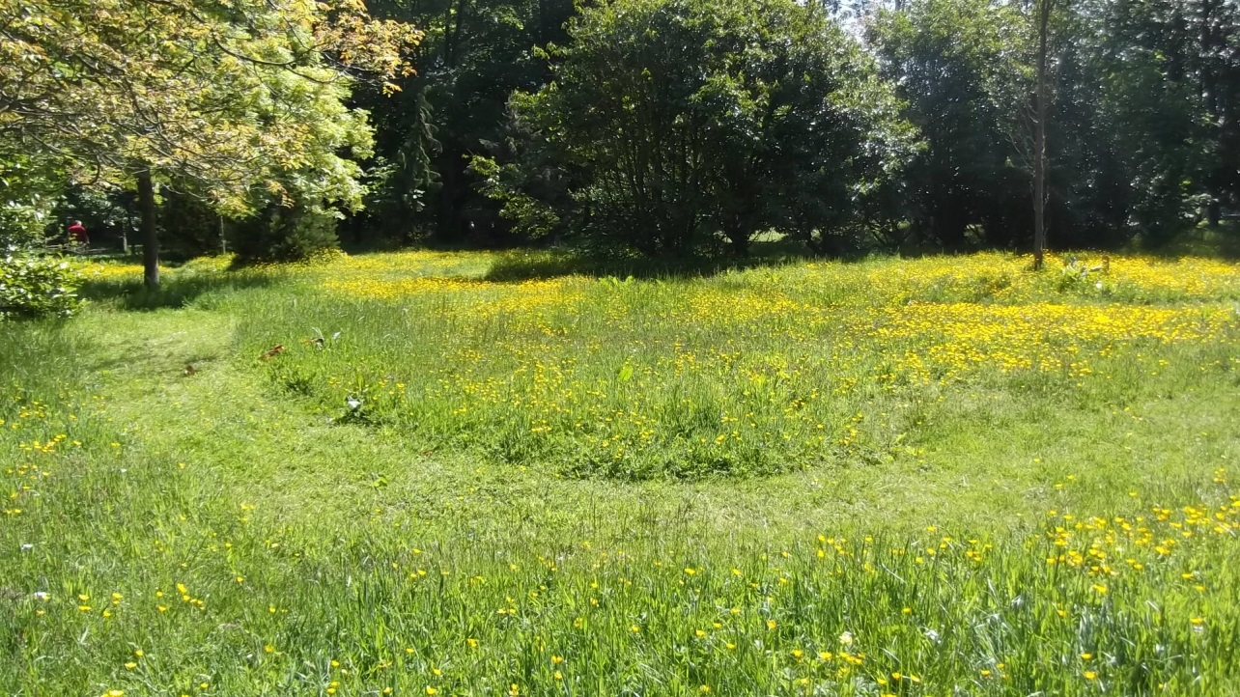

And some more innovative designs:

Bedford Park, Southport: a redundant bowling green has become a fun new labyrinth feature in the park (which can be redesigned at no cost each year)

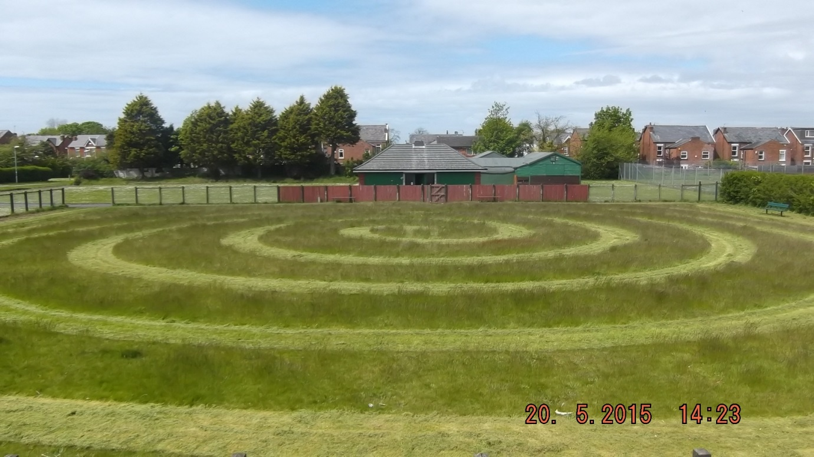

Victoria Park, Crosby: another redundant bowling green has become a fun new labyrinth feature in the park (which can be redesigned at no cost each year)

