Sefton Schools Forum Report

Date of Meeting: | 15 January 2024
Title of Report: | Report on the work of School Improvement
Presenting Officer: | Jacqui Patterson
Reason for Submission to Forum: | - ITEM FOR INFORMATION
Executive Summary: | To follow-up from the previous report to Schools Forum in October 2023 and provide the latest Ofsted position, and the financial commitment and actions for 2023-24
Budget/Risk Implications: | See details
Recommendations: | None – for information
Appendices
Background Papers
(available on request)
Report Originator and Contact Details | Name: Jacqui Patterson  Tele:  E-mail: Jacqui.patterson@sefton.gov.uk

SCHOOLS’ FORUM POWERS & RESPONSIBILITIES

1 ITEMS FOR APPROVAL (DfE can adjudicate where Forum does not agree LA proposal)

2 ITEMS FOR CONSULTATION (Forum provides a view on LA proposal but LA decides)

3 ITEMS FOR CONSULTATION (Forum provides a view on LA proposal but DfE decides)

4 ITEMS FOR INFORMATION (No formal view of the Forum is sought)

1. | Items for information
1.1 | Ofsted Update (as of 1.12.23)  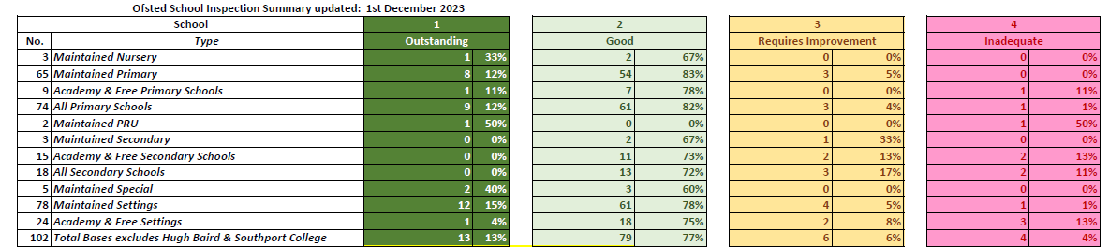  95% of maintained primary schools are rated good or better, with 12% outstanding. 100% of the maintained nurseries are good or better. 2/3 maintained secondary schools are good; 1 is RI, but has recently been inspected and is awaiting its report.
1.2 | School Improvement Financial Commitment 2023 -24  Financial support Costings Total  - Professional Partner School KIT meetings 66 visits @ £250 per visit £16,500  - LA Professional Partner KIT Facilitator at PP meetings: 6 x £450 £2,700  - SIG groups 5 facilitators, 6 meetings each @ £475 £14,250  - CPD group Subsidised training, projects £22,000  - Research School £20,000 per term to deliver commissioned CPD £60,000  - Schools Causing Concern Protocol Delegated as appropriate £38,500  Details:  - All maintained schools, nurseries and PRUs, outside of the LA’s school support package, are offered one ‘Keeping in Touch’ meeting per academic year with a Professional Partner. Schools in the Ofsted window are visited in the autumn term. The School Improvement Service Manager quality assures a selection of visits, and all visit forms are collated for common themes or issues.  Professional Partners are currently made up of 11 Headteachers from across the LA and 4 external consultants.  - CPD is provided termly for the Professional Partners to ensure they are up to date with the latest education news and resources.  - School Improvement Groups (SIGs) are geographic clusters of schools (all phases) established to both build capacity within the LA, through peer-to-peer support, and to ensure that locality-specific priorities were addressed.  There are 5 groups; the LA SI team funds a facilitator for their meetings - these facilitators are all currently external consultants. Implementation plans are produced by each SIG, and SIG Chairs attend the SI Board and are held to account for the improvements.  - This group is a collaborative involving the SI SM, representatives from primary and secondary, SIG chairs, Rainbow hub, and others by invitation (e.g. the Research School).  The purpose of the group is to design a CPD programme that meets the needs of the schools within the current financial climate, but that also prioritises school and LA strategic goals. Regular audits of need are completed and used to inform the decision-making process. The group draws upon expertise within and outside of the LA, but with an emphasis on celebrating internal capacity and good practice.  Subsidised training costs for maintained schools are funded by the SI budget; academies are charged a higher fee. The Research School (previously Meols Cop High School) also receives funding to run evidence-based programmes for any school in Sefton to access (see below).  - The Research School is funded by the LA to run evidence-based training programmes that all Sefton schools can attend. These include a Middle Leader Mastery programme, evidence briefings and subject specific sessions.  - There are 10 schools currently on the protocol: 6 red, 4 amber; 6 primaries, 1 secondary, 1 nursery, 1 special and 1 PRU. 3 schools have been moved from the protocol and 1 has been added.  Schools can be added to the protocol as a preventative measure, sometimes due to a time-limited and specific barrier, as well as due to wider systemic issues.  Bespoke packages of support are in place for schools causing concern, including a termly or half termly challenge meeting where impact is monitored, and support amended where appropriate. Evidence from recent Ofsted inspections shows that LA support is well received and has impact (and in some cases prevented a judgement of SW/SM).

