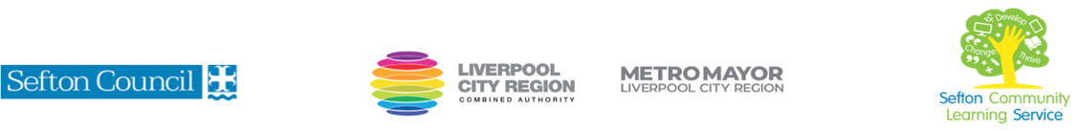
Sewing Machine Functions for Beginners
(Courses are offered subject to viable numbers.)
This course is for: | Adult learners who have not used a sewing machine before or who wish to refresh their skills.
What will I learn: | Course content below is subject to change based on prior knowledge and skills of each cohort.  - Induction: key information about the course and the centre  - How to reflect on your current knowledge and skills and what you want to develop (Initial and diagnostic assessment and setting of personal targets)  - Tools and materials required  - Parts of the machine and their uses  - Sewing machine basic features  - How to thread the machine  - How to thread the bobbin  - Looking at stitches and tension  - Sewing with different types of fabric  - Sew a straight line  - How to wind a bobbin  - Choosing the right needle and thread for the fabric  - How to insert a new needle  - Adjusting sewing machine tension  - How to sew zig zag stitch  - Different stitches and types of fabric  - Make a simple skirt in stretch fabric using stitches and techniques learnt  - Trouble shooting – what to do when something goes wrong  You will have the opportunity to discuss and set your individual learning targets with your tutor and discuss the support you might need to ensure you have an enjoyable and meaningful learning experience
Knowledge and skills needed: | This is a course for complete beginners and no prior subject knowledge or skills are required.  On this course you will need to:  - follow verbal and written instructions and work through them at your own pace  - listen and join in group discussions  - jot down notes to record relevant information  - keep your work organised in a file  - use a PC/laptop or tablet for research  - have some dexterity using your hands
Materials needed: | At enrolment, you will need your NI number and proof of benefits (if applicable).  You will need to come prepared to the lessons with an A4 pad; pen and folder or file to keep your work organised.  Most tools and materials will be provided but you may need to bring some fabric – this will be discussed at the first session.  It will be an advantage, but not essential, if you have access to the internet at home to extend your learning.
How will I learn: | Each session will consist of a dynamic tutor presentation followed by a range of practical activities.  There will be plenty of revision and consolidation and learning will build on previous learning.  Your progress will be monitored by informal assessment tasks and you will receive verbal and written feedback from the tutor to help you make good progress. You will also complete a series of practical tasks to demonstrate your learning
Progression routes: | On completion of this course, you can progress to other sewing courses, e.g. Soft furnishing for beginners, Memory Bear and other craft courses run by SCLS and other local providers.  Ask your tutor for advice and a copy of the progression ladder.  SCLS offers a range of Functional Skills courses from Entry 1 up to Level 2 if you need to brush up your maths and English skills or require a qualification to support you with your career path.  Sefton @ Work will be able to provide independent information, advice and guidance to support you making informed choices for progression into further education, volunteering or employment.

