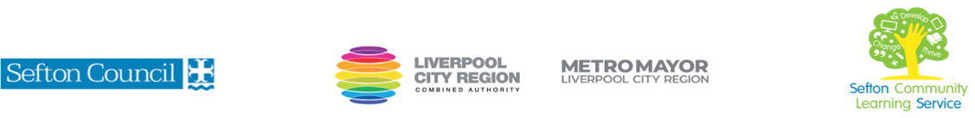
JAPANESE INSPIRED SEWING CRAFTS
(Courses are offered subject to viable numbers.)
This course is for: | Adult learners who wish to create projects inspired by Japanese traditional techniques. These will include bags and visible mending and will be mostly hand stitched. It is suitable for learners at all levels.
What will I learn: | Course content below is subject to change based on prior knowledge and skills of each cohort.  - Induction: key information to have an enjoyable learning experience  - Reflect on what you already know and what you want to learn (Initial and diagnostic assessment and setting of personal targets)  - Materials and tools required for this craft  - A range of Introduction to different stitches and techniques used on basic artifacts.  - How to create a basic fabric square using scrap fabric and boro stitching  - An introduction to using this technique for visible mending.  - An introduction to sashiko stitching patterns to create a sampler, cushion cover, bag, etc…  - How to transfer patterns on to fabric  - How to make a rice bag using a range of skills learnt on this course  - How to measure and cut fabric  You will have the opportunity to discuss and set your individual learning targets with your tutor and discuss the support you might need to ensure you have an enjoyable and meaningful learning experience
Knowledge and skills needed: | This is a course for learners of all levels and no prior subject knowledge or skills are required. A basic level of literacy needed (L1) and on this course you will need to:  - follow verbal and written instructions and work through them at your own pace  - listen and join in group discussions  - jot down notes to record relevant information  - keep your work organised in a file  - use a PC/laptop or tablet for research  - have some dexterity using your hands  - adhere to deadlines to complete projects on the duration of the course
Materials needed: | At enrolment, you will need your NI number and proof of benefits (if applicable).  Your tutor will provide most of the learning resources, but you will need to come prepared to the lessons with an A4 pad; pen and folder or file to keep your work organised. Basic tools and materials will be provided but you may need to bring in fabric and sewing notions. These will be explained in the first session.  It will be an advantage, but not essential, if you have access to the internet at home to extend your learning.
How will I learn: | Each session will consist of a dynamic tutor presentation followed by a range of practical activities.  There will be plenty of revision and consolidation and learning will build on previous learning. You will complete a number of practical projects during the course.  Your progress will be monitored by informal assessment tasks and you will receive verbal and written feedback from the tutor to help you make good progress.
Progression routes: | On completion of this course, you can progress to other sewing courses offered by SCLS, e.g. Patchwork and Quilting for Beginners, Embroidery for Beginners, Basic Sewing Machine Skills, Sewing Alterations – the Basics, as well as other craft courses.  You may also wish to progress to some IT or digital skills courses, especially if you wish to start your own craft business.  Ask your tutor for advice and a copy of the progression ladder.  SCLS offers a range of Functional Skills courses from Entry 1 up to Level 2 if you need to brush up your maths and English skills or require a qualification to support you with your career path.  Sefton @ Work will be able to provide independent information, advice and guidance to support you making informed choices for progression into further education, volunteering or employment.

