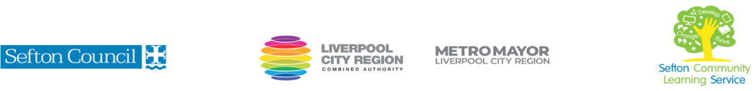
CREATING A FABRIC ADVENT CALENDAR

(Courses are offered subject to viable numbers.)
This course is for: | Learners who want to design and create their own reusable fabric advent calendar
What will I learn: | Course content below is subject to change based on prior knowledge and skills of each cohort. During the course you will learn cutting and stitching techniques to create your calendar  Week 1  - Induction, Initial assessment and setting of personal targets  - Course overview- find out what this course is about and if it is suitable for you  - Materials and tools required  - Basic sewing skills – the sewing machine  - Different types of stitched advent calendar: a bunting type with mini draw string bags and a fabric house shape with pockets  - How to create a small practice piece  Week 2  - How to select design and fabric to use  - Measure and cut fabric into pattern pieces  - Embellish, applique (e.g. numbers) on pieces before construction  Week 3  - Bunting – stitching bags  - Add pockets to front of house  Week 4  - Bunting bags – create channels for drawstrings  - House – stitching pockets using backstitch  - How to join roof piece to main house  - How to create a backing piece  Week 5  - Bunting – created bias tape for hanging bags  - How to create flat bottom for bags  - How to create bias tape for hanging and add into layers when constructing house  - How to stitch layers together  Week 6  - How to add drawstring to bags  - How to add bags to tape  - Ladder stitch and top stitch  - Next steps – adapting skills learnt for further projects  You will have the opportunity to discuss and set your individual learning targets with your tutor and discuss the support you might need to ensure you have an enjoyable and meaningful learning experience
Knowledge and skills needed: | This is not a beginner course and some basic sewing skills are required. A basic level of literacy needed (L1).  On this course you will need to:  - follow verbal and written instructions and work through them at your own pace  - listen and join in group discussions  - jot down notes to record relevant information  - keep your work organised in a file  - Use a digital device to access online resources shared by the tutor  - have some dexterity using your hands  - have basic sewing skills – e.g can use a sewing machine for straight seams
Materials needed: | At enrolment, you will need your NI number and proof of benefits (if applicable).  Your tutor will provide most of the learning resources, but you will need to come prepared to the lessons with an A4 pad; pen and folder or file to keep your work organised.  You will need to bring some material/garments to the class – this will be discussed in the first session.
How will I learn: | Each session will consist of a dynamic tutor presentation followed by a range of interactive activities.  There will be plenty of revision and consolidation and learning will build on previous learning.  Your progress will be monitored by informal assessment tasks and you will receive verbal and written feedback from the tutor to help you make good progress.
Progression routes: | On completion of this course, you can progress to other sewing courses offered by SCLS, e.g. Patchwork and Quilting for Beginners, Embroidery for Beginners, Basic Sewing Machine Skills, Sewing Alterations – the Basics, as well as other craft courses.  You may also wish to progress to some IT or digital skills courses, especially if you wish to start your own craft business  Ask your tutor for advice and a copy of the progression ladder.  SCLS offers a range of Functional Skills courses from Entry 1 up to Level 2 if you need to brush up your maths and English skills or require a qualification to support you with your career path.  Sefton @ Work will be able to provide independent information, advice and guidance to support you making informed choices for progression into further education, volunteering or employment.

