Updated Nov 21

7.00am-7.00pm  Public Swim | 7.00am-7.30pm  Public Swim | 7.00am-7.30pm  Public Swim | 7.00am-7.30pm  Public Swim | 7.00am-9.30pm  Public Swim | 12.00pm-4.00pm  Public Swim | 9.00am-4.00pm  Public Swim
9.00am-10.00am  £1 Swim | 6.30pm-7.30pm  £1 Swim | 2.30pm-3.30pm  Calm Waters | 1.00pm-2.00pm  £1 Swim | 4.00pm-5.00pm  £1 Swim | 2.00pm-4.00pm  Swim & Splash | 2.00pm-4.00pm  Swim & Splash
10.00am-11.00am  Calm Waters | 9.00pm-10.00pm  (Adults Only) | 8.30pm-10.00pm  Calm Waters | 9.00pm-10.00pm  (Adults Only) | 7.00pm-8.00pm  Swim & Splash
7.00pm-8.00pm  Ladies Calm Waters |  | 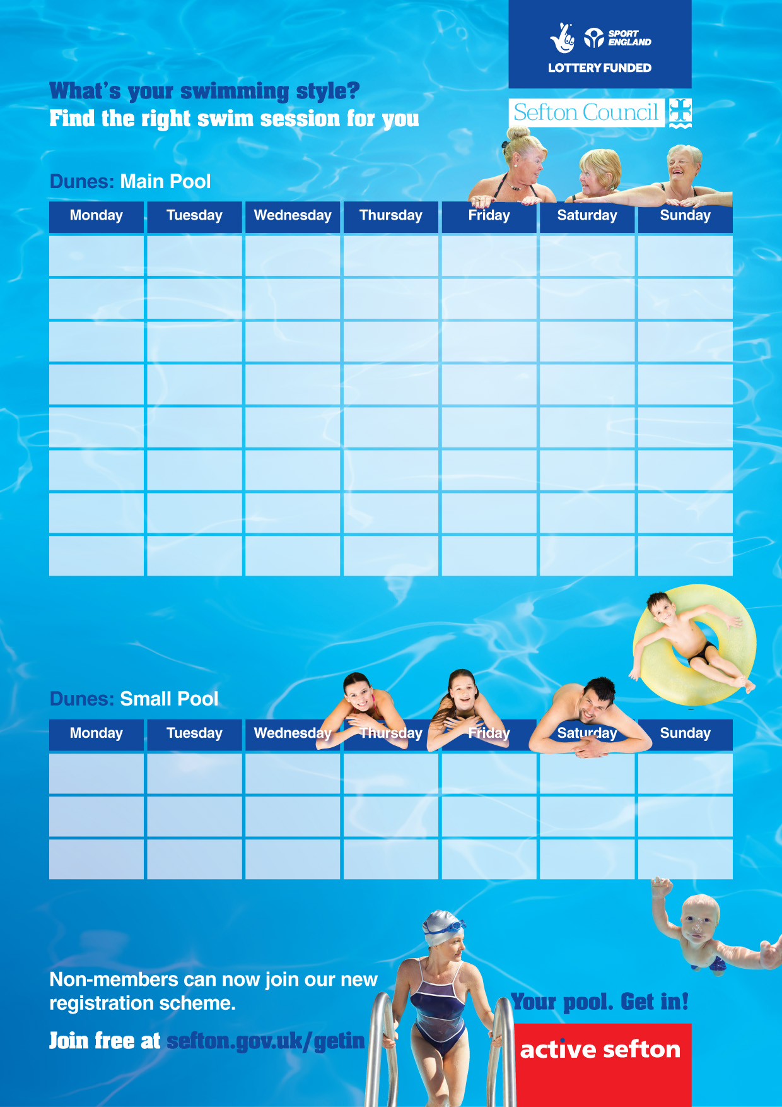 |  | 8.00pm-9.30pm  Calm Waters
Swim & Splash  Disco music and lighting | Calm Waters  Calming music and gentle lighting | £1 Swims  For over 60’s and under 16’s  (Term Time only)
10.00am-1.00pm  Public Swim |  | 10.00am-1.00pm  Public Swim |  |  | 12.00pm-4.00pm  Public Swim | 9.00am-4.00pm  Public Swim
11.30am-1.00pm  Swim & Splash |  | 11.30am-1.00pm  Swim & Splash |  |  | 2.00pm-4.00pm  Swim & Splash | 2.00pm-4.00pm  Swim & Splash

