Sefton Council | 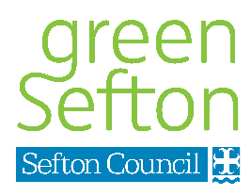
DRONE POLICY | Magdalen House  30 Trinity Road  Bootle  Merseyside  L20 3AB

- INTRODUCTION
Sefton Council has developed this Drone Policy in response to a variety of issues created by drone use on Council owned land, public open spaces and in protected landscapes in Sefton.
Where Sefton Council is the landowner or controller, drones may not be flown without permission. The main reason for this is that liability may fall to the Council if actions are brought about by drone activity when operated from land under our ownership. Sefton Council has obligations to retain Favourable Conservation Status for protected fauna and other special features contained within the Sefton Coast Site of Special Scientific Interest.
Use of drones in the UK is governed by the Civil Aviation Authority (CAA), but before flying a drone any person must remain within all existing laws, not just aviation law.

1.1 The Drone Code
The CAA, alongside aviation groups and others, has developed the drone code. All drone users must remain compliant with the CAA Drone Code at all times, which we summarise here, but the full document can be seen at https://register-drones.caa.co.uk/drone-code

Flying safely and responsibly (Points 1 and 2)
General responsibilities.

1. You’re responsible for flying safely whenever you fly | Always fly within the law, be prepared for something to go wrong. You could be fined or go to prison for the most serious breaches.
2. Always keep your drone or model aircraft in direct sight and make sure you have a full view of the surrounding airspace | 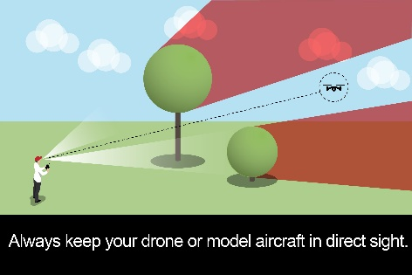

Where you can fly (Points 3 to 7)
Height limits and distances from people, buildings, crowds and vehicles.
Restrictions on flying near to airports.

3. Never fly above 400ft (120m) | 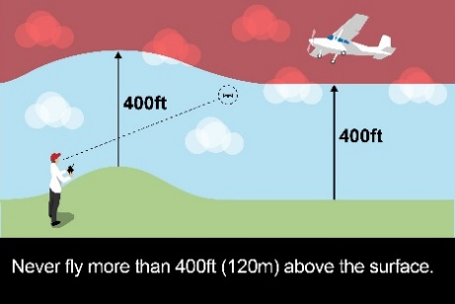
4. Keep the right distance from people (50m), property (50m), vehicles(50m) and busy areas (150m), Crowds of people (150m) and never fly above crowds at any height | 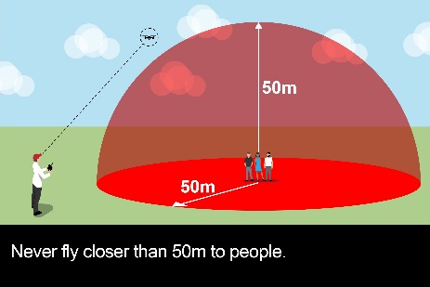
5. Stay well away from airports, airfields and aircraft | 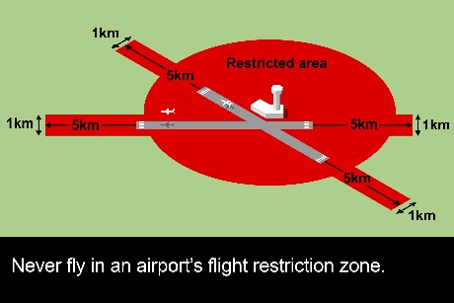
6. Always check and follow any flying restrictions | e.g. restricted airspace, events, emergency incidents
7. Check for local restrictions and temporary hazards | e.g. local byelaws, animals / disturbance, other aircraft

Making every flight safe (Points 8 to 15)
What to do before flying, during a flight and after a flight

8. Make sure you know what your drone or model aircraft can and cannot do

9. Make sure your drone or model aircraft is fit to fly | e.g. check batteries / fuel, check software / firmware & keep it updated
10. Do not fly if the weather could affect your flight | Adverse weather may affect you and your drone
11. Make sure you’re fit to fly | Do not drink and fly, do not fly under the influence of drugs or medication, do not fly if tired or unwell
12. Take action quickly and safely if the situation in the air or on the ground changes

13. Report any dangerous incidents or near misses | These should be reported to the CAA. Also beware of possible security response at airports or other sensitive sites
14. Do not use your drone or model aircraft to make money or for any kind of payment | If you want to do this, you’ll need to get a permission from the Civil Aviation Authority that allows you to conduct commercial operations.
15. If you fly your drone or model aircraft for recreation, you can choose whether or not to have insurance | Insurance is optional if you’re flying for recreation. However, you should remember that you’re responsible for your actions, which means you could be held personally liable for any injury or damage you cause while you’re flying.

Protecting people’s privacy (Points 16 to 21)
Making sure that you don’t invade anyone’s privacy when you’re out flying. What you should and should not do with photos and videos.

16. Respect other people and their privacy

17. Make sure you know what your camera can do and the kind of images it can take

18. Make sure you can be clearly seen when you’re out flying

19. Let people know before you start recording

20. Think before sharing photos or video

21. Keep photos and videos secure

Extra information: Getting a flyer ID and operator ID before you fly (Points 22 to 27)
What you need to do before you fly.
Two things are needed before flying a drone or model aircraft between 250g and 20kg:
- the person who will fly must pass the theory test to get a flyer ID
- the person or organisation that’s responsible for the drone or model aircraft, must register to get an operator ID
If you want to fly and are also responsible for a drone or model aircraft, you’ll need to pass the test to get a flyer ID and register to get an operator ID.
22. You must pass the theory test to get a flyer ID before you fly

23. You must take the theory test every three years

24. The person or organisation that’s responsible for a drone or model aircraft must register to get an operator ID

25. Label your drone or model aircraft with your operator ID

26. Make sure that anyone flying your drone or model aircraft has a valid flyer ID

27. Keep your operator ID up to date

Extra flying permission
If you want to do more types of flying, you’ll need to get the correct permissions or exemptions first.
For example:
- if you want to fly at or near an airport, you need permission from the airport
- if you want to fly at different heights or distances to the ones in this Code, you need permission from the Civil Aviation Authority
- if you want to fly closer to or over a built-up or busy area, you need permission from the Civil Aviation Authority
- if you want to fly to make money or for any kind of payment, you need permission for commercial operations from the Civil Aviation Authority

- LAND OWNED BY SEFTON COUNCIL
Sefton Council is a large landowner within the Borough, managing around 180 parks and open spaces as well as extensive and strongly protected landscapes such as beaches and open sand dune nature reserves. In total this amounts to around 6500 hectares of land (or the equivalent of around 7800 football pitches!). Sefton is a partner to other landowning agencies on the coastline including Natural England, The National Trust and the Royal Society for the Protection of Birds and others.
Much of the land in the control of Sefton Council and these other agencies is within the protected landscape of the Sefton Coast Site of Special Scientific Interest (SSSI). The Council and these other agencies have legislative obligations to protect and conserve the designated Special Features that occur within the SSSI.
These special features are:
- BIRDS – Aggregations of Knot, Grey Plover, Dunlin, Oystercatcher, Bar-tailed Godwit, Ringed Plover and Sanderling
- AMPHIBIANS – great Crested Newts, Natterjack Toads
- REPTILE – Sand Lizard
- INSECT – Sandhill rustic moth
- PLANTS – Vascular plant assemblage, Petalwort, Grey Hair grass and Long-leaved Thread-moss
- HABITATS – Saltmarsh, embryo & mobile dunes, Lowland dry heath, Humid dune slacks and Fixed dune grassland
- The Sefton Coast SSSI is also important for its Littoral Sediment and its Coastal Geomorphology
Further information about these special features can be found at https://designatedsites.naturalengland.org.uk/SiteDetail.aspx?SiteCode=S2000426

Sefton Council is a filming friendly Borough. Those departments which are responsible for the upkeep and maintenance of the filming destinations throughout the Borough, work closely with both the Council’s Corporate Communications Team and also with the Liverpool Film Office to further improve the reputation of the Liverpool City Region as a first class filming destination for the media, TV / film, sales and advertising industries.

- RECREATIONAL OR COMMERCIAL?
The Council operates a fair balance between ensuring good standards of public safety and protecting wildlife, whilst at the same time recognising drone use is a popular and expanding hobby enjoyed by many people.
Commercial users are expected to contact the Council to seek appropriate permissions / licences. The normal procedures for event applications are followed, and all applications are individually scrutinised to ensure that they are both compliant and safe before permission is granted. Suitable timeframes are also needed, so early application is preferred.
Recreational drone users must not use the protected landscapes of the Sefton Coast Site of Special Scientific Interest (SSSI). Without realising it, they could very easily cause disturbance to any of the SSSI Special Features as listed above.
Whether they are being used for commercial or recreational purposes, there are four sets of regulations which apply to the use of drones.
- Aviation regulations which are enforced by the Civil Aviation Authority (CAA) – e.g. CAP No.722
- Data protection regulations apply where the drone is used for capturing personal data and this can be enforced by the Information Commissioners Office (ICO).
- 1981 Wildlife & Countryside Act (as amended by the Countryside and Rights of Way Act 2000)
- Local Byelaws

The larger parks and open spaces away from the protected landscapes in Sefton are regarded as more suitable for recreational drone users.

- ACQUIRING COMMERCIAL PERMISSIONS AND TIMEFRAMES
In order to obtain permission from Sefton Council to use a drone in protected areas, this must be formally requested. We may need to acquire consents from Government agencies / regulators so additional fees and longer timeframes may apply.
Sefton Council will charge facility fees, administrative processing and for scrutiny of applications to ensure that proposals are safe and fulfil our obligations (see separate details for fees and charges). Agreement to Sefton Council’s fees is required before applications are processed.
Sefton Council operates an application process for organised events that are proposed on its land. An applicant may be the drone pilot or company or any organisation intending to utilise a drone services provider. Sefton Council will ask for the following:
- A completed application form
- Details of Public Liability Insurance cover
- A full flight plan including launch / land location and details such as altitude, duration, area coverage, subject matter etc
- Pilot CAA credentials
- A risk assessment
- Agreement to any professional, administrative or facility fees
Ordinarily, reasonable notice is required from applicants – this should be a minimum of 28 days. The possibility of fast tracking applications may not always be available. Where Sefton (and if necessary Natural England) can fast track an application, this will elevate the costs, in addition to those described above (see separate details for fees and charges).
Each application will be individually assessed and closely scrutinised so that Sefton Council is able to absolve itself of any liability attached to the drone works (and other activities associated with the application), is satisfied that the activities are lawful and that they have no impact on the special features of the SSSI.
Sefton is in a unique position to be able to offer drone services to applicants as we have our own drone equipment, fully qualified drone pilot and suitable insurance. Please contact us at Green Sefton for a further discussion if this is of interest.
In the first instance, all applicants should visit Sefton Council’s website and visit ‘All Apply for it Services’, then search for our small events form, or follow this link to the application page https://forms.sefton.gov.uk/SmallEventsform/

- EXEMPTIONS
Sefton Council operates its own drone equipment in order to carry out GPS and photographic survey work associated with flooding, coastal erosion and risk management. The use of drones for these purposes significantly reduces risk levels to our personnel and reduces the amount of time required to carry out surveys over large areas. The data generated is used to help protect our communities and monitor the condition of our natural sea defences.
The emergency services deploy drones within the Borough, sometimes at the scene of accidents, and sometimes in relation to search and rescue situations which can be time critical, especially if we consider the tidal ranges of the rivers Mersey and Ribble, which skirt the Borough from top to bottom. Drone deployment ‘in situations of overriding public interest, may ultimately save someone’s life.

Green Sefton
August 2020

