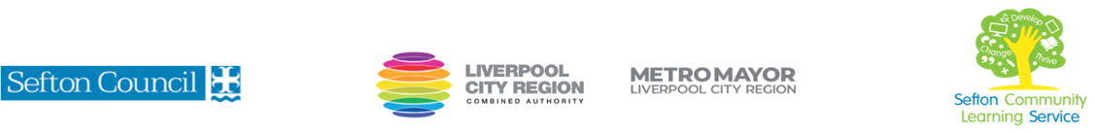
Introduction to Tracing Your Family Tree

(Courses are offered subject to viable numbers.)
This course is for: | Adult learners who interested in learning about their family history, and the lives lived by their ancestors. The course aims to teach you the skills you need to start research on your family tree.  You will have the opportunity to carry out research for yourself. In order to do this, you will need to be able to use a laptop or tablet. You may bring your own device to the sessions.
What will I learn: | Course content below is subject to change based on prior knowledge and skills of each cohort.  Week 1  - Induction  - Initial and diagnostic assessment and setting of personal targets  - Establishing your starting point, who is on your family tree?  - Home archives  Week 2  - Genealogy programmes and websites  - Building your family tree on paper or online  - Checking everything!  Week 3  - Birth, marriage and death records:  - Certificates of birth, marriage and death  - Searching the General Register Office index and applying for copies.  Week 4  - Parish records – where can we find them online? What additional information may they contain?  - How can I find where to locate original records?  Week 5  - Census records: what information do they give us, and what issues are there?  - Street and trade directories  Week 6  - DNA testing  - Putting it all together  You will have the opportunity to discuss and set your individual learning targets with your tutor and discuss the support you might need to ensure you have an enjoyable and meaningful learning experience
Knowledge and skills needed: | This is a course for complete beginners and no prior subject knowledge or skills are required. You will need basic levels of literacy and IT.  On this course you will need to:  - follow verbal and written instructions and work through them at your own pace  - listen and contribute to group discussions  - Make notes and organise work  - use a PC/laptop or tablet for research or to present your work  - keep your work organised in a file or electronically  - know how to search for information using the internet
Materials needed: | At enrolment, you will need your NI number and proof of benefits (if applicable).  Your tutor will provide many of the learning resources, but you will need to come prepared to the lessons with an A4 pad; pen and folder or file to keep your work organised.  You will be working with online sources so you can bring in your own lap top / tablet, or use SCLS devices in the Centre.  It is an advantage, but not essential, if you have access to the internet at home or in the library to extend your learning.
How will I learn: | Each session will consist of a dynamic tutor presentation/demonstration followed by a range of interactive & practical activities.  There will be plenty of revision and consolidation and learning will build on previous learning.  Your progress will be monitored by informal assessment tasks, and you will receive verbal and written feedback from the tutor to help you make good progress.
Progression routes: | On completion of this course, you can:  - continue your personal research or take a more advanced course. These are offered through SCLS, WEA and U3A.  - join a Family History Society  - volunteering at Local History events.  Ask your tutor for advice and a copy of the progression ladder.  SCLS offers a range of Functional Skills courses from Entry 1 up to Level 2 if you need to brush up your maths and English skills or require a qualification to support you with your career path.  Sefton @ Work will be able to provide independent information, advice, and guidance to support you making informed choices for progression into further education, volunteering, or employment.

