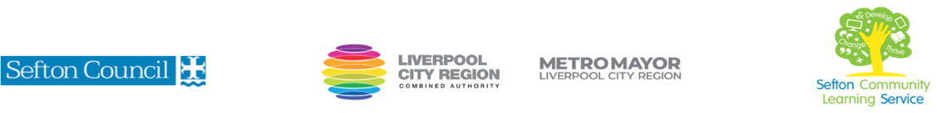
Conversational German for Beginners: Next Steps

(Courses are offered subject to viable numbers.)
This course is for: | Adult learners ready to move on from first phrases to general conversation in German about simple topics. The focus of this course is on speaking and understanding spoken German.
What will I learn: | Course content below is subject to change based on prior knowledge and skills of each cohort.  Week 1  - Induction  - Initial and diagnostic assessment and setting of personal targets  - Introductions and saying a little about yourself (in German)  Week 2  - Hobbies and habits: describing your interests  - Finding out about others: what do other people enjoy doing?  Week 3  - Talking about other people and things: using er/sie/es  - Getting used to verb endings (present tense)  Week 4  - Travel and holidays  - Forms of transport: learning vocabulary  - Buying a ticket and getting around: practising practical requests  - Describing your own holidays  Week 5  - Weather and the seasons: understanding the weather forecast  - Life in Germany: learning about events and customs and how to talk about them  Week 6  - Review of learning: putting together and practice what you have learned so far  - Next steps: how to take your German further  You will have the opportunity to discuss and set your individual learning targets with your tutor and discuss the support you might need to ensure you have an enjoyable and meaningful learning experience
Knowledge and skills needed: | This is a course for learners who have completed our Introduction to Conversational German for Beginners, or who have equivalent knowledge of basic German. It is not suitable for beginners with no prior knowledge of German.  On this course you will need to:  - follow verbal and written instructions  - be prepared to speak and try out pronunciation  - listen and join in group activities  - jot down notes to record relevant information  - keep notes and handouts organised in a file  - expect to follow up each lesson with homework in your own time (30 minutes approx)  It would be useful to have an understanding of basic grammatical terms (verb, noun etc) and to be able to use a PC/laptop or tablet to access online learning resources
Materials needed: | At enrolment, you will need your NI number and proof of benefits (if applicable).  Your tutor will provide many of the learning resources, but you will need to come prepared to the lessons with an A4 pad; pen and folder or file to keep your work organised.  It will be an advantage, but not essential, if you have access to the internet at home to extend your learning. If needed, your tutor will be able to support you with IT skills required for your course.
How will I learn: | Each session will consist of a dynamic tutor presentation followed by a range of interactive activities.  There will be plenty of revision and consolidation and learning will build on previous learning.  Your progress will be monitored by informal assessment tasks, and you will receive verbal and written feedback from the tutor to help you make good progress.
Progression routes: | This course will give you the basics you need for travelling to German speaking countries (Germany, Austria, Switzerland). On completion of this course, you can progress to other language courses at SCLS or other local colleges, or enrol for further German courses with an online provider. You may prefer to practise your German conversation skills in an informal language exchange club, with a private tutor or subscribe to a German learners’ magazine.  Learning a language is a great way to whet your appetite for other subjects, so look out for other courses offered by SCLS.  Ask your tutor for advice and a copy of the languages progression ladder.  SCLS offers a range of Functional Skills courses from Entry 1 up to Level 2 if you need to brush up your maths and English skills or require a qualification to support you with your career path.  Sefton @ Work will be able to provide independent information, advice, and guidance to support you making informed choices for progression into further education, volunteering, or employment.
V- July22 (2)

